Myths, Miracles, Mysteries, Mission – following the Saints
Introduction

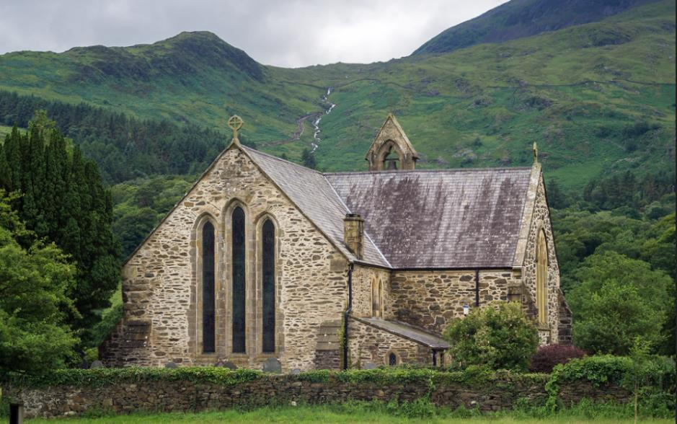
Adam Court/flickr St Mary’s Church, Beddgelert, Wales, UK
Have you ever walked past a church and noticed that its name is that of a saint? And have you ever wondered why so many churches seem to be called after saints?
By the fourth century, it began to be the practice to dedicate new churches to a ‘patron’ saint. Images of that person were often displayed in the churches and the name of the saint would be displayed. Today, many churches are dedicated to all kinds of saints, but some Christian denominations now do not use them to dedicate their buildings.
The Christian creeds, our statements of what we believe, say that ‘we believe in the communion of saints’ - holy women and men who have been faithful followers of Jesus Christ and who have often lost their lives through persecution of the Christian faith. Some Christian denominations recognise saints ‘days’ in the Christian calendar when particular saints are especially remembered and churches dedicated to particular saints hold special services, ‘patronal festivals’, on those particular days. Across the world, some of these dates are very well known outside the Church, such as St Valentine’s Day on February 14th or the St Patrick’s Day celebrations on March 17th.
Some saints are said to be ‘patron saints’ of particular groups of people, sometimes because of some event or legend about their own story. In the UK there are four ‘nation’ saints, St George for England, St David for Wales, St Patrick for Ireland, and St Andrew for Scotland.
This set of sixteen resources is designed to offer you a range of ways of finding out more about St Patrick, the patron saint of Ireland and finding out about the mission, myths, miracles, and mysteries associated with him and to ask how we understand these things today.
There are four ‘pathways’ for you to follow, and you can mix and match them if you like. They are:
YELLOW JOURNEY – word-based resources for people who like to read information, talk about things and consider questions, perhaps in a study group. The Yellow Journey also guides you through the best information we have (eg the Bible for biblical saints) moving on to how we learn from, evaluate and use other traditions about the saints.
BLUE JOURNEY – for people who like to engage with Scripture, use prayers, and use Christian reflections. The Blue Journey also begins from the best information we have (eg the Bible) through to prayers and traditions associated with particular saints.
GREEN JOURNEY – image and activity based for people who like to explore, create, look at images and get out and about. The Green Journey also delves into things like the traditions of saints around the world, seeing them through the eyes of other Christians.
PINK JOURNEY – for people who want to explore Christian faith more deeply, find out more about following Jesus, and using the ‘lens’ of the saints to create opportunities for thinking about how we live our lives.
Another way to mix and match the resources is to follow the information across the four journeys about the person first and as much factual material as is available, then think about the mission of that person and where and how that was recorded, then move on to the miracles associated with that person and finally the mystery of the saints and what their stories might mean for us today.
You can use these resources whether you are a Christian or not, as an individual study or in a group of friends.

This grid shows you the range of the resources for St Patrick and how you can mix them:

 | The Man | The Mission | The Miracles | The Mystery
Yellow Journey | Who was St Patrick? | A Voice and a Vision | An Easter Fire | A Magic Mist
Blue Journey | Paul and Slavery | Call of Samuel | Elijah and the Priests of Baal | Banishing Darkness
Green Journey | St Patrick’s Grave | The Letter to the Soldiers of Coroticus | St Patrick’s Fish | 17th March: the Blue and the Green
Pink Journey | Following Patrick | The Shamrock | The Snakes | St Patrick’s Breastplate

The Man: Who was St Patrick?

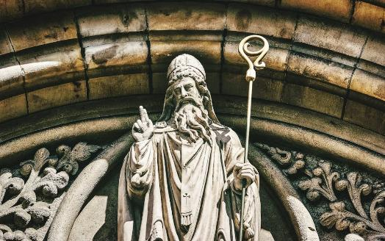
Image by K Mitch Hodge on Unsplash
There is a rich tradition of wonderful Irish myths and legends and many surround St Patrick. What we can know of his life comes principally from two short pieces of writing. The Confessio, his spiritual autobiography, and his Letter to the Soldiers of Coroticus, about persecution of new Irish Christians.
Patrick was born in Britain sometime in the 5th century AD. His family were likely Romanised British people, and Christians. His original name may have been something like Magonus Succetus. By his own account, when he was 16 years old, Irish pirates raided the family home and took him to Ireland as a slave. Here, for six years, he was kept as a herdsman during which time he meditated on his Christian faith and what God wanted for him. He says he had a dream of a ship to help him escape, and then ran away back to Britain, nearly starving to death and facing many dangers. He found his family and may then have gone on to Europe, where he studied for the religious life and for ordination to the priesthood.
He says he had another dream in which he felt called to return to Ireland as a missionary. Once there, he travelled through Ireland, converting and baptising many people, ordaining priests, and enduring many trials. He was careful to dialogue with the Celtic tribal peoples, the ‘magicians’ in the writings and show their leaders respect, though convinced of his need to convert them. However, some of his Christian superiors back in Britain were critical of him, although he was in essence a humble man. Despite that, he is called First Bishop of Armagh and Primate of Ireland. He is often credited with bringing Christianity to Ireland (possibly around the year 432), though it is likely Christian contact had already been made before he went as a missionary. Scholars do not agree exactly when he died, mooting c460 or c493.

What this means for us today
Patrick’s life seems to have been made around a series of journeys, some chosen and some enforced. Journeys in those times were often difficult and dangerous – sea crossings, lack of food and the possibility of violence at every turn. Yet after being taken where he did not want to go, Patrick seems to have found purpose in making His Christian faith into directed journeys, bringing the faith to those he encountered along the way.
Many people today are looking for purposeful journeys to something concrete and meaningful. Rather than just drift through life, many people are finding something deeply spiritual in modern forms of pilgrimage or encounter with others. Patrick can inspire us, as Christians, to be intentional about our faith and finding ways to be more attentive to God’s call.
Although Patrick was taken to Ireland as a slave and needed to escape his captivity, something about the place and its people must have mattered enough to him to need to go back there and turn the faith that had sustained him into living hope for others. This part of his story can remind us that whatever adversity we have gone through in life can often be turned into a positive to help others.
Some questions to think or talk about:
- Today, we would say the 16-year-old Patrick was a victim of people trafficking. How do you think Christian faith sustained him while he was a slave and gave him a purpose? How can we support kidnapped and trafficked people today?
- What do you make of Patrick’s directive dreams/visions? Have you ever had a powerful dream, or answer to prayer, which helped you solve a problem or suggested a way forward?
- If you were to write a spiritual biography like Patrick’s Confessio, what events would you mark as being particularly significant in your journey of faith?
- Where do you see people turning adversity into positive stories of hope for others?


Image by Three-shots on Pixabay

The Mission: A Voice and a Vision
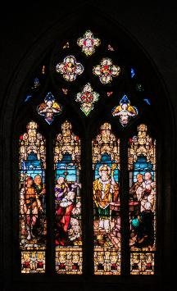
Image by K Mitch Hodge on Pixabay
A few years later I was again with my parents in Britain. They welcomed me as a son, and they pleaded with me that, after all the many tribulations I had undergone, I should never leave them again. It was while I was there that I saw, in a vision in the night, a man whose name was Victoricus coming as it were from Ireland with so many letters they could not be counted. He gave me one of these, and I read the beginning of the letter, the voice of the Irish people. While I was reading out the beginning of the letter, I thought I heard at that moment the voice of those who were beside the wood of Voclut, near the western sea. They called out as it were with one voice: “We beg you, holy boy, to come and walk again among us.” This touched my heart deeply, and I could not read any further; I woke up then. Thanks be to God, after many years the Lord granted them what they were calling for.
In his Confessio, Patrick writes about the vision in the night with a man coming with a letter asking him to go back to Ireland. He’s clear that his parents would like him to stay with them and not leave for any more dangers; yet the vision of the letters and the voice of the Irish people are too compelling. He sets about preparations to respond to what the vision asks.
What this means for us today
Jesus sought only to do the will of the Father, even though he knew it would lead to his suffering and death. Many Christians who seek only what God wants for them find themselves doing unexpected things. Many think they are unprepared or don’t have sufficient skills to respond to the call, but God’s desire for them is so strong they find they can overcome the easy response to look the other way or do nothing. We see people being ordained as priests who never thought they could get through ordination and training. We see people volunteering on the streets for the love of Jesus, helping others in trouble or distress. We see people becoming mission partners and going to places they never thought to visit or feel at home. We see people having dreams about Jesus or angels walking into their local churches, asking what it might mean. St Patrick shows us how strong these spiritual experiences can be and how they lead to an equipping for the task ahead.
Some things to think or talk about:
- How do you think Patrick’s parents felt about what had happened to him, and about his determination to go back to Ireland?
- When have you felt prompted by God for the next step in your journey of faith?
- Why do you think Patrick was so deeply affected by the plea from the ‘Irish people’? What do you think the Irish people might have felt about what Patrick did in their country?


Image by Margarita Kochneva on Pixabay
The Miracles: An Easter Fire


Image by Alexas Fotos on Pixabay
There are two early hagiographies (writings about the saint’s lives often from the point of view of victorious Christianity) which have survived about St Patrick. These date from the late 7th century. One is called the Vita Sancti Patricii (Life of St Patrick) by Muirchú moccu Machtheni and there are some more writings by a person called Tírechán. Both of these seem to be derived from an earlier writing called the Book of Ultán which is now lost. These are the earliest writings. Later ones include even more legends and miracles, but seem much further from what might have been known about Patrick himself.
As with many hagiographies, Patrick is portrayed as a strong leader who does battle with other religious beliefs and customs, overcoming Pagan beliefs and religious idols with the truth of Christ.
For example, one particular incident is described where Patrick goes up against Lóegaire mac Néill, the king of Tara. The king forbade Patrick to light an Easter fire on the Hill of Slane, but Patrick did it anyway.
Accordingly Saint Patrick, in his celebration of the holy Paschal feast, kindled a divine fire, very bright and blessed, which as it shone forth at night, was seen by almost all the dwellers in the plain…. Then the magicians answered and said, O king, live for ever. As for this fire which we behold, and which has been lighted up this night before one was lighted in thy house, that is, in the palace of Temoria, unless it be put out on this night on which it has been lighted up, it will not be put out for ever. Moreover it will overcome all the fires of our religion. And he who kindled it, and the kingdom that will follow, from which it is kindled this night, will overcome both all of us and thee too, and it will draw away all the men of thy kingdom, and all kingdoms will yield to it, and he will fill all things, and will reign for ever, and ever. https://pages.ucsd.edu/~dkjordan/xy/Patrick/Muirchu.html
The Pagan peoples, albeit possessed of temporal power, have sorcerers and spell casters who are mortally afraid of the Christian message. The light of the Paschal fire is such that it cannot be overcome and will overwhelm the Pagan beliefs and customs, such is the irresistibility of Christ.
What this means for us today
Lighting candles in windows at night has often been a simple protest against oppression; people light candles in church or at home in memory of loved ones and as a sign of love and hope. We sense, instinctively, the meaning and power of a light shining when the sun has gone.
In many churches the Easter mystery is celebrated with the lighting of a fire on Holy Saturday, from which the Paschal candle is lit and the light of Christ proclaimed into the darkness. But perhaps it is easy to forget, in a world of street lights and lit windows, the sheer power of the symbolism of light and heat blazing in the utter dark and cold and the power of the hope it portrays. Imagine that ‘blessed fire’ of Patrick burning in the black landscape for all to see. Jesus cannot be put out by any human agency or by the power of sin and death and rises to offer eternal life to all who believe in him. This is indeed an incredible message to share with others: do we really appreciate who might be drawn to the light and heat of the flames? Do we bear the Paschal fire within us when we share our faith with others?
Some things to think or talk about:
- Why do you think the Pagan peoples were said to have been so afraid of the Easter fire?
- Where do we read about the light that shines in the darkness in the Bible and what do you think it means?
- What point do you think Muirchú was trying to make about Patrick’s missionary work in Ireland?
- When do you light candles, use a torch, or value a light shining in the dark?

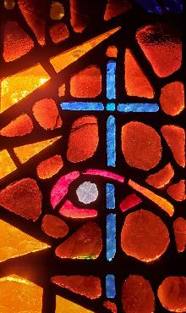
Image by Sos8 6 on Pixabay
The Mystery: A Magic Mist


Image by Lovelooking on Pixabay
There are two sorts of Magic Mist in the stories about St Patrick, and which generate two different sorts of miracle which show the power of steadfast Christian faith.
Some of the legends around St Patrick are written in the form of a series of contests between St Patrick and Pagan chieftains and believers, called ‘the magicians’ because they are skilled in powerful spells. So the contest is between these spells and the power of prayer.
One of these contests is called the ‘Fog Duel’ where the magicians produce darkness, snow and thick fog, and the people are all cold and terrified.
AND the magician, beholding how his art was scorned and set at small account, once again by his enchantments covered the places that had been whitened with snow, even with a palpable cloud of thick darkness. And fear and trembling came on all whom it covered, or at least they experienced how closely it shaded them from the brightness of the true faith. Nor let it be marvelled that strangers to the darkness of the true light which illuminates every man entering this world should be involved in the darkness of magicians, who, with blind and hardened heart, worshipped the prince of darkness. And Patrick in his wonted words addressed the magician, that he would make this cloud to pass away; but the magician answered even as before. Then did the son of light pour out a prayer -to the Eternal Light, the Sun of Justice, and immediately the material sun arose and shone forth, and the darkness was dispersed. And the people which had hitherto sat in dark ness, now beholding the great light, proclaimed their thanks and their praises, and magnified Patrick, who was the preacher of the Eternal Light.
https://archive.org/stream/saintpatrick00oleauoft/saintpatrick00oleauoft_djvu.txt
This unnatural fog is a spiritual battle; we are to understand that the people are being prevented from hearing the gospel and responding to the light of Christ. Blind to the truth of the Christian gospel and kept from the warmth of faith, the people are miserable.
But Patrick breaks through the fog and darkness with prayer, so that the sun breaks through and disperses the magic mist, and releasing people from their misery into claiming Christ for themselves. The magicians are thus defeated and Patrick’s mission vindicated. We are surely meant to hear echoes of ‘The people who walked in darkness have seen a great light’ (Isaiah 9.2) in the account of Patrick’s victory and bringing of the Good News to the people of Ireland.
There is also in Irish folklore a story of the Féth fíada, which is a concealing mist or cloak which members of the Tuatha Dé Danann (supernatural beings in Irish myth) could use to hide themselves from human beings.
Patrick’s hagiographers take this folklore idea and ascribe it to Patrick to explain how he escaped danger from those who would seek to kill him. They tell how King Lóegaire mac Néill, the High King of Ireland, sent warriors to ambush Patrick and his followers as they travelled to the Hill of Tara. But Patrick prayed a powerful prayer of protection, so powerful that they were all miraculously concealed, so that they appeared to enemies as a herd of deer with fawns and the assassins missed them. Because of this the famous prayer known as St Patrick’s Breastplate, is also known as ‘The Deer’s Cry’ (see Pink Journey 4).
What this means for us today
The stories of the magic mist are meant to be read spiritually. Without Jesus, we are the people who walk in darkness. Christian mission enables the darkness to be swept away and the light and comfort of the Christian gospel illuminates not only the land through the power of the sun, but people’s minds and hearts as well. The stories suggest how other beliefs and practices which are resistant to the Christian message and want to destroy it, hold people in the darkness and don’t offer the chance of the life of abundance God wants for everyone. The stories are also a vindication for Christian mission and the importance of offering Christian faith to everyone who has not had an opportunity to hear about Jesus. The story of the deer also sends a strong message about how God protects us from perils and dangers and how we can develop a spiritual resilience to all that is evil.
Some things to talk and think about:
- Many stories and legends are set as a contest between good and evil, and we see this reflected in books, video games and films today. Why do we want good to triumph and why does it matter that those who walk in darkness get to see the light?
- What are the drawbacks to presenting people who are not Christians as ‘enemies’? Can this justify suppression or conversion (by force or faith), and decisions about how people ‘ought’ to live? Where do we see questions about this today?
- How do you think modern missionaries approach people who are not Christian today? Why might this matter in how we share our faith with others in today’s world?
- When and how have you experienced God’s protection?
- What do you think these stories about Patrick tell us about the power of prayer?

Image by Baptiste lhuerette on Pixabay
The Man, Patrick: Being a Slave
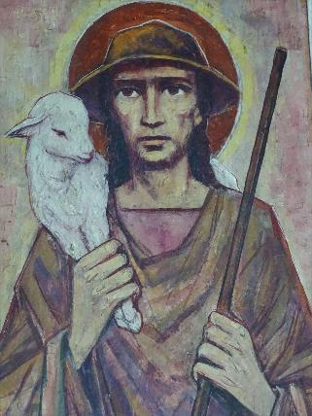
Image by Pumukel on Pixabay
Were you a slave when called? Do not be concerned about it. Even if you can gain your freedom, make use of your present condition now more than ever. For whoever was called in the Lord as a slave is a freed person belonging to the Lord, just as whoever was free when called is a slave of Christ.
1 Corinthians 7.21-22
Patrick’s Confessio tells us that for the six years he was a slave and made to tend animals, he did as St Paul suggests in the First Letter to the Corinthians, and concentrated hard on building up his faith and discerning God’s call.
After I arrived in Ireland, I tended sheep every day, and I prayed frequently during the day. More and more the love of God increased, and my sense of awe before God. Faith grew, and my spirit was moved, so that in one day I would pray up to one hundred times, and at night perhaps the same. I even remained in the woods and on the mountain, and I would rise to pray before dawn in snow and ice and rain. I never felt the worse for it, and I never felt lazy – as I realise now, the spirit was burning in me at that time.
https://www.confessio.ie/etexts/confessio_english#01 section 16
Patrick’s body was bound to his slavers, but in his mind and spirit he was freed by prayer. His captors had no control over his increasing love of God and sense of awe. As he tended the sheep even in cold and icy conditions, he was able to increase in faith and in a sense of purpose beyond his situation.
For most of us, thankfully, being a slave is something we will never have to endure, although there may be those among us in our congregations and communities who have come to Britain having been trafficked or otherwise bought and controlled by others. Yet there are other forms of loss of freedom and autonomy, from the conditions imposed by the structures of society, to the diminishments of illness and old age. Faith can help navigate those strictures and similarly create the conditions for love and awe of our world and our place in it.

Some questions to think about:
- St Patrick said he was kidnapped as a teenager and taken to Ireland. What would that experience have been like? How might learning about St Patrick help us to appreciate people who are, or have been, enslaved today?
- How do you think growing in faith and spending time in prayer helped to sustain St Patrick when he was tending the animals? What can we learn about spiritual resilience to the evils of the world from his story?
- What kinds of chains and strictures exist in our own society? How can faith help us overcome them?
- What do you think St Paul meant us to understand by becoming slaves of Christ?


Image by simple aign on Pixabay
The Mission: Called By God

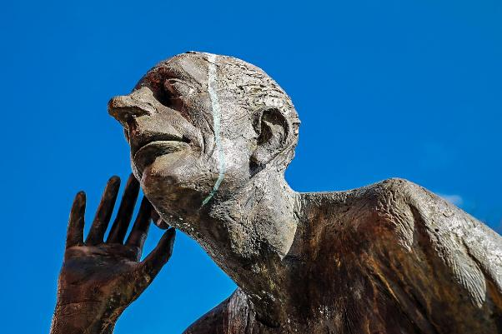
Image by couleur on Pixabay
Then the Lord called, ‘Samuel! Samuel!’ and he said, ‘Here I am!’ and ran to Eli, and said, ‘Here I am, for you called me.’ But he said, ‘I did not call; lie down again.’ So he went and lay down. The Lord called again, ‘Samuel!’ Samuel got up and went to Eli, and said, ‘Here I am, for you called me.’ But he said, ‘I did not call, my son; lie down again.’ Now Samuel did not yet know the Lord, and the word of the Lord had not yet been revealed to him. The Lord called Samuel again, a third time. And he got up and went to Eli, and said, ‘Here I am, for you called me.’ Then Eli perceived that the Lord was calling the boy. Therefore Eli said to Samuel, ‘Go, lie down; and if he calls you, you shall say, “Speak, Lord, for your servant is listening.”’ So Samuel went and lay down in his place.
1 Samuel 3.4-9
Samuel does not at first recognise that the call he hears is from God. His spiritual awareness is not yet developed enough to realise that God may enter directly into our lives. Eli, however, recognises that this is a divine intervention and tells Samuel what to expect. What Samuel receives is no gentle word but a mission to make ‘ears tingle’.
Patrick’s call develops over the time he spends herding animals and as he studies and trains for ordination. This is not a simple or easy path. In his Confessio, he writes:
So I’ll never stop giving thanks to my God, who kept me faithful in the time of my temptation. I can today with confidence offer my soul to Christ my Lord as a living victim. He is the one who defended me in all my difficulties. I can say: Who am I, Lord, or what is my calling, that you have worked with me with such divine presence? This is how I come to praise and magnify your name among the nations all the time, wherever I am, not only in good times but in the difficult times too. Whatever comes about for me, good or bad, I ought to accept them equally and give thanks to God. He has shown me that I can put my faith in him without wavering and without end. However ignorant I am, he has heard me, so that in these late days I can dare to undertake such a holy and wonderful work. In this way I can imitate somewhat those whom the Lord foretold would announce his gospel in witness to all nations before the end of the world. This is what we see has been fulfilled. Look at us: we are witnesses that the gospel has been preached right out to where there is nobody else there!
Patrick discerns from his life experiences and prayers that he has a missionary calling. He knows this will not be an easy ride, but a considerable challenge, and yet he is confident and confirmed in responding to God’s call to enter the ‘holy and wonderful work’ of being an evangelist.
Some questions to think about:
- What do we have to do to discern how God is calling us?
- Samuel had a wise teacher to help him recognise God’s call. What wise teachers do you see in your own life who guide you in your own faith and Christian life?
- Patrick said he had been on a long journey to find his mission in life. How has the journey of faith over time developed your sense of vocation or relationship to God?
- Both the call of Samuel and Patrick’s missionary calling come with the possibility of tough times ahead. How does a sense of call and Christian purpose equip us for facing struggle and difficulty?
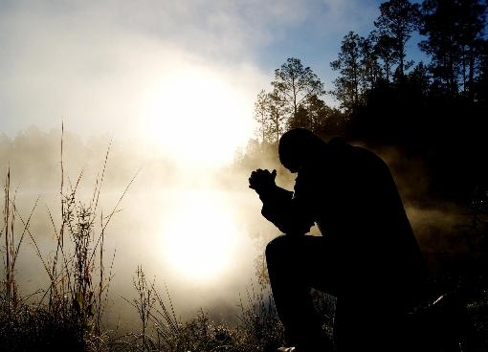
Image by Pexels on Pixabay

The Miracles: Elijah and the Priests of Baal

Image by Pexels on Pixabay
So Ahab sent to all the Israelites, and assembled the prophets at Mount Carmel. Elijah then came near to all the people, and said, ‘How long will you go limping with two different opinions? If the Lord is God, follow him; but if Baal, then follow him.’ ….
Then the fire of the Lord fell and consumed the burnt-offering, the wood, the stones, and the dust, and even licked up the water that was in the trench. When all the people saw it, they fell on their faces and said, ‘The Lord indeed is God; the Lord indeed is God.’
1 Kings 18. 20-21; 38-39
This is the account of a contest between different forms of belief and worship. The worship of Baal, who was revered as a weather and fertility god, tied to agricultural cycles within polytheist Canaanite religion, is seen as the worship of a pointless idol contrary to the commandment of Yahweh, the true God of Israel. This is demonstrated definitively in a dramatic contest of fire from heaven – which divine presence will reveal itself in a dynamic way to accept the sacrifice. Of course the priests try their hardest to no avail to call down evidence of Baal, but Yahweh is revealed as the one who responds, so that the people may believe.
So it is that Patrick battles the supernatural darkness of the magicians and also defiantly lights and preserves the Holy Fire. It is a similar demonstration of what it means to have faith and to discern the true God, who keeps promises and responds when God’s people call.

Some questions to think and talk about:
- Jesus says: You shall not put the Lord your God to the test (Matthew 4.7 also see Deuteronomy 6.16). Yet these battle scenarios seem to be testing whether God is really there and will respond. How might we be tempted to ‘prove’ God to others without letting God lead the way?
- What do you make of the way Yahweh not only responds with the required fire but goes even further to consume the water-soaked offering and all the water round it?
- What do you make of the drought in the land in the Elijah story and the heavy rain after the contest?
- How do you think the audiences for stories featuring contest miracles might have reacted?
- Do you think there is more talk about ‘contest’ between faiths in modern day Britain?


Image by r q on Pixabay

The Mystery: Banishing Darkness


Image by minder on Pixabay
In the beginning was the Word, and the Word was with God, and the Word was God. He was in the beginning with God. All things came into being through him, and without him not one thing came into being. What has come into being in him was life, and the life was the light of all people. The light shines in the darkness, and the darkness did not overcome it.
John 1. 1-5
Imagine you are walking late at night in thick fog. Your torch cannot penetrate the darkness and all the usual landmarks simply disappear. It’s a very scary feeling to feel enveloped in the darkness and disorientated by fog. It’s not surprising that this scenario is vividly imagined in Hollywood horror films! In the stories about St Patrick battling magic mists (Yellow Journey 4), we are meant to feel the unnatural, cold, creeping horror of the mist conjured up by the magicians, which keeps the people shut in. But the natural world is used to convey spiritual truth, so that in these legends of the magic mist, we are meant to understand that Jesus, who is the Light of the World, cannot be kept in the dark by the power of any other natural or supernatural force. The opening chapter of John proclaims this mystery and its power, promising that the light of Christ cannot be overcome. When St Paul met Jesus, he was dazzled and overcome by the brilliant heavenly light, and experienced a loss of physical sight until he emerged into the light of Christ and became his ardent follower (Acts 22.6-16)
But how do we talk about this spiritual truth with others? How do we talk about lights in the fog and finding a way to speak about the mystery of the Word and the Light?

Some things to talk and think about:
- How do we share accounts of becoming a Christian with those who have never heard about Jesus? What sort of conversations and stories might be most pertinent in today’s society?
- Should we assume that ‘darkness’ points to ignorance or evil? Where do we also find God in the darkness?
- If we proclaim that Jesus Christ is our Light, how do we show others around us that we live up to living in that light? How do we show the Light of Christ in our daily lives?

A Prayer
Lord Jesus Christ,
We thank you for the example of holy women and men
Who have kept the faith and witnessed to others that they might believe.
Watch over all who seek to serve you,
And over all who are persecuted and die for your name’s sake.

We thank you for the mystery of grace and miracles of healing,
We ask your blessing on all who seek you
That they might meet you through prophets in places of injustice;

Through your loving invitation and call to serve you;
At places where people come for healing and salvation;
At places where all hope seems lost.
Amen

Image by Unknown on Pixabay
The Man: St Patrick’s Grave

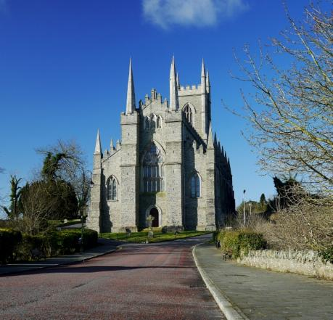
© Copyright Rossographer https://creativecommons.org/licenses/by-sa/2.0/
The Cathedral Church of the Holy Trinity, which is also known as Down Cathedral, is a Church of Ireland place of worship famous for being close to what is believed to be the resting place of St Patrick at the top of Down Hill. For that reason, many people journey to the historical site to find out more about Patrick, but it is also a place of pilgrimage and prayer.
Why do people like to journey to sites where they believe saints are buried? In the early centuries of Christianity, the remains of holy men and women were considered especially precious and capable of working miracles. These relics were powerful objects to be treated with the utmost care and veneration. Wherever they rested, the place of their rest was to be considered holy and so very often became a place of pilgrimage as people sought out that holiness, often for superstitious reasons as well as genuine expressions of faith.
Today, we might wonder why Christians of the past set such store by bits of bone and human remains that may or may or not have belonged to a particular person from long ago, and why those Christians wanted to create shrines where people could start or end a pilgrimage, or kneel in prayer.
So how can we reimagine relics and the resting places of saints like Patrick for today?
It might help to think about how relics point us to a physical body and a real person, and remind us that the saints are not some work of fiction or shadowy myth. This might be particularly important with a saint like Patrick, whose life is shrouded in all sorts of fascinating, but also confusing, myths and legends.
In a sense, it doesn’t matter whether we can prove that such a relic actually belonged to this or that person; rather the relic points backwards in time to a human being made and loved by God, who lived and died and who can set us an example. Relics create linkages between miracle stories and the hard facts of our existence - that we are creatures who live and die, and the fact that so many Christians have died because they loved God and were true to their faith – something which is still going on in the world today.
So, many people feel inspired to visit the resting places of saints from long ago because it connects them to Christians who have gone before and believed that prayer is not an empty gesture but that God does hear us and respond to us, and that the Holy Spirit directs us and inspires us.
So the physical location at Down Cathedral associated with the body of St Patrick as a physical person who lived and died as a faithful Christian, has become a place where people find inspiration for their own lives, healing and a sense of new life as they discover, through prayer and pilgrimage, what wonderful things God has in store for them.
https://www.downcathedral.org/visiting/
Digging into the Mystery – something to do
• Imagine you are an archaeologist and have just discovered a small human bone from the time of St Patrick, or St Brigid, or St Columcille. Now imagine the body the bone belonged to, and then imagine that body as a living, breathing person. Now imagine that person’s family around them, and their daily lives. What might they have eaten for dinner? What clothes might they have worn? How would they travel around and what dangers might they have faced? If you find it difficult to imagine, do a bit of research to find out about life in those days long ago.
• Now imagine having a conversation with one of these saints back then. What might you want to talk about? What might you want to ask them?

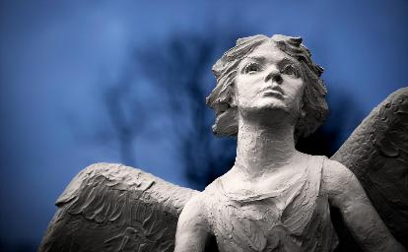
Image by terski on Pixabay
The Mission: The Letter to the Soldiers of Coroticus

Image by aditto9 on Pixabay
I declare that I, Patrick, – an unlearned sinner indeed – have been established a bishop in Ireland. I hold quite certainly that what I am, I have accepted from God. I live as an alien among non-Roman peoples, an exile on account of the love of God – he is my witness that this is so. It is not that I would choose to let anything so blunt and harsh come from my mouth, but I am driven by the zeal for God. And the truth of Christ stimulates me, for love of neighbours and children: for these, I have given up my homeland and my parents, and my very life to death, if I am worthy of that. I live for my God, to teach these peoples, even if I am despised by some.
https://www.confessio.ie/etexts/epistola_english#
The background for Patrick’s letter is persecution of his new Christian converts, for whom he requests mercy. What he says, however, is that he feels himself to be a stranger, an alien and an exile from his own country back in Britain. Yet his motivation for being in Ireland is the mission on which God has sent him. He has given up his home and family to pursue this mission and must respond to God’s call. Being a stranger in Ireland comes with pain and danger, and lack of support, but he must still pursue his calling of teaching the faith in this new place.

Digging into the Mission – some things to do
- What do you know about modern mission agencies and the partnerships they support? Have a look at some videos of people in the field, such as this one: https://www.instagram.com/reels/DWgEuP8k5Ll/ or this one https://churchmissionsociety.org/blog/news/hope-from-the-edges-june-2025/ How does this work contrast with what St Patrick was trying to do?
- Not all mission stories are about ‘success’, whether growth of congregations or people coming to faith. What else do you think Christian mission encounter might be about?
- Imagine you are having a meal with a Christian family living in this country whose birth origins are in another country. How might they want to share their stories of faith with you? How might you be challenged and changed by that?
- How do you think this letter might have been received? Patrick talks about ‘savage wolves devouring the people of God as they would bread for food’ (section 5). Have a look at this story from the Church Mission Society about how reconciliation through Christ can change enmity into peace-making and reconciliation. https://churchmissionsociety.org/stories/enemies-turned-brothers-in-christ/


Image by marsjo on Pixabay

The Miracles:


Image by Irenna on Pixabay
Jocelin of Furness, writing his The Life and Acts of St Patrick, around 1185, describes a list of many miracles and wonder stories which Patrick is supposed to have carried out, or which took place to illustrate his spiritual journey. One in particular, has given rise to an interesting ‘loophole’ in Irish tradition for the idea of fasting, or refraining from meat during Lent, called ‘St Patrick’s fish’.
Jocelin tells how Patrick, as a monk, having sworn himself to abstinence and fasting, was overcome by a desperate desire for meat. He managed to get hold of some pork and hid it from his companions, intending to eat it later out of sight. But then Patrick was confronted by a vision of a being with all-seeing eyes who says that it knows what he has done. Patrick is horrified and spends the night weeping, but is comforted by an angel he has met before, Victor, who tells him he is forgiven if he promises to mend his life. The only question is, what to do with the hidden meat?
When St. Patrick, rising from the earth, utterly renounced and abjured the eating of flesh-meat, even through the rest of his life; and he humbly besought the Lord that He would manifest unto him His pardon by some evident sign. Then the angel bade Patrick to bring forth the hidden meats, and put them into water; and he did at the angel bade; and the flesh-meats, being plunged into the water and taken thereout, immediately became fishes. This miracle did St. Patrick often relate to his disciples, that they might restrain the desire of their appetites. But many of the Irish, wrongfully understanding this miracle, are wont, on St. Patrick s Day, which always falls in the time of Lent, to plunge flesh-meats into water, when plunged in to take out, when taken out to dress, when dressed to eat, and call them fishes of St. Patrick. But hereby every religious man will learn to restrain his appetite, and not to eat meat at forbidden seasons, little regarding what ignorant and foolish men are wont to do.
https://archive.org/stream/saintpatrick00oleauoft/saintpatrick00oleauoft_djvu.txt
So this story of the meat-into-fish reprieve has become a folk memory, by which some Irish people during Lent down the ages have doused their meat with water and then eaten it as ‘fish’ (and often eating pork as in the story). https://www.museum.ie/en-IE/News/2023/From-shamrock-and-rosettes-to-Patricks-Pot
But Jocelin was trying to make the point that the miracle of meat into fish was a pardon for Patrick and a way of showing that his repentance allowed him to grow in faith. He also records that Patrick never ate meat again. The miracle story is a little parable about how we can sin and be forgiven and how God can change our hearts and minds when we make mistakes or waver in our faith.

Digging into the Miracle – something to do
- How would you start a conversation about miracles? How might telling some of the stories about St Patrick create a good framework for talking about faith?
- Do some research, or ask around your church congregation or study groups and find out what kinds of things do people give up for Lent today. Or what do people take on for Lent? How would you encourage someone who had trouble keeping their Lenten promises?
- How do you think we sometimes get round what God asks of us, and make excuses for not following Jesus as faithfully as we could? Make a list of any excuses you have made recently. If you don’t have a spiritual director or accompanier, or attend the sacrament of reconciliation where you can talk about this, it can be worth reflecting on those excuses and failings with someone who can remind you of the love and mercy of God who wants to see us all do better.
- What other fish miracles can you find in the New Testament? What do these miracles tell us about Jesus and the nature of God?


Image by AssafDavid on Pixabay

The Mystery: 17th March – A Nation’s Saint

Image by haruudu on Pixabay
It’s worth remembering that St Patrick is not just the patron saint of Ireland. He is also the patron saint of Nigeria. And he is also the patron saint of engineers.
The celebration of St Patrick’s Day on 17th March has become a massive event, not just in Northern Ireland, and in the Republic of Ireland, but also in the United States of America where the day is often celebrated with parades. The amount spent on the party and decorations in the States is about $7.7 billion! It is not primarily a celebration of the saint in many places, but a celebration of all things ‘Irish’. Patrick’s shamrocks get combined with all kinds of lucky tokens, images of leprechauns, rainbows and pots of gold. The day is celebrated with music, food and dancing, people wear green and of course drink pints of Guinness!
But did you know that the original colour associated with St Patrick was blue and not green?
In Irish folklore, a 10th century queen Gormfhlaith (whose name means blue sovereign) was shown as a woman wearing a blue robe and she stood for the sovereignty of Ireland, the Flaitheas Éireann.
So in keeping with the emphasis on blue, the earliest depictions of St. Patrick from the 13th century, show him wearing blue clothes. When Henry VIII declared Ireland a separate kingdom in 1542 the country was given a coat of arms of a golden harp on a blue background. Similarly, when George III created a new order of chivalry for the Kingdom of Ireland, the Order of St. Patrick, its official colour was a sky blue, and this became known as St. Patrick's Blue. https://www.smithsonianmag.com/arts-culture/should-st-patricks-day-be-blue-180954572/ Even today, the University College of Dublin (UCD) sports teams play in St Patrick’s Blue.
Over time, ‘green’ and the Emerald Isle of lush fields and hills began to become more closely associated, and spread to an association with nationalism. For example, during the 1798 Irish Rebellion, the clover became a symbol of nationalism, and the ‘wearing of the green’ on lapels became a regular practice. Uniforms also became green. And so gradually green has replaced the blue to become a national colour and of course this is the colour that is now particularly associated with St Patrick’s Day.
The flag of Ireland, however, is green, orange and white, where green represents the nationalist and/or Catholic communities, the orange represents Protestant communities and the white between them represents peace.
Something to do:
- Find out how flags and colours represent something about a country. How are flags designed and the colours chosen? https://www.bbc.co.uk/newsround/26530974
- Imagine you are going to design a flag or logo for your church or local service like a school or a hospital. What shapes and colours would you want to use and why?
- Have a look round some of the local churches in your area. How are colours used within the church and what stories do they tell?

Image by Steppinstars on Pixabay

The Man: Following Patrick

Image by Alexey Hulsov on Pixabay
So I am first of all a simple country person, a refugee, and unlearned. I do not know how to provide for the future. But this I know for certain, that before I was brought low, I was like a stone lying deep in the mud. Then he who is powerful came and in his mercy pulled me out, and lifted me up and placed me on the very top of the wall. That is why I must shout aloud in return to the Lord for such great good deeds of his, here and now and forever, which the human mind cannot measure.
St Patrick’s Section 12 from his Confessio tells us how he thinks of himself as a simple, unworthy person, who humbly accepts that he never started out with many skills or abilities. Yet Jesus raises him up to do God’s will.
Compare this with the story of Harrison Okene who was trapped in a sunken boat. Although, like his colleagues, he could so easily have died, he found he had practical skills that could keep him alive in an air bubble he found. He discovered food and cola to drink and kept panic and fear away by singing songs of praise to God, until he was rescued. Afterwards, he found an increased love of the sea, despite his terrible ordeal and trained as a diver.
He says: ‘I know there is a God, and there is a God beside me. I know he has a great purpose for me. I always feel so comfortable and guide myself. I try not to offend anybody and I try to trust life, because when humans are close to death, that is when they understand … We are all one.’ Meaning comes from ‘the lives you touch’. https://www.theguardian.com/lifeandstyle/2023/sep/26/i-survived-three-days-in-a-capsized-boat-on-the-ocean-floor-praying-in-my-air-bubble
With God nothing is impossible (Luke 1.37). This seems to be something the saints really believed and lived by. Do we live by the same belief in God’s love and mercy?

Responding to the challenge St Patrick sets us:
- St Patrick talks in his Confessio about being like a stone stuck deep in the mud. When have you felt like that in your spiritual life and what has helped you get out of the ‘stuck’ places?
- St Patrick also talks about the obstacles he had to overcome, in particular being a simple country person and an uneducated man. How does God equip us for the tasks of mission if we lack the skills we think we need? What gifts have you got to offer? What gifts do others see in you?
- How did you feel about Harrison Okene’s story of survival? How do the trials of life equip us to make more of the future? What about people who can’t move on from traumatic experiences and need help?
- St Patrick also reminds us of the need to praise and give thanks to God for the gifts we are given. How can we be more mindful of thanksgiving and being grateful for all that we have been given?
- St Augustine of Hippo wrote: ‘If you ask me what is the first essential in the religion of Christ, I shall answer: Humility. And what is the second? Humility. And what is the third? Humility’ (Letters, 118:22). What role does humility play in our spiritual lives?


Image by CJMM on Pixabay

The Mission: The Shamrock

Image by fsHH on Pixabay
Put St Patrick or St Patrick’s Day into any search engine, and you will be greeted with a flood of bright green shamrocks, one of the national symbols of Ireland. The word comes from the Irish seamróg, meaning little, or young, clover. Exactly what plant is meant is an interesting discussion for botanists, but Trifolium dubnium is a kind of clover common in the green lands of Ireland, and the arrangement of three leaves around a stem in various clovers is instantly recognisable.
At the time of St Patrick, local religious beliefs had many myths and rites associated with the natural world, triple deities and things happening in threes. So legend has it that St Patrick used the three leaves of the shamrock, all part of the same plant, to explain the mystery of the Holy Trinity, Father, Son and Holy Spirit to the people around him. It would have made sense to talk to people following the ancient traditions using something from the natural world, and something that echoed their thoughts about the sacredness of the number three.
The Creed begins: We believe in one God, Father, Son and Holy Spirit, but how God can be a unity, yet made known to us in three ‘persons’ is difficult for many people to understand. The legend of St Patrick shows how he used a common feature of the natural world to covey the theological reality of one God in three persons that people might find hard to grasp.
Where else might we follow St Patrick and find ways to talk about God in the world around us and find simple, appealing things to lead people to more understanding and appreciation of the Christian faith?

Responding to the Challenge St Patrick sets us:
- Other examples from the natural world to explain the Trinity have included water: (ice, liquid, steam), an egg (shell, white, yolk) or an apple (skin, flesh, pips). Do you think these analogies work? Do you think these ideas work better or less well than the idea of the shamrock?
- What does the Holy Trinity of Father, Son and Holy Spirit mean to you? How would you talk about the Trinity to a person who was not a Christian?
- Spend some time with the Nicene Creed and see which parts of it really resonate with you and connect with your spiritual life. You could use this resource: https://www.dioceseofnottingham.uk/resources/the-creed
- How can saying the words of the Creed help to deepen your spiritual and theological understanding? And how might saying the Creed connect you to millions of other Christians saying the same words around the world?
- St Patrick found an important spiritual tool within the natural world around him. How might nature and the wonder and awe of creation nourish and enlarge your own journey of faith?


Image by Mercedes Kamijo on Pixabay

The Miracles: The Banishing of Snakes


Image by jggrz on Pixabay
One of the best-known legends about St Patrick is that he drove all the snakes out of Ireland with his crozier – his bishop’s staff. In fact there were no actual snakes in Ireland, so what is at the heart of this unusual legend? The banishing of the snakes does not occur in the spiritual biographies written about St Patrick in the 7th century, but later writers mentioned the story, such as Gerald of Wales in his Topographia Hiberniae, who said the story about the snakes was a ‘pleasant conjecture’, while Jocelin of Furness, a 12th century monk, wrote a Life of St Patrick, full of the saint’s miracles and good works and may well be one of the main sources for the legend. He wrote:
Then turned he his face toward Mannia, and the other islands which he had imbued and blessed with the faith of Christ and with the holy sacraments; and by the power of his prayers he freed all these likewise from the plague of venomous reptiles.
https://archive.org/stream/sainFJocelinFtpatrick00oleauoft/saintpatrick00oleauoft_djvu.txt
It is likely that the legend developed as a parable about Patrick’s work as a missionary bringing the faith to people who had not heard the Good News of Jesus. As in the Garden of Eden, the snake is used as a symbol of evil or of subverting God’s plan for human beings in the creation. In many paintings of Jesus or the Virgin Mary, they are showed crushing a snake under their feet, as a symbol of overcoming Satan.
So it is likely that the idea of Patrick banishing snakes from Ireland suggested a cleansing of the old beliefs and old ways in favour of Christian faith. It suggests someone active and dynamic, getting rid of the old order and making room for the new. Or perhaps the legend illustrates a possibly added sentence to the letter to the Romans in the New Testament, where it says ‘The God of peace will shortly crush Satan under your feet. The grace of our Lord Jesus Christ be with you’ (Romans 16.20).
Another way of thinking about the banishing of the snakes is the close association with holiness and the beauty and peace of natural world as it reflects God’s creation. In the stories about Patrick, he causes fountains of clean water to come from ground which act as healing places; he brings the sun to banish unnatural fog; he causes the ground to swallow what is evil.’. In effect, in addition to converting people to Christianity, everywhere he goes is beautified and made safe, telling us by the way, how lovely the natural world of Ireland is.

Responding to the Challenge:
- Do you think legends have truth hidden inside them? If so, how can we work out the truth that is being told when the facts might be difficult to obtain?
- How would you talk about the legend of the banishing of the snakes with others? What would you say the story was really about?
- What happens, though, if we start treating people as ‘snakes’ and want them gone? Could this sort of story be a way of justifying getting rid of people we don’t like?
- What do you think people of the time might have made of the banishing of snakes?
- What do you think about the idea that living out Christian faith also has the capacity to make the world beautiful around us?


Image by idefixgallier on Pixabay

The Mystery: St Patrick’s Breastplate

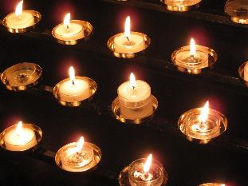
Image by Darndale on Pixabay
This famous prayer, the Lorica of St Patrick, is attributed to him from the year 433, but no one really knows who wrote it, although it is said to be the words he uttered to keep himself and his followers safe from assassins, when his enemies saw only deer. So this prayer is also called the Deer’s Cry. Many people know this prayer best from the 15 lines in the middle (in bold) which ask for Christ’s protection all around. But it is worth spending time with the prayer as a whole and praying through the prayer in full.

I arise today
Through a mighty strength, the invocation of the Trinity,
Through belief in the Threeness,
Through confession of the Oneness
of the Creator of creation.

I arise today
Through the strength of Christ's birth with His baptism,
Through the strength of His crucifixion with His burial,
Through the strength of His resurrection with His ascension,
Through the strength of His descent for the judgment of doom.

I arise today
Through the strength of the love of cherubim,
In the obedience of angels,
In the service of archangels,
In the hope of resurrection to meet with reward,
In the prayers of patriarchs,

In the predictions of prophets,
In the preaching of apostles,

In the faith of confessors,
In the innocence of holy virgins,
In the deeds of righteous men.

I arise today, through
The strength of heaven,
The light of the sun,
The radiance of the moon,
The splendour of fire,
The speed of lightning,
The swiftness of wind,
The depth of the sea,
The stability of the earth,
The firmness of rock.

I arise today, through
God's strength to pilot me,
God's might to uphold me,
God's wisdom to guide me,
God's eye to look before me,
God's ear to hear me,
God's word to speak for me,
God's hand to guard me,
God's shield to protect me,
God's host to save me
From snares of devils,
From temptation of vices,
From everyone who shall wish me ill,
afar and near.

I summon today
All these powers between me and those evils,
Against every cruel and merciless power
that may oppose my body and soul,
Against incantations of false prophets,
Against black laws of pagandom,
Against false laws of heretics,
Against craft of idolatry,
Against spells of witches and smiths and wizards,
Against every knowledge that corrupts man's body and soul;
Christ to shield me today
Against poison, against burning,
Against drowning, against wounding,
So that there may come to me an abundance of reward.

Christ with me,
Christ before me,
Christ behind me,
Christ in me,
Christ beneath me,
Christ above me,
Christ on my right,
Christ on my left,
Christ when I lie down,
Christ when I sit down,
Christ when I arise,
Christ in the heart of every man who thinks of me,
Christ in the mouth of everyone who speaks of me,
Christ in every eye that sees me,
Christ in every ear that hears me.

I arise today
Through a mighty strength, the invocation of the Trinity,
Through belief in the Threeness,
Through confession of the Oneness
of the Creator of creation.

Responding to the Challenge:
One of the things we might think about in relation to this prayer associated with St Patrick is how we see ‘signs’ from God about the pathway our life should take.
- If you were going to pray a prayer for protection, what would you want to pray?
- The prayer lists various dangers and enemies. Make a list of any modern dangers you would want to include today.
- Make a picture or a video of what the prayer represents.
- Try using a guided meditation to enter into the prayer more deeply and meaningfully, like this one: https://contemplativeathome.com/morning-meditation-st-patricks-breastplate/
- What would it mean for your life to live completely surrounded by the love and protection of Jesus? What ONE thing would you change now to make that possible?

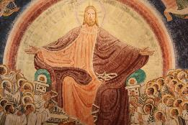
Image by steenml on Pixabay

