Introduction
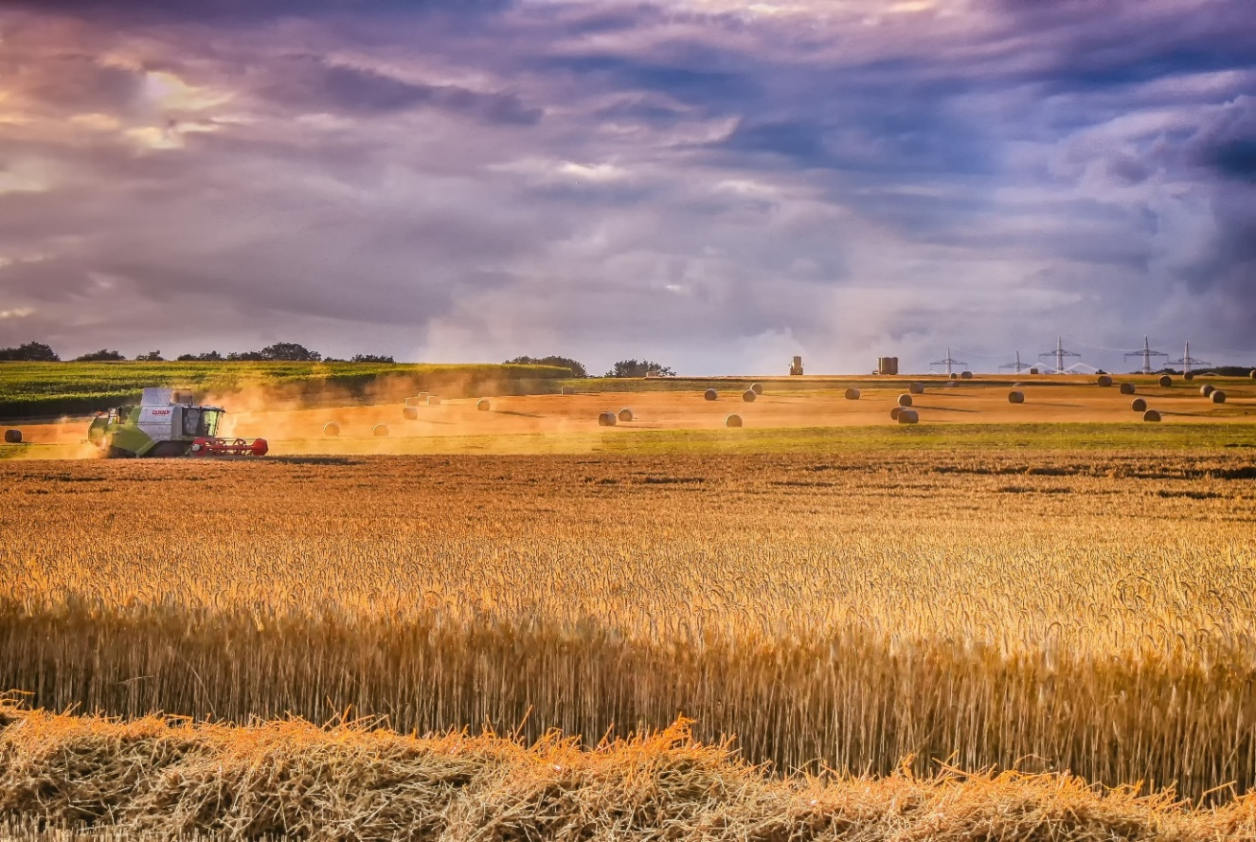
When the Hawkstone Farmers’ Choir won the 2026 TV competition Britain’s Got Talent, raising the issue of mental health in the farming community, it was perhaps the first time many people across the UK had thought about what a serious and significant matter mental health is for the people who work the land and produce our food.
Farming can be a joy, but it can also be a severe physical, emotional, financial and, yes, spiritual struggle. Those who work on farms work long hours, often have no rest days, sick days or holidays, are subject to the complexities of the weather, and can make very little or no money. The stresses and strains of caring for livestock, diseases like bluetongue and bovine TB, raising crops, keeping farm machinery going, and dealing with problems like illegal hare coursing on their land, can place burdens on farmers of which most people are unaware.
Competition, government tax and regulation and legal complexities also add to farming strain. Serious worries about whether farms can be passed on to new generations have also escalated in recent years. The very nature of farming is also simultaneously both very public and very isolating. If your farm is not functioning well, so that the fields or buildings look mismanaged, there is no way of hiding that from neighbours, particularly in the farming community; and that amplifies the burden of shame and sense of failure which farmers can feel.
Sadly, some farmers are leaving their farms or taking risks leading to life-altering accidents. There is intergenerational loss as young people find they cannot viably take on continuity of the farming life that is in their blood, leaving other members of their families isolated. Experiencing poor mental health or taking one’s own life is significantly higher than in the general population. Since farmers often have access to firearms this method of suicide is also significantly higher.
This reflective resource however, is for all those affected by difficulties around deteriorating mental health and death within the farming community. We have heard stories from farmers about continuing stigma around suicide, and concerns about how such deaths are viewed within the Church. We want to offer ways of thinking about what it means to farm in our modern world, and offer routes, through the Bible, to understanding how God mourns with us and comforts us. We look at the story of Naboth’s Vineyard in the Old Testament First Book of Kings, which is about a powerful king who covets a particular parcel of land. We hear the cry of Job, also from the Old Testament about his suffering and loss. We look at how the story of the Prodigal Son in the Gospel of Luke in the New Testament can offer us a way of understanding God’s mercy and love. And finally we hear from the Psalms how God hears the sorrow of the broken-hearted. None of this will solve the struggles in farming, or bring back those who have died, but we hope it will bring some solidarity, hope, and peace to those currently struggling, anxious about faith, or bereaved. We also hope local church congregations using this resource will find it helpful in understanding more of what farmers face in today’s society, and a biblical base for providing practical, emotional, and spiritual support to the farming communities who live and work around them.
We reflect on:
What it means to tend the land
What it means to endure stress and loss
What it means to reach the end
What it means to carry on

What it means to tend the land
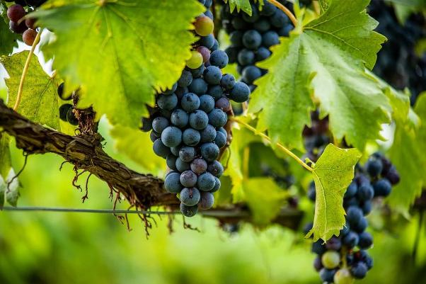
Exploring I Kings 21 1-3; 9-10; 20-21
Naboth the Jezreelite had a vineyard in Jezreel, beside the palace of King Ahab of Samaria. And Ahab said to Naboth, ‘Give me your vineyard, so that I may have it for a vegetable garden, because it is near my house; I will give you a better vineyard for it; or, if it seems good to you, I will give you its value in money.’ But Naboth said to Ahab, ‘The Lord forbid that I should give you my ancestral inheritance.’
[Jezebel] wrote in the letters, ‘Proclaim a fast, and seat Naboth at the head of the assembly; seat two scoundrels opposite him, and have them bring a charge against him, saying, “You have cursed God and the king.” Then take him out, and stone him to death.’
Ahab said to Elijah, ‘Have you found me, O my enemy?’ He answered, ‘I have found you. Because you have sold yourself to do what is evil in the sight of the Lord, I will bring disaster on you.
The story of Naboth’s Vineyard may resonate with rural communities. A powerful leader wants to control Naboth’s land and say what is to be done with it. King Ahab construes his desire for the vineyard in terms of money and transaction, but to Naboth the land is his ancestral land – he and his family are invested in the very soil and the plants they tend; the idea of a ‘better’ vineyard doesn’t make any sense. The land is more than just a possession or a transaction; to tend it and keep it is a sacred obligation.
When Naboth pushes back against the power of the King, he is seen as a nuisance and an obstacle, so he is simply overridden. Jezebel organizes for him to be betrayed and destroyed, - and he is stoned to death.
But God sees the injustice and promises that Naboth’s death will not be in vain. Elijah the prophet stands up and speaks God’s word into the greed and power that cost Naboth his life. God vindicates the sacred duty of caring for the land.

Stewardship
‘For me, possessing land is like having a child; you are responsible for it, and you are tasked with looking after it, its wellbeing should be your priority. I am the legal owner of some land, but I have an ethical and moral obligation to look after that land.
That obligation is due primarily to the generations that went before me. Like most people, I inherited much of the land I farm. The land was passed to me on the understanding that I would care for it and pass it on in good heart to the next generation.
This was never said explicitly, but from the time I was in short trousers I was carried on shoulders around fields looking at livestock and crops.
A love of the land and an understanding of the enduring relationship between a farming family and the few acres in their stewardship was passed on to me.’
Pat O’Toole, Irish Farmers Journal 17th May 2023

Reflection: Psalm 24.1 says ‘the earth is the Lord’s and everything in it’. Farming is a business but it contains within it a sacred connection to the creation in which God delights. The land, the crops which grow on it, the animals which graze it, these are intimately connected to human endeavour and the responsibility to tend and maintain the creation. When the farming community is forced by circumstance to move away from the proper nurture of the land, that is a source of deep frustration and pain.
Christians have a responsibility to understand how farmers feel about the land they farm and the food they produce.
The story of Naboth’s Vineyard can help us explore how God hears the cry of those who are crushed and oppressed by powers that they cannot control or withstand. God values the ancestral lands stewarded through generations. And God watches over those who love God’s creation rather than just see land as a source of money or passing whim. When the farming community struggles with bureaucracy, regulation and unfair pricing, God is with them in the struggle.

A Prayer
God of the living and the dead,
You saw the power and desire of King Ahab
And the love Naboth had for his vineyard.
You saw the injustice and sent your prophet
To name it before the King.
Lay your hand, now, upon our farms,
On all who struggle with injustice
On all who fear the land will not be theirs
Or for future generations.
Lord, hear our prayer
And let our cry be heard.
In the name of Christ,
Amen
What it means to endure stress and loss 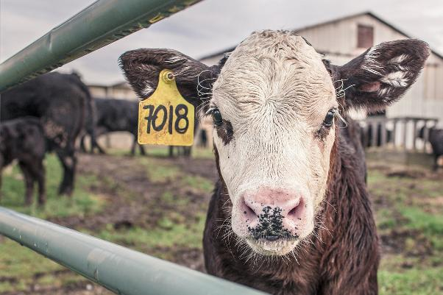
Job 3.20-26

Why is light given to those in misery,
and life to the bitter of soul,
to those who long for death that does not come,
who search for it more than for hidden treasure,
who are filled with gladness
and rejoice when they reach the grave?
Why is life given to a man
whose way is hidden,
whom God has hedged in?
For sighing has become my daily food;
my groans pour out like water.
What I feared has come upon me;
what I dreaded has happened to me.
I have no peace, no quietness;
I have no rest, but only turmoil

Stress
Nearly three-quarters of England is now in drought after the driest July on record, with farmers facing tighter irrigation restrictions, poor crop yields and mounting pressure on livestock feed and water supplies.
The National Drought Group confirmed on Monday 10 August [2026] that 71.3% of England is now in drought, covering around 45 million people.
The government said it was stepping up its drought response and was actively considering further support for agriculture, although no additional farming package was detailed in the announcement.
NFU deputy president Paul Tompkins warned that conditions were becoming increasingly serious.
“With no meaningful rain forecast in the coming weeks, the situation facing farmers and growers is increasingly concerning,” he said.
The warning comes as 1,534 irrigation restrictions are now in place in East Anglia, while 302 abstractors are in the process of having the amount they can take from rivers cut by 50% because of exceptionally low flows.
A further 14 abstractors in the Wensum catchment in Norfolk have already been required to stop abstracting water because of low river levels and concerns over the environmental impact.
Tompkins said the effects were already being felt across both arable and livestock businesses.
“Many farmers have completed the earliest harvest on record, with poor yields in key crops reported in some areas of the country.
“Livestock and dairy farmers are already using winter feed because grass has stopped growing, while growers are working hard to keep fruit and vegetables watered, but many are struggling to access the water they need.”
Livestock farmers are beginning to draw on winter forage stocks earlier than normal because of poor grass growth.
The lack of adequate feed is also expected to put pressure on milk production.
The NFU is calling for a risk register for vulnerable farm businesses, a more responsive abstraction licensing system and longer-term investment in water infrastructure and climate adaptation.’

https://www.farminguk.com/news/drought-now-grips-71-of-england-as-farm-pressure-builds_68959.html

Reflection: The words of Job echo many in our rural communities who suffer stress and loss. Too much rain or no rain at all affects harvests, vegetables and fruit yields. If drought takes the grass, livestock must be given expensive winter feed or bought in. Fuel costs and vet bills for outbreaks of diseases add to the burden. Adverse weather compounds the difficulty of managing the cycles of ploughing, sowing and harvest.
Jesus talks in parables about times of sowing and looking after animals and implies the struggle with invasive plants in crops, the problem of poor soils and the worries about wolves taking the animals. Yet it is to shepherds in the fields that God’s Good News comes. The story of hope comes to those who are anxious about their animals and livelihoods. Even where there is profound anxiety, and feelings of darkness and hopelessness, God can bring new news. And this is where everyone needs to help, from governments to local churches and neighbourhoods. What needs to happen to support farming communities through times of trial? And what needs to change to lessen and share the burden?
Job’s suffering is real. It is not a drill. But he is given a vision of the greater purpose that God has created and is working out. Connecting to God’s creation in its great mystery gives him context as his life turns around and he enters out of his distress and suffering into comfort and blessing.
A Prayer

Lord, you said,
That with you, burdens are light.
We are heavy laden
Take the strain from us.
Lift from us the yoke of anxiety.
Lighten us with new hope.
Amen
What it means to reach the end

Many people feel lost, bewildered, angry, or ashamed when a person they love takes their own life, and these deep, conflicting emotions can add to the burden of grief and loss. The Church has had its part to play in driving a stigma around suicide. In the past, it was felt that life because life is God-given it is therefore a deep sin against God to end life oneself. People who had died this way were also often denied Christian burial. Today we understand much better that the path to suicide is complex and often mysterious and sometimes impossible to understand or explain away. The pain for those grieving is sometimes compounded by the process for an inquest, which will establish facts but not necessarily get to the ‘why’ of it all. Today we understand that sometimes for people who are experiencing depression or overwhelming stress, that life just seems to shrink to a dot, where there is no other place to go and there is no ‘choice’ about whether to live or die in that moment. Tiny, even trivial things, like the weather, can be the final thing that cannot be borne. There doesn’t have to be a plan, or a ‘decision’. While not knowing ‘why’ can be painful, we know that God knows what a person is going through.

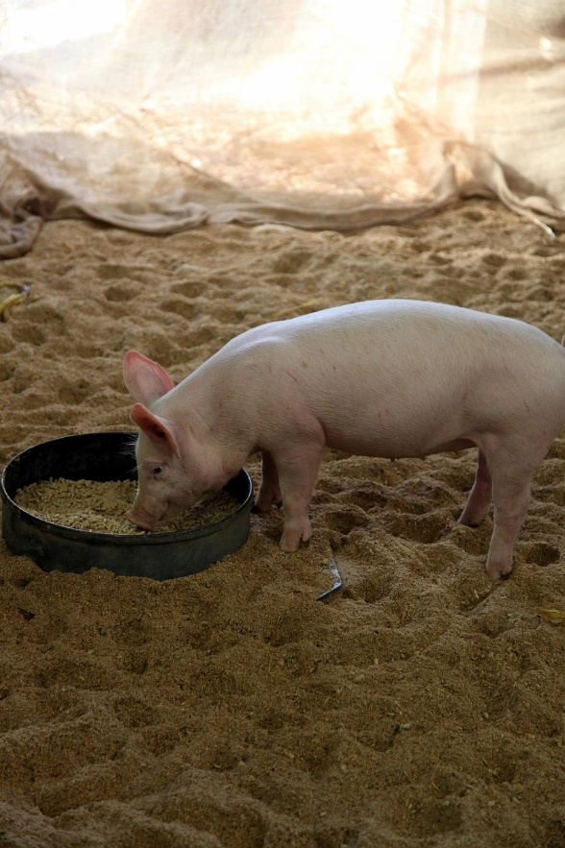
The Prodigal Son: Luke 15:20-32
But while he was still a long way off, his father saw him and was filled with compassion for him; he ran to his son, threw his arms around him and kissed him.
“The son said to him, ‘Father, I have sinned against heaven and against you. I am no longer worthy to be called your son.’
“But the father said to his servants, ‘Quick! Bring the best robe and put it on him. Put a ring on his finger and sandals on his feet. Bring the fattened calf and kill it. Let’s have a feast and celebrate. For this son of mine was dead and is alive again; he was lost and is found.’ So they began to celebrate.
“Meanwhile, the older son was in the field. When he came near the house, he heard music and dancing. So he called one of the servants and asked him what was going on. ‘Your brother has come,’ he replied, ‘and your father has killed the fattened calf because he has him back safe and sound.’
“The older brother became angry and refused to go in. So his father went out and pleaded with him. 29 But he answered his father, ‘Look! All these years I’ve been slaving for you and never disobeyed your orders. Yet you never gave me even a young goat so I could celebrate with my friends. But when this son of yours who has squandered your property with prostitutes comes home, you kill the fattened calf for him!’
“‘My son,’ the father said, ‘you are always with me, and everything I have is yours. But we had to celebrate and be glad, because this brother of yours was dead and is alive again; he was lost and is found.’”

Reflection:
The prodigal son is an example of a person who has lost everything and is effectively dead. All his resources are gone and he has nothing left and is utterly alone. But in the time of darkness and distress, he remembers the one who gave him life and determines to get back to him. He expects condemnation and is prepared to be punished for his choices. But this is not what happens. The Father is waiting for him and looking out for him and instead of condemnation and punishment the prodigal is welcomed with love and feasting and restoration of his dignity and worth. We too then, can be sure that the God of love who knows where every sparrow falls, surrounds all who have died by suicide with eternal compassion. Every person who is lost, is found.

A Prayer
Loving God,
When life seems no longer worth living
And everything is gone
Help us to find the way home

Loving God,
When all our money is spent
And there is nothing left to sustain us
Help us to find the way home

Loving God,
When those we love are lost
And we are surrounded by grief
Help us to find the way home

Loving God,
We know you wait for us
Whatever we have done or not done
In you, we find our way home

Amen

What it means to carry on
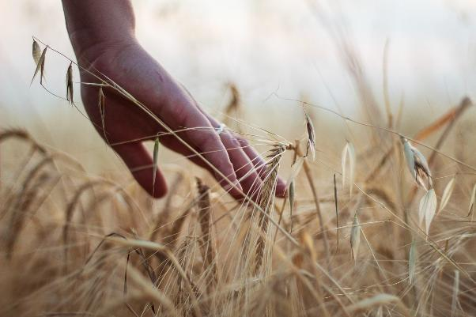

Psalm 34.17-18
The righteous cry out, and the Lord hears them;
he delivers them from all their troubles.
The Lord is close to the broken-hearted
and saves those who are crushed in spirit.

Ms Richardson remembered the passion Jack had for farming and the bright future he was destined to have.
"Jack had so much to live for," she added.
"He was cheeky and witty, but could also be very quiet. He always did the right thing and was a special young lad.
"Jack was caring and absolutely loved farming. Whenever farming was on the news, he gave his opinion and was absolutely distraught about where the industry finds itself in at the moment.
"But he was optimistic and looked forward to a future in farming.
"He wanted to be an agricultural mechanic and take on the family smallholding when he grew up.
"Unfortunately that will never happen."
Jack's passing earlier this year has provoked difficult questions for the family over mental health in the farming community.
"The day he died, I was heartbroken and torn to pieces," Ms Richardson added.
A procession of tractors paid tribute to young farmer Jack Allott at his funeral on Friday (February 28).
"Knowing he will no longer be here is something we have to live with. But it does not make it any easier.
"We had no idea about the extent to which he was suffering and that he found himself in a position to which he found it difficult to come out of.
"Mental health in farming is such a huge problem. Jack had his mind set on what he was going to do and did it.
"There is also a huge amount of pressure for people to be nicer, more caring and more understanding of others.
"I am angry he is no longer here but I hope he is in a much better place. I will carry Jack with me wherever I go, but words fail to describe the pain and loss of his passing."
John Allott, Jack's father, said what happened to his son was 'tragic'.
"He had such a bright future and we talked about the ways in which he wanted to farm and be part of this industry in the future," Mr Allott added.
"Jack had dreams and aspirations to be a farmer. It is absolutely tragic that he will never be able to fulfil what he was born to be.
Jack Allot, aged 15, died by suicide in 2025
https://www.farmersguardian.com/news/4410280/farmers-turn-procession-mourns-loss-barnsley-farmer-jack-allott
Farming cannot simply stop when there is a crisis, an illness, an accident or someone dies. Animals still need feeding; crops need tending. Bills have to be paid; the cycles and seasons of farming life still have to be anticipated. This can feel so hard when memories of a person’s death and how they died are prompted by the everyday talk of farming life.
In some places, comfort comes in the form of continuing into the future what the person lives for – harvesting the crop of a farmer who planted it, for example. There are a number of land-based memorials which can turn the sadness and bewilderment at loss back into positive, hopeful actions, but these depend on what the lost person found most meaningful about farming life.
Sometimes dressing a tractor or other piece of farm machinery can be a way of honouring the person who has died, so that their memory is woven into the future of the farm’s affairs as happened to remember Jack Allott.
When Robert Thompson aged 21, died by suicide, the local farming community organised a memorial tractor run to remember him, raise awareness and raise funds for mental health charities. The tractor convoy included both vintage and modern tractors and was headed by Rob’s own tractor. The route went through many local villages, ending up passing Rob’s own farm in tribute. It took place on Good Friday.
Rob Chapman, a 29 year old farmer died by suicide in 2015. To remember him, his community began the #tractorselfie4rob social media movement, posting pictures of tractors and their owners to raise money and awareness for the charity Papyrus. The charity was chosen by Rob’s parents. [NB this charity, set up to help young people with suicide prevention, is currently in administration].
It can be helpful if other members of the farming community show solidarity and care for the person’s family. And it will help if the local church communities can help support the health and wellbeing of the farming families in their areas. It can be hard to find time to grieve and to keep the farming tasks going and help to provide space for grief and ways to honour the person who has died is always important.
Anglican Churches celebrating the Festival of Creation in Christ on the first Sunday in September might well find this a good opportunity to reflect on how this occasion relates to rural life and to support for the farming community.

A Prayer
Bless, O God of eternal life,
all who have died by suicide.
Grant them rest and peace from their inner turmoil
and the assurance of your compassion and love.
Comfort those who mourn in their deep sense of loss.
Strengthen them to face any questions of pain, guilt and anger
and help us to reach out in love to all who mourn.
through Jesus Christ our Lord.
Amen.
https://www.churchofireland.org/prayer-worship/book-of-common-prayer/resources-in-the-case-of-sudden-and-unexpected-death/prayers-for-use-in-cases-of-sudden-and-unexpected-death
Resources 
Farming Community Network (FCN)
FCN offers confidential support to farmers, farm families and farm workers on a wide range of issues — from emotional wellbeing to practical problems on the farm. They provide one-to-one support, signposting and local volunteers who understand farming life. https://fcn.org.uk/
RABI
The Royal Agricultural Benevolent Institution helps those in need across the agricultural community, with an aim to close the farming wellbeing gap. They can support with welfare visits, emergency grants and signposting to specialist services. RABI also runs wellbeing and resilience projects for people working in farming. https://rabi.org.uk/
NFU
The National Farmers’ Union (NFU) and related NFU online resources maintain directories and guidance tailored to the farming community — including farm-focused mental health support and local services. There are signposts to wellbeing support for farmers https://www.nfuonline.com/
YANA (You Are Not Alone)
YANA is a farming community initiative offering peer support and wellbeing services aimed at those working in agriculture. They focus on creating a network so farmers can talk to others who understand the demands of the job. https://www.yanahelp.org/
The Farm Safety Foundation (Yellow Wellies):
This organisation seeks to address risk taking behaviour in farming and reduce accidents and deaths. It runs campaigns like #MindYourHead to raise awareness. https://www.yellowwellies.org/
The DPJ Foundation
A Welsh charity set up in memory of Daniel Picton-Jones, the charity offers help to ‘share the load’ by support through specific local counselling, and awareness through community activities and social media discussing mental health. The charity offers a bespoke training package to help https://www.thedpjfoundation.co.uk/
Other UK support services
- Samaritans — free phone 116 123 (24/7) for anyone struggling to cope.
- Shout: Text SHOUT to 85258 (Confidential text support).
- NHS — Local GPs can offer referrals to mental health services, including crisis teams. The establishment of mental health hubs in particular areas may also help.
- Many rural areas have local charities that can provide face-to-face or phone support.
- Perennial – for people, including those in the farming community who work in horticulture – offering support and help, including relating to health matters https://perennial.org.uk/
- Local Agricultural/Rural Chaplaincies – contact for emotional, spiritual and practical support from clergy.
- Coroner’s Court Support Service – a charity providing care for bereaved families dealing with an inquest. Norfolk Coroner’s court has an Anglican chaplain available.
General advice in times of crisis
Farming family members often carry the burden of supporting loved ones with deteriorating mental health and constant worries. If you’re supporting someone, look after your own wellbeing first — you can better help when you’re being supported yourself. Look to how your local church can help. Contact farming charities for help on how to talk about farming and general rural problems and on how to approach conversations, find practical help, and any respite options. A peer support group for families in farming can be helpful and enables mutual sharing and support.
For employers within the farming community
Encourage mental-health training in agricultural workplaces and community groups with the aim of making it ok to talk about wellbeing at meetings, auctions and social events. Promote local and national farm support numbers and make information easy to find on farm noticeboards.
Funeral Resources:
https://www.churchofireland.org/prayer-worship/book-of-common-prayer/resources-in-the-case-of-sudden-and-unexpected-death/prayers-for-use-in-cases-of-sudden-and-unexpected-death

Picture credits
P1 Image by analogicus on Pixabay
P3 Image by u_4213z2yo13 from Pixabay
P5 Image by Ryan McGuire from Pixabay
P7 Image by Cherry Stenson from Pixabay
P9 Image by Batatolis Panagiotis from Pixabay
P12 Image by NoName_13 from Pixabay

Bible quotations are from the New Revised Standard Version Bible, copyright © 1989 National Council of the Churches of Christ in the United States of America. Used by permission. All rights reserved worldwide.

