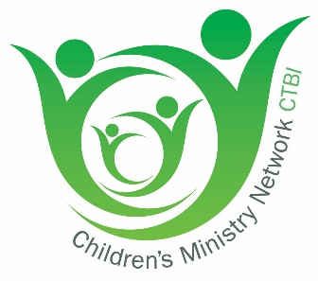

The Children’s Ministry Network of Britain and Ireland
Promoting reflection and best practice for the whole church

CMN Terms of Reference

- NAME AND STATUS of the Group is ‘The Children’s Ministry Network of Britain and Ireland’ (CMN) and it shall be a network recognized and affiliated to Churches Together in Britain and Ireland (CTBI).

- THE WORK of CMN supports the ministry of churches among children and families by:
- Advocating the full participation of children in the life and ministry of the church
- Facilitating contemporary theological reflection leading to practical action
- Identifying, developing and evaluating appropriate resources and encouraging training
- Offering national comment on relevant issues
- Reflecting the diversity of theology across denominations and organisations and providing professional support for its members.
The Work is facilitated through two conferences per year and participation in a European conference every three years.

- REPRESENTATION ON CMN is open to:
- All national officers of denominations that are full members of CTBI and, as appropriate, Bodies in Association, and Agencies
- other bodies as determined by CMN
- CTBI and its national bodies
- A limited number of individual memberships, by invitation of CMN, for people not connected with a denomination or organisation, but who are active in the work of CMN; for a two-year period, for a maximum of four years. Individuals can be nominated by any member of CMN, to be put to a CMN Business Meeting.

4. THE STRUCTURE comprises:
- The Network: A Moderator (who shall not be counted as a representative of his or her denomination), a Secretary, a Treasurer, and two representatives from each of the bodies included in Section 2 above and the Convenors for the time being of each of any Working Parties or Sub-Groups
- The Executive Committee. The Officers and three members of the Network as may be elected. In appointing the Executive, representation of Ireland, Scotland, Wales and England shall be secured as a matter of course. Due care shall be taken with regard to ensuring a reasonable diversity across the Committee.
- Working Parties or Sub-Groups as required.
- Something about CTBI

5. FINANCE AND SERVICING
- The Group will be serviced by secondment from its member bodies for specific areas of work.
- The administrative expenses will be met by an equal annual contribution from the member bodies. The amount of this contribution will be decided annually.
- The Accounts sit within the CTBI accounts, managed by CMN and administered by CTBI.

