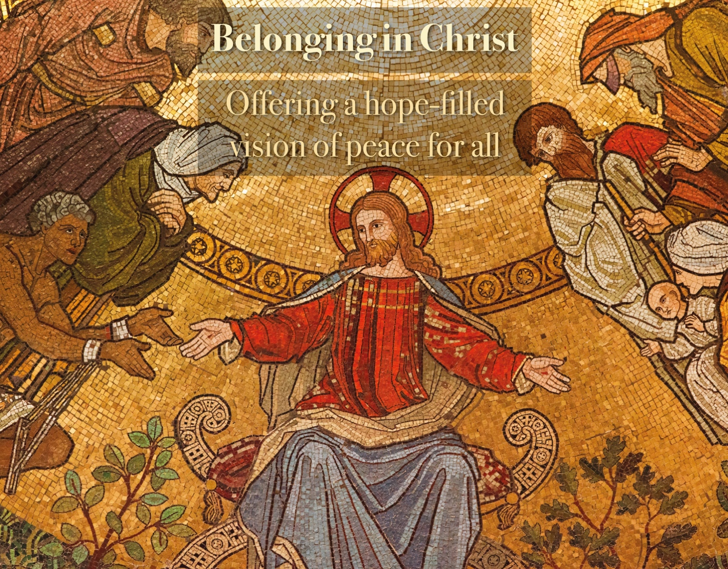

Belonging in Christ: offering a hope-filled vision of peace for all

Introduction

Each year during Lent local ecumenical groups take time together to reflect on the progress of our work towards Christian unity and to challenge themselves to take action on those issues of shared concern. CTBI seeks to support and encourage this work through resources that connect with the major themes that have arisen in our British-Irish ecumenical dialogue. This year we want to share some of the learning arising from our reflections on themes of identity-based conflict, barriers to belonging and the resulting pressures on relationships. The challenges we contemplate in this work are depressing and can feel overwhelming: political alienation, fragmentation, polarisation, isolation, hatred of the other and the experience and threat of violence. Despite the scale and severity of these challenges, our conversations have been empowering and hope-filled. We find support in the solidarity with people who share the same concern for wounded communities and encounter hope in the gift of our shared faith, central to which is Christ’s promise of peace. In Scripture we are not only reminded of our responsibility to act, but we also find the inspiration for that action in the Word of God and the example of Christ. At a time when the Church is also being impacted by the corrosive effects of polarising and divisive narratives that seek to define belonging in terms of rejection or exclusion of the other, it is vital that we share the learning from our work of Christian unity, including self-critical reflection on our faults and failings. This can be increasingly difficult as we encounter rising indifference and hostility, but in standing and speaking together we can support each other and increase the impact of our efforts.

Week 1

Presence and accompaniment at the heart of communities

Scripture

Matthew 5: 13-16

Reflection

When we contemplate the depth of division in the public debate on many social justice issues and witness how the shockwaves from these destructive clashes can impact local communities, we can feel powerless to transform this concerning reality. Moreover, the hostility that can sometimes be experienced in response to calls for solidarity, inclusion, understanding or even just respectful debate, can be intimidating and draining.

Our Scripture for today reminds us that we have an important role to play through sharing the hope we find in our faith and the challenge of the ethical principles that flow from that faith. Churches continue to be important institutions at the heart of local communities, journeying alongside people in the greatest joys and sorrows of their lives. That presence provides a foundation for relations of trust. In recent times of conflict, such as in the experience of local communities impacted by riots, we have seen that church leaders, alongside representatives of other faith communities, continue to be regarded as honest brokers, even in an increasingly secular society. This creates an opportunity for the Church to contribute to bridge building, helping to reach those who are alienated, isolated, or feeling pushed to the margins, creating opportunities for encounter and the development of mutual understanding. The legacy of this long-standing presence and investment in communities can be a gift to the Church and to the wider community in troubled times, yet we should also not be naïve about the ways in which this leadership position has also made the Church a contested space in contexts of identity-based conflict. This is challenging to navigate as we seek to communicate a message of welcome and belonging for all. Recognising in our ecumenical dialogue that this is a shared challenge can help us to convey an authentic collective Christian witness in a fracturing public square.

Today’s Scripture calls us to a confident embracing of the opportunities we are given to show leadership, valuing the resources that support us in this work. At the same time we are also called to recognise with humility that we are part of divided communities, living these divisions and called to speak honestly from that experience rather than preaching from a place of distance or superiority.

While having an important contribution to make to the work of transformation, the Church is not solely responsible and is called to work in dialogue and partnership with others, valuing what they bring to the experience of the community. An important message emerging from our listening within CTBI has been the way in which the polarised and divisive debate we can often encounter in the media contrasts with the pastoral experience of the local church where we are inspired and encouraged by the generosity, compassion and resilience we find in the surrounding community. Helping to communicate the truth of this experience is both a challenge and an opportunity for the Church.

Questions for reflection and discussion

- What gives you hope and encouragement about the contribution the Church can make to the work of building bridges and overcoming divisions in society?
- What do you consider to be some of the most significant barriers or limitations on the role of the Church in this work?
- Who are some of the most important partners for the Church currently in this work?

Actions

- Consider the different ways in which your local church community communicates with people – internally and externally. Does anything surprise you as you reflect the messages conveyed about how “our community” is defined in your context?
- List the main places people meet and gather in the wider community – how present is the Church in these different contexts. What might be the implications of this for the leadership role of the Church alongside others?
- Review recent communications from your Church and consider whether there are any opportunities that could be developed to help share the stories of solidarity, outreach and care that demonstrate the compassion and resilience of the local community.

Prayer

Lord,
We give thanks for the opportunities given to the Church to show leadership in troubled times,
and for the resources we can bring to struggling communities.
Bless those who work and volunteer in our churches,
keeping these connections alive
and bearing witness to the gift of your healing love.
We are grateful for the inspiration we find
in our accompaniment of communities
who seek to respond with generosity and solidarity
to those in need.
May these examples be a light for a world that is struggling with the darkness of division.

Amen.

Week 2

The hope of belonging

Scripture

Jeremiah 29:11

Reflection

We believe that the Good News of our faith is not intended only for Christians and that God’s love is extended to all people, made in his image and likeness. We recognise too that our actions can fall short of this vision, placing conditions on our acceptance of people or communicating to them that they have to be like us or do things our way to be part of our community.

A recurring theme in our work in recent years has been the need to reflect on the difference between welcome and belonging. Churches will often, rightly, aspire to be places of welcome for all, drawing on the practice of hospitality that we see modelled throughout Scripture. Too often though we can be content with offering welcome and stop short of asking the deeper questions about what it would take to create the conditions in which everyone could feel that they truly belong. This may require some members of the community to make room for change, even to give up some things they consider important, to allow the community to grow and welcome people from diverse backgrounds. Undoubtedly this can be difficult, perhaps especially for those who have invested a lot in the work of building the community. Without making this space we cannot explore the new possibilities that people with other identities and perspectives can bring.

Within our church communities there are many people who are struggling with their sense of belonging. They may feel that they have received an initial welcome which is conditional on their ability to change and adapt, or that positions of leadership will not be available to them. Others may feel that their contributions, which were once important, are no longer valued, and that the changes being asked of them are too great or too costly. These challenges often do not have easy answers, but a commitment to courageous listening can help people to feel seen and heard as we search for the best way to reconcile different needs, keeping before us God’s vision that all would have hope for the future. Being honest about these internal struggles does not weaken the leadership role of the Church. It helps us to empathise with others who are grappling with these tensions in other parts of society, including the political leaders who are called to represent diverse interests and aspirations in the service of the common good.

In seeking to offer a hope-filled vision for all that extends beyond our Church communities, we are also called to consider the needs of those who may feel that the Church has contributed to the barriers to belonging they have experienced. Christianity has, historically, had a privileged place in Britain and Ireland. Today, there has been a decline in the influence of churches while Christians have taken many positive steps to embrace a more diverse and pluralist public square, but we can still have blind spots about the extent to which our influence in shaping the culture can be alienating for some.

We also know that not all viewpoints are consistent with a vision of belonging for all. Attitudes and behaviours that attack, diminish and dehumanise people need to be countered in truth and justice. For Christians, Scripture provides us with solid foundations for this alternative vision, offered in a spirit of love. It also challenges us to speak out and take action to address unjust structures that impede people’s sense of belonging. Our ability to engage in this work is enhanced when we support and promote diversity in our leadership so that our conversations and our working together are enriched by different perspectives.

Questions for reflection and discussion

- Can you think of a time when you experienced a crisis of belonging, whether in church or in a different context? What were some of the factors that contributed to that? Can you think of any actions that could have helped you or did help you in that situation?
- When you think of those who experience marginalisation in your local context who are you most concerned about? What do you consider to be their needs?
- Where do you see signs of identity-based conflict and crisis in your local community? What is currently being done to address this? What factors are exacerbating these problems?

Actions

- Review some local news items. What, if anything, is being communicated about who belongs, and who is excluded in your community?
- Find a social media post or an opinion piece from a person whose viewpoint you disagree with. Consider whether you can identify any points of connection or shared values that could help you connect with those who hold these views in a way that upholds the dignity of all people.
- Identify a group doing positive work to address identity-based conflict in your area. How might you support and encourage their work?

Prayer

God of all,
Help us to find a way to be bridge-builders,
especially where the gaps between people appear hopelessly wide.
Give us the courage to face our blind spots
and commit to the uncomfortable conversations about reconciling difference
to help all to belong.
Be near to all those who are struggling with the feeling that they don’t belong.
Help them find hope of connection in compassionate outreach.
In your mercy heal those whose struggles with identity and belonging
have brought them down a path of hatred and violence.
We pray that all who feel lost will find a home in you. Amen.

Week 3

Reconciling identities and experiences

Scripture

2 Corinthians 5:11-21

Reflection

Events of recent years have underlined the interconnectedness of our lives, not just at local community level, but internationally. Yet despite the weight of evidence pointing to the need for us to come together to address the challenges facing the whole of humanity, the forces pulling us apart appear to be growing stronger. It can feel like society is becoming much angrier and more hostile.

The Church with its calling to the ministry of reconciliation has an opportunity to bring hope and healing by listening to the pain that lies beneath the anger: loss of hope for the future, sense of decline or lack of opportunities, alienation, isolation or feeling unsupported or uncared for. The pastoral experience of the Church guides us towards purposeful listening, which is not just about hearing people’s pain, but being attentive to their needs and advocating for their rights.

One of the major barriers to bringing people together to work for a better future is often the lack of a sense of a shared past. Different experiences of and perspectives on the past form deep divides and the shadow of past injustices or conflict can loom large over communities. The Church brings to these questions the hope of reconciliation and the conviction that even where injustices of the past cannot be undone, new relationships of mutual respect, truth and justice can be formed.

The Church does not approach these questions of division – past or present – from a place of distance, but as part of the community, affected by the same hurts and tensions. The leadership role of the Church means there is a particular responsibility to engage in critical self-reflection and to model generosity and grace in taking steps that make real and visible our commitment to reconciliation.

We do so mindful that God’s gift of reconciliation is available for all of us, on a personal level, as a source of renewal and hope. This message can be a lifeline for those who have perhaps embarked on damaging or destructive paths to help them find their way back to place of belonging and connection.

Questions for reflection and discussion

- When you think of the main wounds underlying tensions in your community what comes to mind?
- Where do you see these being addressed or discussed?
- Do you see the Church bringing a vision of reconciliation to these questions – if not, why not?

Actions

- Identify opportunities to pray for reconciliation in your church context. Could you be intentional about naming particular divides you would like to see healed?
- Explore opportunities to communicate about reconciliation beyond the church, including local press and social media, how might these be used to address painful issues in your community?
- Consider offering a bible study on the theme of reconciliation to explore what issues this brings to the fore in your context.

Prayer

God of mercy and compassion,
We pray that we might live up to our calling
to work for reconciliation in our communities.
May we continue to challenge ourselves
to reach out beyond our comfort zones
to be near to those who are struggling.
Help us to listen with compassion and purpose,
especially when others’ experiences
are challenging or unsettling.
Keep before us the hope
that even where the hurts of the past have been great
and the wounds run deep
all can be renewed in your love.

Amen.

Week 4

Creating Spaces of Grace

Scripture

James 1:19-27

Reflection

When faced with an angry and noisy public square, we can be tempted to retreat in search of safe spaces. The manipulations and misrepresentations of the online world can feel particularly threatening.

As we reflect on our Scripture passage for today we are prompted to think about how our faith shapes how we communicate and engage with others. Unsurprisingly, great emphasis is placed on the importance of listening before we act – both to the Word of God and to one another – so that the content of our communication will reflect our values and our calling as disciples.

Retreating into echo chambers can give a sense of security. This is not always negative. Often in our ecumenical conversations participants express appreciation for the solidarity we experience in spending time with those who share our values and our concern for society. This can be a much-needed source of support and encouragement to strengthen our engagement in the work of social justice in a wider context. Exposure to this wider context is critical because it opens us up to different perspectives, challenges our assumptions, and helps us to make balanced assessments of complex situations.

In a church context there is currently considerable reflection and dialogue about engagement with social media platforms. Some churches have decided to withdraw from particular platforms, or pause their engagement, due to concerns about unethical and harmful practices, and the impact on the wellbeing of individuals and communities. Others have made a conscious decision to retain and invest in their presence on these platforms to endeavour to provide a space for authentic Christian witness, extending invitations to dialogue and prayer.
In our conversations there have been two main threads to our recommendations. Firstly, that we would examine together the possibilities offered by social media for connection, outreach, “social listening” – using these platforms as a resource to hear concerns that might not otherwise reach us, and to share our messages. This engagement needs to be supported by education about the risks, dangers and misrepresentations of social media. Greater cooperation across different churches and with other partners could allow us to amplify messages and respond strategically in times of threat, such as when communities or sectors of society are being misrepresented. Recent positive experiences in this area for CTBI include collaboration across different sectors of society to communicate a message of solidarity to refugees and people seeking asylum.

At the same time there is also a recommendation that churches would help challenge our over-reliance on social media and the online environment, creating opportunities for in-person engagement and real connection. The online environment can feel so much safer because we can have more control over how we interact, but the possibilities for greater connection and impact can outweigh the risks of in-person engagement.

Whether online or in-person we should not underestimate the contribution we can make to setting the tone for conversation, creating spaces of grace and faith-filled engagement, grounded in listening, where our contribution to dialogue reflects the values that flow from our faith.

Questions for reflection and discussion

- Has your use of social media changed in recent years? What factors have influenced any changes?
- How effectively does the Church use social media in your context?
- How would you like to see social media used for connection and outreach?

Actions

- Consider whether you could develop or adapt an existing social media strategy in your church context to support ecumenical collaboration in sharing messages of invitation, outreach and welcome to those who may be feeling unheard or alienated?
- Could you share some examples of things that have concerned you in recent engagement on social media? How has the Church been responding to these challenges and what more could be done?
- Could you identify potential partners beyond the churches that are communicating effectively in ways that seek to build bridges and promote inclusion and help amplify these messages?

Prayer

Loving God,

We pray that we will always remember
to take the time to listen to your Word,
and to listen to one another,
with hearts open to hear your plan for us.
May we keep you
at the heart of all our encounters
whether in-person or online
and be guided by our faith
in how we communicate
to create spaces of grace
in the midst of anger
and confrontation.
Amen.

Week 5

Leadership

Scripture

Matthew 5:1-12

Reflection

At a time when Christian identity is being drawn into the contested space of societal conflict it can be helpful to turn to the Beatitudes as a reminder of how we are called to show leadership in society and how, even when living by those values proves costly, we are not alone. Christian leadership is not disconnected from public opinion because the call to love our neighbour is a call to listen to the concerns of the community, but this listening and engagement is anchored in the values of our faith. We may feel that this goes without saying, but in recent reflections about the challenge of distortion or co-option of Christian heritage and identity, it was suggested that churches may need to reflect critically on the content of their messages, because too often we fall into the trap of being reactive, allowing our language to be dictated by others. Challenging divisive language and attitudes is undoubtedly important, but at least equally important is the need to proactively and positively state our values, even where this may appear obvious.

The Beatitudes remind us that standing up for what is right and seeking to act justly may not bring immediate rewards. On the contrary, the commitment to justice can often put people at risk of attack. In recent years we have seen church leaders, as well as leaders in other sectors of society, subjected to criticism and sometimes abusive behaviour because of their stance on social justice issues. Currently, through the work of the Churches Refugee Network and our support for the Church of Sanctuary project we are particularly conscious of the attacks on those organisations working to support and show solidarity to people seeking asylum, but similar experiences have also been reported by people working to address racism, to promote interreligious dialogue or advocate for climate justice.

Showing our support for those who are giving positive leadership can make an important contribution. At a time when many people are feeling alienated from political processes it can be helpful to highlight the work of those political leaders who are engaged in efforts to bring people together and encourage more Christians to consider politics as an area where they can show leadership. In recent times churches have also found themselves having to speak up to defend the right to peaceful protest and make the case that this is not incompatible with our support for positive engagement with political processes.

At times of tension and struggle communities appreciate seeing their leaders come together. This can help give a sense of security as well as hope. Christian churches, especially working in partnership with other faith communities, can often form the heart of collective community responses to challenge because of their trusted and established position in the community but also because of positive perceptions of the values that inform their leadership.

Questions for reflection and discussion

- Do you feel the Church is currently doing enough to support and encourage positive leadership in other sectors of society?
- What messages about political leadership, if any, do you hear communicated in your church context? Would you like to see any changes in that regard?
- Where do you see partners in this work beyond the Church in the local community?

Actions

- Examine recent communications on social justice issues in your local church context. Is this engagement predominantly proactive or reactive? Are we taking for granted that people understand where we are coming from in terms of our values?
- Consider reaching out to show solidarity with an organisation or individual in your community in a situation where there has been hostility towards their work.
- Assess the level of preparedness in your church context to respond to a critical or emergency situation. Are the relationships in place that would allow you to join or convene a collective community response? If not, what steps might you need to take?

Prayer

Lord,
We pray for all those in positions of leadership in our communities,
that they will feel supported
to work for the common good.
We pray especially for those leaders
who have been subjected to abuse or attack
for their commitment to the work of justice.
Inspire all of us
to find the right opportunities
to show leadership
in a spirit of partnership and solidarity.
Where communities are under pressure
we pray that their leaders
will set differences aside
to bring people together
and give the transformative
gift of hope. Amen

Week 6

Empowering younger leaders

Scripture

Luke 2: 41-52

Reflection

In our conversations about societal divisions the theme of youth features prominently because of concerns about how these divisions are impacting their lives and their wellbeing. The focus of the conversation will be different in different places. In some churches there is a concern about the absence of youth, and in others a dilemma about how best to respond to their presence, making space for their leadership, vision and concerns. As we seek to engage the wider community beyond the church generational divides can be a real barrier to effective communication with younger people.

Today’s Scripture prompts us to think about the difference in expectations that can impact young people’s leadership. Often churches will think of young people in terms of the support they need, rather than the gifts they bring. In 2018 the Irish Inter-Church Meeting on the theme ‘Realities are greater than ideas? Reflecting on the common good in divided communities’ included a panel of young leaders from Youth Link, an ecumenical project to support young people and youth ministry. Participants shared with church leaders how growing up in communities wounded by conflict had impacted their lives with the mental health challenges that have impacted them as well as their family and friends, the lives lost to suicide, drugs and to criminality, and the lack of support for them to stay in education and employment.

The daily reality they described was shocking for many of the church leaders. Writing after the event Co-Chair Bishop Brendan Leahy noted that he was struck by how these challenges “are magnified under the relentless spotlight of social media”. He observed that:

In spite of this, however, our youth participants inspired us with great hope. The honesty and resilience they displayed challenged and encouraged all of us as they made an impassioned plea for all young people who have made bad choices in the past to be given another chance. There is a lesson in that for all of us as we reflect on our hopes, and our failings, as we seek to give leadership and pastoral care in divided communities.

Questions for reflection and discussion

- How do you see the Church investing in young people – who might be excluded?
- How effectively do you feel your Church balances the need for both support and empowerment in its approach to engaging with young people?
- Are there issues impacting young people you feel ill-equipped to discuss? What might help you feel more confident about this?

Actions

- Examine the ways in which churches are supporting young people impacted by violence through the Synergy Network – https://wearesynergy.org.uk Might any of these ideas be relevant in your context?
- Explore the resources offered by Roots for Churches to support intergenerational engagement in Church: https://www.rootsontheweb.com/i-am-looking-for/resources-for-intergenerational-church Could these offer any new ideas for engagement in your context?
- Are there any youth-led dialogue events in your context you could support or join?

Prayer

Lord,

We pray for younger leaders in our community
that they will be empowered
to bring their gifts and talents,
knowledge and experience,
to the work of building a better future for all.
Be near to all those young people
who are struggling with issues of identity and belonging
amid pressures that can feel relentless.
May the Church be generous
in its outreach and engagement with young people
to the benefit of all.

Amen.

Week 7

Sharing hope for the future

Scripture

Matthew 13:1-23

Reflection

Jesus often used parables to connect with people by inviting them to reflect on different perspectives through story, rather than trying to win arguments. Today’s Scripture reminds us that the stories and messages we share will not always be appreciated and understood by everyone but can be transformative in some places.

We are called to reflect on the opportunities we might have in our local church context to connect people through story, moving away from the arguments for and against different policy decisions, to engage with the stories of those who are affected. As churches we can ground this work in prayer, encouraging people to hear stories of those who are struggling and pray for their needs.

We are also invited to reflect on how we might share our own stories in a way that maximises the opportunity for connection. Sharing our identity and our sense of community is more gratifying and affirming when this is met with appreciation by others, rather than rejection. The Church has the opportunity to create spaces for encounter, working in partnership with others, where people can share their identities in a context of sensitivity and mutual respect, and come together around shared challenges.

Today’s Scripture reminds us that this work of sharing our faith can be difficult. It is important to think about where we find support for ourselves. The challenges we face to not have easy solutions and require long-term commitments. The practice of self-case and self-compassion can help us to show grace and empathy to others, laying the foundations for our reaching out in faith to all those who need to receive a message of hope and healing.

Questions for reflection and discussion

- Can you think of a novel, play or movie that has helped you to understand experiences or perspectives different to your own? What were the factors that helped you connect to the story?
- In your experience what kinds of topics are uncomfortable or polarising in conversation at present? How is the Church responding to these challenges?
- Can you think of any examples of displays of identity that make you uncomfortable? What would need to change for you to experience this as positive?

Actions

- Could you partner with those in the arts to have a story-telling event around issues of identity and belonging in your community?
- Could you facilitate a dialogue about the challenges of mission and discipleship in the current context?
- Identify a self-care action you could take to support yourself this week.

Prayer

Loving God,
In a world where people need stories of hope and connection
help us to be resourceful and creative in our efforts
to share our faith and the hope we find in you.
Give us the courage to share our own stories
truthfully and respectfully
and to listen to those of others
with open hearts
allowing hope to flourish and grow.

Amen.

