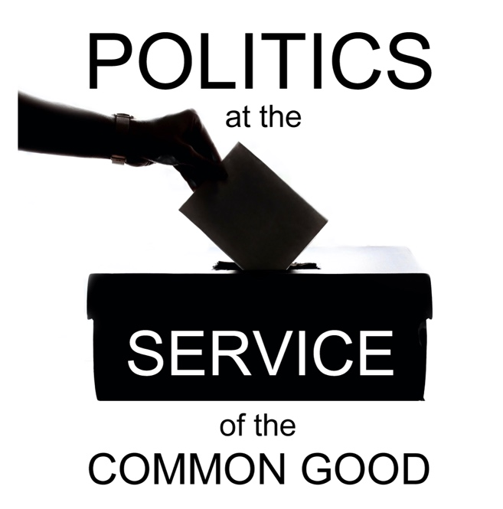

Politics at the Service of the Common Good

Week 7
Participation
Scripture: Matthew 28: 16-20

Reflection
Participation is essential if we are to shape the political culture in accordance with our values. Yet it can also be true that participation is most difficult to achieve when it is most needed, namely when people are struggling and losing faith in political processes. Often when we think of what concerns us about politics today what comes to mind are policies and messages we consider harmful – the content in the political space. Equally concerning, however, is what is missing – the silence of those who have become disillusioned or who have to struggle to make their voices heard as a result of marginalisation.
We rightly take care to be clear that it is not the place of the Church to tell people how to vote, but are we perhaps over-cautious in calling people to recognise their responsibility to inform themselves about the political choices and decisions that affect them, and to vote according to their conscience when given the opportunity to do so?
From a pastoral perspective could we do more to encourage those who are considering, exploring or pursuing a career in politics as a vocation to serve their communities? Could we do more to acknowledge the ways in which people contribute to shaping the political culture and informing political processes through their involvement in the community and voluntary sector and other civic leadership positions?
Our calling as disciples of Christ to bring the Good News of the Gospel to all those who need to hear it requires us to engage with the realities in which people live, keeping our focus firmly on relationships. Work and relationships in the political space are a critically important part of that reality, but how often do we bring the lens of discipleship to our reflections in this area, and how might it change our approach and attitudes if we did?
It is no accident that the reflection on this week’s theme contains more questions than answers. Involvement in political processes is a personal decision that can entail difficult choices about what we prioritise in terms of our time and effort, what we think we can contribute and ethical considerations about the types of issues we may wish to get involved in. This work also requires a wide range of different roles and gifts, and so it is not about promoting a one-size-fits-all approach.
It would not be helpful in our local church context to be prescriptive about the forms political engagement should take, but we can make a valuable contribution by sharing about the good work that is happening and allowing people to bring their questions and ideas. Mentoring opportunities for young people who may wish to learn more about different career options is one example of the kind of support that might be offered.
It may be helpful to reflect on how closely we connect our work in the areas of discipleship and faith development with the political context. In our bible studies, worship and other events how do we encourage participants to reflect on how our faith shapes our values and how we apply these values in the political space? How might we be called to show our love for our neighbour by encouraging them to be heard and seen in the political space, and standing in solidarity with them to call for solutions to any barriers that get in the way of their participation?
As we prepare for General Elections in the coming year in both the UK and Ireland are we discussing these questions in our local inter-church dialogue? If so, how might we build on that shared concern to have a meaningful collective impact for the common good? If not, what is holding us back and how might we address that?

Questions for reflection and discussion
- What do you think are the main barriers that hold people back from getting involved in politics?
- What could political leaders do differently to encourage more people to get involved?
- How might the Church contribute to encouraging wider political participation?

Actions
- Identify opportunities to share some of the thinking this reflection series has prompted for you.
- Identify ways in which you could help share practical information to help people participate in elections – such as voter registration requirements, information on where and when to vote etc.) in your local church context (e.g. notice boards, social media, bulletins).
- Use the resources on the Churches’ General Election website to prepare for the next General Election: churcheselection.org.uk. There you can find practical information about ways to get involved (e.g. by hosting a hustings) and resources will be shared from a range of faith-based organisations about different issues that will be important in the forthcoming General Election.

Prayer
Creator God,
The dignity of every person
matters to you.
Everyone’s voice is important
and is heard by you.
When political processes
marginalise and exclude people,
communities are wounded
and the bonds of solidarity,
so integral to the common good,
are weakened.
Give us the courage and compassion
to get involved,
to contribute to the building
and re-building of relationships,
helping people feel seen and heard.
Restore the faith of those
who have become disillusioned
so that our political culture
can be enriched
by the diversity of gifts and experiences
present within our communities,
for the good of everyone.
Amen.

