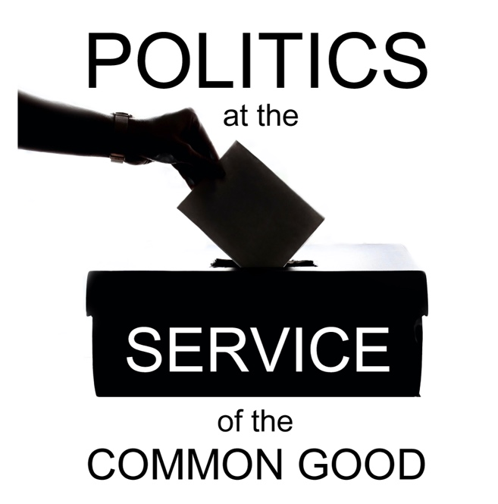

Politics at the Service of the Common Good

Week 6
Communicating our Values
Scripture: Matthew 13: 1-9

Reflection
Words have a powerful impact on relationships. The choices we make in language can cause people to feel seen or to feel excluded, to feel wounded or to feel inspired. The language of our political discourse can influence people’s sense of belonging and the relationships between different groups in communities and in the wider society. The lack of references to solidarity, compassion and the common good, too often exacerbated by the presence of harmful stereotypes and dehumanising language, can sometimes alienate those working to build community from the world of politics.
What action might we be called to take as people of faith to address this gap? In an increasingly secular society, with a steep decline in religious literacy, it can feel like faith-based contributions will end up like the seeds that fell on the stony ground, unable to take root. This is a real challenge which our ecumenical cooperation helps to address. Working collaboratively with Christians of other denominations, as well as with people from other faith communities, results in processes of dialogue and discernment that strengthen our messages, build confidence and amplify our voices.
Our capacity to influence is not limited to the sowing of seeds, we can also cultivate the soil to support the flourishing of a just and compassionate political culture. There is also a real opportunity for deep listening and relationship-building when we are working from a place of humility rather than privilege. When we think of communication we often think first and foremost of what we want to say, but speaking is of course just one element of communication: how we listen and what we model through our behaviour are just as important, if not more so. How courageous are we prepared to be in listening to the ways in which our own language and communication may cause others to feel excluded and/or wounded?
If we consider examples of interventions that were successful in sharing Christian values as part of political debates we see that these had impact because what was being communicated was more than words:
- appeals for peace and reconciliation made by representatives of different religious communities speaking out of their experience of investing in challenging dialogues to address their own divisions;
- calls for compassion for refugees coming from people who are actively engaged in accompanying people seeking asylum;
- demands for justice from those engaged in the pastoral care of victims and survivors of injustice and abuse.
What we are modelling by standing together, and standing with those who need our help, is as important as what we are saying. In this increasingly fractured and fragmenting world, communicating care and connection offers hope and encouragement to those who are struggling and a challenge to those who could be doing more to respond, helping to transform the relationships that shape our political culture.

Questions for reflection and discussion
- What might be holding us back from sharing the Good News of the Gospel in a world where people so desperately need to hear it?
- What concerns you about the language of political debate at present?
- How can we build, and rebuild, the confidence of people of faith to contribute to shaping the political discourse?

Actions
- Listen to a recent political debate – in the media, in Parliament etc. – what, if anything, is conveyed about the values underlying the different positions?
- Identify an advocacy initiative from a faith-based perspective that had a positive impact (such as a letter, protest, vigil or statement). What were some of the characteristics of this action that contributed to its success? Consider how you might learn from this in your own context.
- Identify ways in your local church context that you could amplify the voices of those who might otherwise struggle to be heard, modelling solidarity and inclusion.

Prayer
God of mercy and compassion,
Help us to appreciate the power of our words,
their capacity to wound or to heal,
to welcome or to marginalise.
Open our eyes to the consequences
of our silence
in a world where so many people are struggling.
We pray that those who most need
to hear a message of hope
will find that support today
in the compassion and solidarity
of their neighbours.
We pray that the Church
will continue and do more
to amplify the voices of those
who take a courageous stand for compassion and solidarity,
shining the light of Gospel values
on the challenges that divide people and weaken communities.

Amen.

