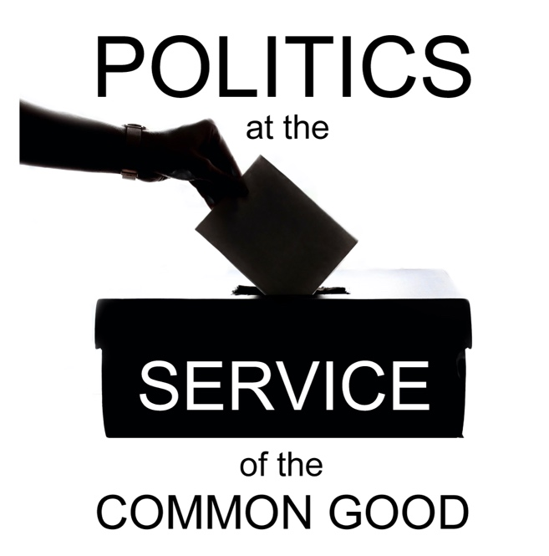

Politics at the Service of the Common Good

Week 5
The Politics of Peace
Scripture: John 14:15-27

Reflection
Violent conflict is a devastating manifestation of the failure of political processes and the breakdown of political relationships. At a time when violent conflict is proliferating around the world we are acutely conscious of the ways in which our national politics relates to the wider international context – both in terms of the way global events and challenges impact our political choices and in the way our political leaders represent us in their international engagements.
The connection between politics and peace-building extends from the promotion of community relations at local level through to the resolution of conflicts between nations in multilateral institutions. Churches, with their base in local communities, and also having networks of fraternal relationships that extend around the world, have an opportunity and a responsibility to speak into political processes from their pastoral experience in a spirit of dialogue and cooperation.
Keeping before us a vision of peace as one of the most urgent objectives for our political leaders is an important first step. For Christians, this vision is informed by the understanding of peace and reconciliation we find in Scripture. It is much more than the absence of violence, and certainly not a superficial peace that seeks to minimise difference or silence dissent. Instead, it is an ambitious vision for the restoration of right relationships through justice, calling us to be reconciled to God, to one another and to the whole of creation. It calls us to strengthen our commitment to human rights and the protection of human dignity for all people.
There are many ways in which we can engage in advocacy and awareness-raising in support of peace-building efforts. The work undertaken by many churches in areas like racial justice, climate justice and to address inequalities in global social and economic development, including the addressing of structural and historical injustices, make a significant contribution to conflict resolution and prevention.
At a time when military responses to conflict are being consistently prioritised over diplomacy, dialogue and relationship-building – not least in terms of the financial investment – making the case for investment in dialogue, as well as modelling a commitment to dialogue in our engagement with issues of justice and peace, can help to keep a focus on this urgent need in the wider political discourse.
As the humanitarian toll of global conflict continues to rise we can use our voices and use our networks to keep a focus on the human impact of war and violence: the death and destruction, the displacement of people and the separation of families, the lasting impact on children and young people of this trauma and loss, the environmental damage and humanitarian catastrophes. Churches are helping to mobilise people in a range of ways including advocacy for people’s needs, collecting funds and other essential items, welcoming those who have come here fleeing for their safety, and remembering in prayer all those who are suffering and at risk.
In these troubled times, our Scripture passage for today reminds us that Christ promises us a peace that surpasses our human understanding. Coming together to pray for peace and reconciliation we can help to bring that promise to those who need to hear it most.

Questions for reflection and discussion
- What concerns you most when you think of issues of global peace and security today?
- Who inspires you with their contribution to the work of peace and reconciliation?
- What do you think should be the most urgent priorities for political leaders in the work of global peace and security?

Actions
- Choose two conflicts that are happening in different parts of the world at present and reflect on the causes and the factors that contributed to the outbreak of violence. What common themes can you identify?
- Consider the response to conflict promoted by churches through the Church of Sanctuary movement (https://churchofsanctuary.org). Could you help to promote this in your local context?
- Could you encourage others to pray for peace, perhaps thinking particularly about those conflicts that are not currently featured in the news headlines, where people may be feeling forgotten?

Prayer
Loving God,
Help your Church to be a sign of hope
in a world that desperately needs to be reminded
of Christ’s promise of peace.
Inspire global political leaders
to a renewed commitment to dialogue,
to human rights and to reconciliation
for the good of all.
Amplify the voices of those suffering
the consequences of violence
that their cry for help might challenge
the conscience of the world.

Amen.

