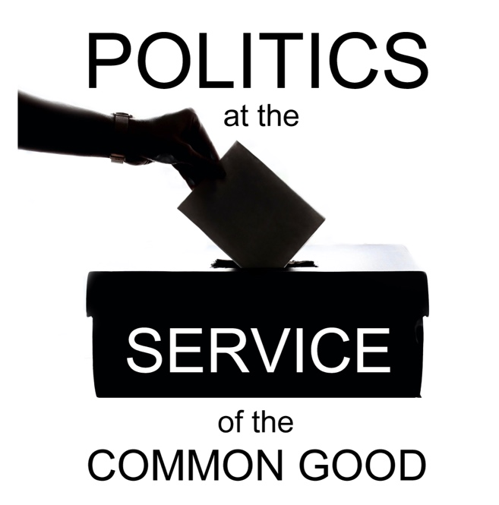

Politics at the Service of the Common Good

Week 4
Working together for the common good
Scripture: Galatians 6: 1-10

Reflection
The challenges facing our communities are complex. Some have deep roots in our history, some are global in nature, many are both. No one section of society working in isolation can effect lasting change and this is also true of political leadership, which needs the experience and resources of civic leaders and local communities to help address societal challenges.
Positive working relationships between leaders from different backgrounds at the level of local communities can contribute to the development of a political culture that has the common good at its heart. Too often opportunities for collaboration are limited, arising in the contexts of emergency responses or urgent needs, with insufficient investment in the long-term work of relationship-building. The dialogue that occurs in the context of election campaigns is an important part of the political process, but regular structured engagement beyond elections can have a transformative impact on community relations.
Churches, alongside other civic leaders, can help create such opportunities for relationship-building, convening conversations and inviting contributions from leaders in different sectors. This is particularly important where there are experiences of alienation or marginalisation in communities and a need to rebuild trust and establish mutual respect.
From a community perspective respect will entail, amongst other things, clear communication and consultation on the issues that affect those who live there. For politicians, it is about respect for the work that they do and a recognition of the difficulties they can face in seeking to balance competing interests and allocate limited resources. Communities have an important role to play in holding elected representatives to account, challenging political decisions, actions and language that have a negative impact. At a time when increasing numbers of politicians are expressing concern for their safety, it is important to be alert to the harmful impact not only of personalised attacks on political leaders, but also of negative stereotypes and generalisations that damage the reputation of politics itself, deterring people from considering political leadership as a way to serve their community.
Our Scripture passage for today invites us to reflect on how Christians are called to live in community, supporting and challenging one another, working together for the good of all. The relationship-building work that takes place within our church communities has its failings, and we have had to work hard to develop structures and processes that provide accountability and help restore trust, notably in the area of safeguarding. Is there learning we can share from our experiences of acknowledgement and outreach that could help in bringing people together to work for the common good in our local communities?

Questions for reflection and discussion
- Do you know the elected representatives for your area?
- What opportunities do you have currently to engage with your elected representatives? Could the quality of this engagement be improved?
- How would you like to see politicians and civic leaders relating to one another? How close does the current reality come to this image?

Actions
- Could churches/faith groups in your area organise an event to support and encourage politicians? By inviting political leaders to share their stories, might you encourage others who may be considering political leadership as a way to serve their communities, thinking particularly of young people and groups that are currently under-represented?
- Would you consider organising a question time meeting for local elected representatives (or hustings in the lead up to an election) in your area?
- Could you identify opportunities to invite political leaders to contribute to regular community-focussed initiatives you participate in?

Prayer
Loving God,
Help us to work together
for the good of our communities,
respecting everyone’s contribution
and listening to everyone’s needs.
We pray for those who are struggling
with the pressures and demands of leadership,
may they find solidarity and compassion
in the communities they seek to serve.
We pray that our local church communities
will encourage cooperation for the common good
in the way we live out the call to love our neighbour
in generous invitation to all
especially those most in need of our support.

Amen.

