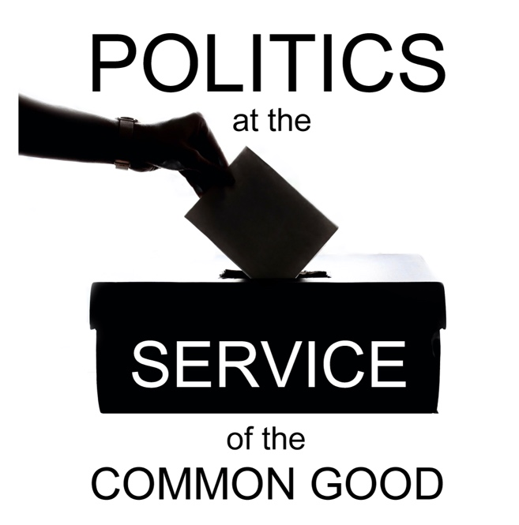

Politics at the Service of the Common Good

Week 3
A Vision for the Common Good
Scripture: Jeremiah 29:7

Reflection
How might a focus on the common good change the nature of our political conversations and choices? The common good is an ancient philosophical concept that is often held in opposition to narrow self-interest. Christian social ethics connects the idea of the common good to the vision of the Kingdom of God and the work of justice required to bring about the social conditions that reflect that vision.
Today’s Scripture passage reminds us that Christians are called to a socially engaged faith, working to transform our communities for the good of all, in line with the values that flow from our faith. Looking around our communities we can see many inspiring examples of different ways in which Christians are responding to this call, working to address the root causes of injustice to achieve the conditions that will protect the dignity and rights of all.
The way in which churches and faith-based organisations engage in community-building and social justice work has been changing over the years, and there is valuable learning to share from this journey. Increasingly there is a recognition of the need to move away from the language of being ‘a voice for the voiceless’ and doing things for people, to approaches based on partnership and accompaniment, amplifying through respectful listening the voices of those who may struggle to be heard in political debates. This is reinforced by the understanding that working for the good of the whole community requires us to work in partnership with people of different backgrounds, experiences and beliefs, representing the full diversity of our society.
In encouraging people to engage with the language of the common good, including political leaders, it is important to be alert to the risks that this language can be distorted or manipulated to promote the needs of majority groups over minorities or of privileged groups over those experiencing marginalisation. Asking critical questions about who is included, and who may be excluded, ensuring no one is left out or left behind, can help mitigate this risk.
A real commitment to the common good offers a unifying vision that does not deny our differences, and the tensions that may exist between our different aspirations for the future, but points us to a deeper connection that we share. It creates space for the contribution of a Christian social ethic as part of the debate, offered in humility as one among the plurality of perspectives that co-exist in a diverse public square, enabling us to seek common ground and a basis for cooperation from a place of authenticity.
The vision and promise of the Kingdom of God brings a message of hope which finds expression in the work of justice and can be shared respectfully with all those who seek to contribute to that work. We should not underestimate the value of witnessing to unity and inclusion in a context of division and fragmentation. These efforts can have a transformative impact on the environment that shapes our political culture.

Questions for reflection and discussion
- How often do you hear the language of ‘the common good’? Where do you hear it?
- What comes to mind when you consider work in your community that contributes to the common good?
- Where might you have opportunities to open up conversations on the theme of the common good?

Actions
- Identify a group of people who may be feeling excluded from conversations about the common good and the future of the local community. Consider how you might take the first steps to reach out and invite them to a conversation.
- Consider inviting local elected representatives and/or candidates to a listening session about an issue that impacts the local community, paying particular attention to how the conversation might be framed in terms of the common good, with the inclusion of a diversity of perspectives and priority given to those most impacted by the issue.
- Could you create space in your local church context to reflect prayerfully on the theme of the common good, inviting reflection on how we are called to see beyond self-interest and what it might mean to seek the good of the community in our particular context?

Prayer
Loving God,
Open our eyes to the opportunities that exist
for us to make our contribution to the common good,
to strengthen our communities,
and bring hope to those who are struggling.
Open our hearts to the needs
of those who are feeling forgotten, unheard or pushed to the margins.
Open our minds to the possibilities
for partnership and cooperation
at the service of the common good.
Help us to contribute
to a culture of respect, inclusion and participation
in our local communities
that models what we hope to see in the wider political culture.

Amen.

