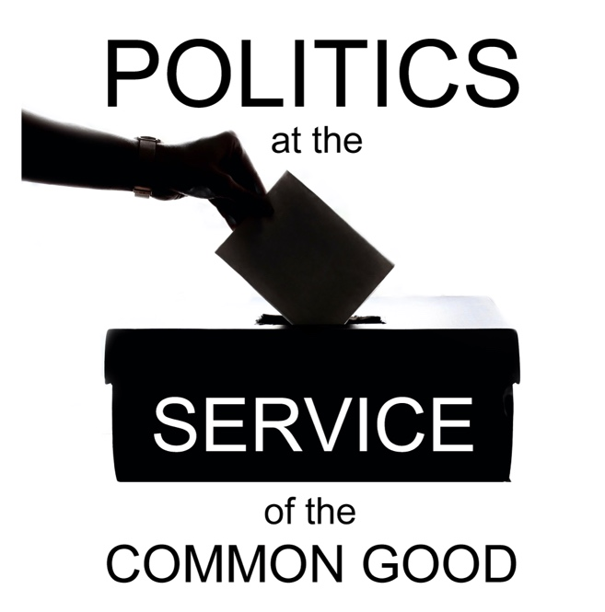

Politics at the Service of the Common Good

Week 2
Overcoming Polarisation
Scripture: John 17: 20-26

Reflection
Christ’s dream of unity for his disciples challenges us to face up to the ways in which our fractured fellowship weakens our witness and undermines our reconciling mission to a wounded world. That challenge is all the more stark at a time when a widening and deepening polarisation is inhibiting our ability to unite people in action for the common good.
This is not a problem that lies outside the Church but one that is keenly felt within our church communities, as well as the wider society. We desire to bring people together, particularly at a time when interconnected social crises are causing so many to struggle and suffer, and there can be a fear of opening up discussions on the social justice issues that are producing stark divides in the wider society, especially when these debates are marked by a lack of respect and even aggression. At the same time, we are aware that the healing of these divides and the work of building a just and compassionate society requires us to examine the impact of our political choices, including how these are experienced by people who are different to us. If we are to offer a vision for the common good, we need to be ready to hear all voices. How can we help move people from a place of confrontation to one of compassionate curiosity, recognising the need to explore other perspectives even when we disagree strongly?
What might the Church offer in this context as a sacred space that is also a shared community space in which we come together as people with all our flaws, shortcomings and limitations? Speaking with humility from the experience of our ecumenical journey we can share something of the learning from the steps we have taken to acknowledge the damaging consequences of division, to engage in self-critical analysis about our own role and contribution, and to develop a culture of hospitality and welcome in which we can practice respectful listening and search for mutual understanding, placing the emphasis on what connects us – our shared identity as followers of Christ. We have resources in Scripture that can help us as Christians to ground our reflections in that spirit of connection, and also principles and values that flow from Christ’s teaching that resonate with people of different faiths and beliefs. An intentional reflection on the resources we draw from our faith may help to build confidence as we seek to support the challenging conversations that will be necessary if we are to bring people together for meaningful cooperation for the common good.
When it comes to the wider debate in the public square on socio-political questions we look to our political leaders in particular to set a tone for the conversation. Political narratives that reinforce or deepen polarisation, excluding and even targeting groups of people within society are harmful to the common good and we have a responsibility to challenge these, offering instead an approach that reflects our connections, our shared responsibilities and our commitment to the common good. Naming the challenges honestly and openly, articulating the fears and sharing with humility about how we are navigating these tensions and endeavouring to resist the temptation of the easy answers can set a helpful tone for the conversation. This acknowledgement helps us to go deeper and examine the impact of polarisation on our work and witness, such as the way it shuts down space for dialogue and places obstacles in the way of collaboration, restricting our ability to find and build on common ground.
We come to this conversation with a calling to be bridge-builders, and hope that the patterns that contribute to this paralysing polarisation can be broken, with experience to draw on in supporting that transformation.

Questions for reflection and discussion
- Do you feel comfortable talking about politics with your friends and family? What are some of the challenges you encounter when engaging with these questions?
- Think about a time when you gained new perspectives and understanding from dialogue with someone whose beliefs and/or experiences were very different to your own? What were the conditions that allowed this to happen?
- To what extent do you see the local church engaging honestly and courageously with the challenge of polarisation?

Actions
- Consider using the tools that are available through social media to research views and perspectives that are different to your own on political and/or social issues seeking to learn something new and perhaps surprising about the hopes of those who share this view.
- Identify an organisation, locally or nationally, that is modelling respectful dialogue around difference. What can you learn from their approach?
- Might you consider initiating an informal conversation with someone who thinks differently to you on political and/or social issues, perhaps with an invitation to coffee, to explore where you might have common ground in your hopes for the future?

Prayer
Loving God,
Renew our commitment to the work of building relationships,
giving us hope that polarisation can be overcome.
Help us to trust in our neighbour,
and show compassion for those blinded by fear, anger and prejudice.
Open our eyes to the blindspots
that may limit our own engagement and outreach.
We give thanks for the hope-filled work of unity in a fragmented world.
Help us to strive to live up to Christ’s dream for his followers.

Amen.

