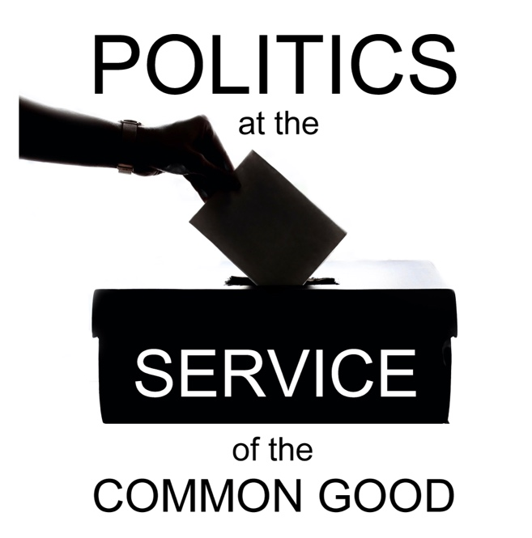

Politics at the Service of the Common Good

Week 1
A Message of Hope
Scripture: Jeremiah 29: 10-14

Reflection
In CTBI our work as an ecumenical body, promoting unity in diversity, often prompts us to reflection and dialogue on the societal pressures and fractures that weaken and damage relationships, and to consider together what it means to be called to be reconcilers in this context. In discerning how we might best bring a collective Christian witness to a diverse and pluralist public square, seeking to build bridges at the service of a wounded society, we consider how we relate as churches and individual Christians to others in positions of leadership – other faiths, other civic leaders and political leaders – with whom we share a responsibility to work for the common good.
With General Elections for both the UK and Irish Governments expected to take place by early 2025 we have been reflecting on the role of politics and political leadership in protecting and promoting the common good at a time of widening and deepening polarisation. We are conscious, on the one hand, of the positive contribution of politics as a vocation to serve one’s community – a calling taken up by many Christians, and supported by churches in a range of different ways including prayer and pastoral support, convening community dialogue on important issues, advocacy and the contribution of voluntary services to respond to societal need. On the other hand, there is concern that political discourse that exacerbates or even exploits identity-based fractures in society is weakening our collective commitment to the common good, with those who are most in need paying the greatest price.
This Lenten series invites us to consider how churches and individual Christians might best contribute to shaping and supporting the kind of politics that reflects our values, by keeping a commitment to the common good at its heart. This invitation to reflection and dialogue is offered in a spirit of hope. As our Scripture reading for this week reminds us, our faith calls us to take a long-term view when it comes to the work of building relationships and rebuilding trust. Our trust in God’s unfailing love and commitment to us gives confidence that what is broken can be restored. Our approach to this work is not conditioned by the timing of election cycles, but we are also aware that these can provide important moments of societal reflection on the political choices that impact our communities, and the values that inform those choices.
On our ecumenical journey we have often found that the invitation to dialogue can be a powerful first step, even when we don’t know what will come next. Churches are experienced in the practice of hospitality which has deep roots in our Christian faith. We can draw on this to create spaces for listening that allow us to identify and explore community concerns, while reaching out to those who are in a position to respond – including, but not limited to, political leaders.
A hope-filled approach to conversations about the vision for the future that might inspire our political decisions and choices does not require us to deny the very difficult realities that people are facing. On the contrary, it is only by demonstrating the willingness to engage with people’s struggles and suffering that we can offer real hope that trust can be restored and that participation, including political participation, will matter.
We can offer this invitation in the confidence that we have real hope to share in the many stories of people from our local churches and surrounding community who are working to heal divisions and address the injustices that push people to the margins of our society. We have an opportunity to amplify and build on this work, convening the kinds of conversation that may help contribute to a compassionate, inclusive and respectful political discourse.

Questions for reflection and discussion
- What gives you hope?
- Where do you see signs that people may be lacking hope?
- How might the local church intentionally offer a message of hope to the surrounding community through listening and dialogue?

Actions
- Look at the news from whichever source you normally use, noting how many of the top five stories have a hopeful element to the narrative. Consider how this makes you feel and what we might learn from this.
- Create a visual display around the theme of hope, perhaps drawing on some of the ideas from this week’s discussion and reflection.
- Could you amplify a hopeful story of relationship-building work from your local community by sharing on social media or retelling the story in conversation?

Prayer
Loving God,
Inspired by the promise
of your mercy and unfailing love,
may we have the confidence
to take those first steps
towards repairing what is broken
in our communities
and in people’s lives.
Help us to see
that although we do not have all the answers
you are with us,
guiding our steps.
We pray that our efforts
might help to restore hope
for ourselves and anyone who is struggling.
We give thanks for the work of all those
who accept positions of leadership to serve our communities.
We pray that you might renew our collective commitment
to the protection and promotion of the common good.

Amen.

