Everything Under the Sun:
theological reflections on light and warmth

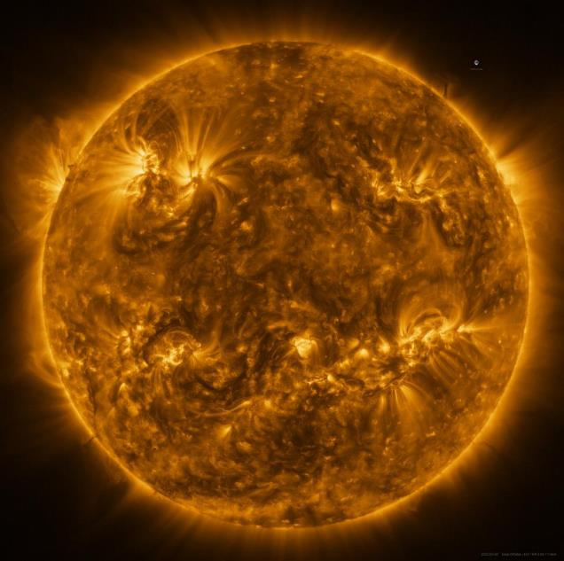
ESA & NASA/SOLAR ORBITER/EUI TEAM The sun as seen by Solar Orbiter in extreme ultraviolet light, 7th March 2022.

Introduction: Myths and Legends
From earliest times, human beings have lived their lives by the star that shines upon the Earth: the Sun. Many have worshipped the Sun as a divine being, giving life-giving light and warmth, making plants grow and determining the limits of human activity. As many religious myths developed, people imagined the Sun as a blazing chariot or a boat being driven across the sky by a divine being from sunrise to sunset. Because the Sun travelled inexorably, and because of the terrifying occasions when the sun was eclipsed and the world turned dark and cold, mythology developed of pursuers like wolves or dragons trying to devour the Sun and bring about the world’s end. Sometimes rituals would be enacted to drive such predators away and make sure the sun rose again tomorrow.
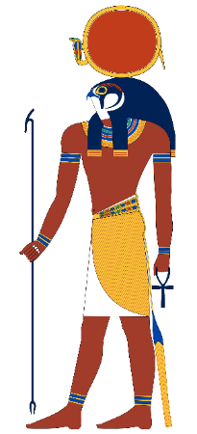
The divine Sun was understood to be extraordinarily powerful, bringing gentle warmth and light but also scorching, withering disaster. One Chinese myth explained this by having a goddess, Shiho, wheel one of her son/suns across the sky in her vehicle, but when her other children, also suns, decided to join her instead of waiting their turn, the planet was nearly destroyed until a hero, the archer Hou Yi, was able to despatch the renegades. Disaster still nearly happened when he was about to kill the last of the suns, but a child stole his final arrow. So, fortunately, just the one sun remains.
In the Egyptian myths, the sun-god Ra not only sails across the sky to create day for humans but returns to the east by way of the underworld, bringing day to the dead who lie beneath., - a dangerous journey because of attack by an evil serpent whose activity was intuited from eclipses.
An interesting Maori legend says that humans were upset by the speed of the sun’s passage as they didn’t have enough daylight to get all the things done that they needed to do, so a hero and his brothers wove a net, caught the Sun and fought him, exhausting him so that the Sun can now only travel slowly across the sky, providing plenty of daylight.
In the UK, a number of ancient monuments are associated with the Sun. Stonehenge with its summer solstice celebrations is perhaps the most well-known, but there is also the great monument at Newgrange in Ireland, built more than 1000 years before Stonehenge, which is famous for the way the winter solstice sun shines along its passage, through a roof box, allowing dawn sunlight to extend over a few days into the rear of the chamber. As the sun rises on those days the beam widens to shine through the whole room for 17 minutes.
The purpose of this winter solstice illumination is likely to have been to mark the lengthening days of the winter solstice as well as the triumph of life over death, but also perhaps a way of ensuring, or demonstrating, that the sun grows again after the solstice; a sign of hope and confidence in new beginnings.

The Science of the Star
The Sun has figured prominently in scientific enquiry and remains a source of important study today. In the ancient worldview and throughout medieval times, the Sun was imagined to circle around a stationary Earth. This placed the Earth – and human beings- in the place of most importance within the cosmos, with the Sun and Moon, the planets and the stars arrayed in concentric circles around the Earth, forming a neat picture of the Creation decreed by God.
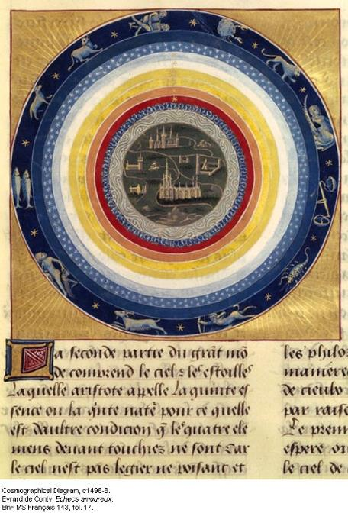
Heliocentrism had been proposed as early as the 3rd century BC. However, this remained a speculative philosophical concept until Copernicus in the 16th century proposed a mathematical model of a heliocentric system. Theoretical models proposed by Kepler and followed by observational evidence gathered by Galileo led to the establishment of understanding that the Earth orbits the Sun but these ideas were at first fiercely opposed by Church authorities of the time because such heretical ideas upset the ‘place’ of God in the universe, looking down from an ultimate heaven beyond the creation and who had ‘fixed’ the stars and the procession of sun and moon in their places.
Today, scientific observation (and renewed theological understanding) has confirmed that the Sun is just one star on an outer spiral arm of a huge galaxy of stars and that our galaxy is similar one of countless others scattered throughout an expanding universe. We further know that stars like the Sun have a life cycle, from their formation from clouds of dust and gas under gravity, igniting nuclear fusion, to the ‘main sequence’ during which hydrogen coverts to helium, releasing energy. When the fuel runs out, stars may balloon into a red giant phase, cooling and expanding until gravity overcomes them and they collapse into a new dwarf phase. Enormous stars collapse so catastrophically they may explode into a supernova, scattering heavier elements throughout space (including those found in our bodies) formed as they run out of fuel. Other massive stars may collapse into the superdense state which forms neutron stars or even may become a black hole. Yet others similarly cool and fade, becoming faint or invisible lumps of material.
Our own star, a type G main-sequence star, or yellow dwarf, will finally start to run out of hydrogen in about 5 billion years, become a red giant, expanding and engulfing the inner planets, including Earth, before collapsing to a white dwarf state. After about 8 billion years it will be cold and dead and shine no more. Scripture too suggests that at the end of time, the sun will go dark, to be replaced by the everlasting brightness of God’s glory.
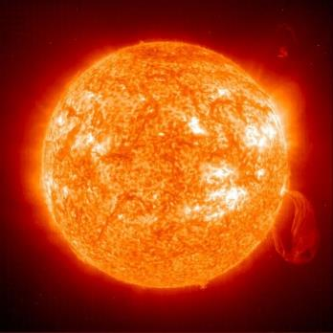
Current science is interested in the sun’s own 11-year cycle of activity and the incidence of greater (solar maximum) or lesser activity, in particular solar flares which have the capacity to disrupt communications and interfere with the climate. While NASA seeks to dispel panic stories about life on earth being wiped out by huge flares, it is a matter of concern that communications and GPS could be disrupted by flares affecting the atmosphere, given that planes, for example, rely on this technology and the developed world is particularly dependent on power grids. In February 2022, it was reported that solar activity destroyed 40 SpaceX satellites.

Why should we care about a theology of the Sun and sunlight?
As has been shown, the Sun has figured prominently in human enquiry and sense-making. Human beings have tried to make sense of the Sun’s heat and light and its rising and setting, because it is so constant and so intrinsic to human wellbeing and activity. Through religious narratives, people have tried to make sense of the presence of the Sun (and the moon) and relate it to the purposes of God (or gods) to understand why the Sun exists and why it behaves as it does.
Scientific enquiry has given us a detailed understanding of the Sun within the cosmos, and further understanding of the extraordinary relationship between the Earth’s features and our star, enabling and sustaining all life on this planet.
From the initial clash between a theological cosmology that insisted on geocentrism to cement God in the heavens, we now need a theological description of God’s creation, the precious fragility of life on earth and the sun’s role in that, as we come to understand the processes involved in climate change and seek to deal with what that means for future generations. And that perhaps means going beyond a purely descriptive scientific understanding, to re-examine the importance of the creation narratives, the miracle of life on earth, the role of sunlight in our lives, the harnessing and use of sunlight as solar energy, the challenge of an energy crisis and deep concerns about climate change.

The creation narratives – cosmological objects as witnesses to God the Creator
In Genesis, God is described creating the universe so that all that is comes into being and its manifestations can be observed by God. The creation and all that it is in it is ‘good’ and pleasing and delightful to the creator God. There is a rightness about the universe and the way it operates. The Sun is a great light whose purpose is to illumine the period of day: it delivers not only light and warmth but also time. The Moon, conversely, is a lesser illumination for the period of night when the Sun is absent. These things are easily verified by simple observation and this therefore serve to reinforce the theological understanding asserted by Genesis that the Sun and Moon come into existence by God’s intention. Further, celestial objects like the Sun and the Moon are not, in the Hebrew Scriptures, entities to be worshipped in their own right, but their obviousness points to the creator God behind them.
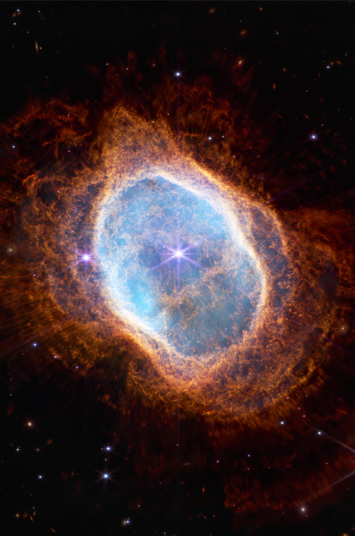
The Sun and Moon and stars are witnesses to God’s glory and power; when we look up at the sky in wonder and awe we are to glimpse the staggering imagination, power and delight of the Creator who can bring such things into being. Recent images from the James Webb telescope have given even more detail to the beauty of the universe.
If the procession of sun and moon changes, as during an eclipse, in Scripture this signifies calamity and huge disruption to the natural order as will both presage and attend ‘the day of the Lord’. Instead of imagining predators eating the sun, eclipses witness to God’s power and intention to bring judgement and remaking of the world in the end times. Similarly, when Jesus dies on the cross, it is reported in the synoptic Gospels that darkness fell on the earth during the daytime.
In other places within Scripture, God’s direct intervention in human affairs is marked by an apparent interruption in the motions of sun and moon in order to alter time. Famously, in the story of Joshua’s victory over the Amorites, the sun stands still to provide more time, and in the miracle of Isaiah 38.8, the shadow thrown by the gnomon of the sundial of Ahaz appears to reverse the sun’s course and therefore turn back time.
The anthropic principle
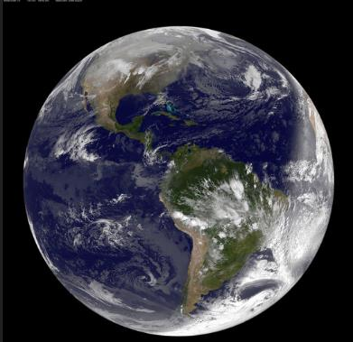
Another particular scientific enquiry which touches on the accounts of the Creation comes from interrogation of the extraordinary fine tuning of particular requirements which make our planet habitable. Much of this requires the Earth to be at its particular distance from the Sun, so that it can be warmed by the Sun but not lose its atmosphere or its liquid water. Further the Sun most likely has to be a G type star on the main sequence to provide the amount of energy necessary for life on this planet to develop and flourish. While there is an active search for other habitable planets like ours elsewhere in the universe in the hope that there might be other ‘Earths’ with biological life out there, none have yet been NASA confirmed as having definite signs of what we call life.
So the scriptural account of the creation which centres on the planet on which we live, seems to endorse what the anthropic principle (strong and weak) seeks to propose – that there is something extraordinary about the fact that we are able to live on this planet. The cosmological values which surround us, the strength of gravity, the composition of the atmosphere, the geologic activity of the Earth, the presence of water and the moon to create the tides – all these things contribute to life on Earth but are not found elsewhere as far as we know. Yet all these things are described in Scripture as flowing from God’s intention and loved and delighted in by God.
Day, Night, and Human Activity
The Sun is also an important marker of time in the ancient world. Sunrise to sunset would delimit the majority of human activities. Before clocks and watches, people divided their time according to where the sun was in the sky. Hunter-gatherers knew the habits of animals by the amount of heat and light in the environment and so when to expend energy looking for food; farmers know when to till, sow and harvest according to the amount of daylight available.
Today we know a great deal about the importance of sunlight not just in terms of reckoning where we are in the day but the importance of sunlight to our wellbeing. We require a certain amount of sunlight to form vitamin D and can become deficient if we are not exposed to enough sunlight. Further, we all have circadian rhythms which have a day/night cycle, so that we are creatures which are most active during daylight hours and need to sleep at night. People who have to work against their circadian cycles (such as night-shift workers) may become less healthy as the body tries to overcome its natural rhythms. An acute lack of sunlight, such as experienced in the winter months or in times of persistent overcast skies, can result in a drop in mental wellbeing, or SAD (seasonal affective depression). Nonetheless, the Sun is always, in some way present. The moon reflects the sun’s light, and the dancing light-shows of the auroras are caused by charged particles from the sun (the ‘solar wind’) interacting with atoms and molecules in the atmosphere.
Some people have been kept in captivity in complete darkness as a form of torture. Living in total darkness without the sun as a ‘re-set button’, means that the body’s internal sense of time begins to free-run. Circadian disruption is linked to depression, insomnia, metabolic and hormonal disturbances, and impaired concentration. One might compare the sunless gloom that settles over Job.
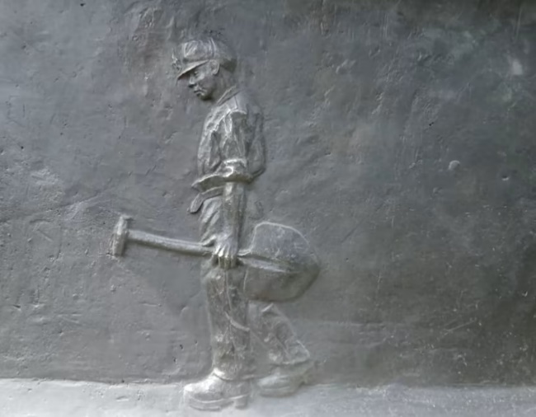
Picture credit: ITV Central
Miners’ Memorial, National Aboretum
Some workers, such as miners, working deep underground, have to learn to adapt to darkness. When miners, cavers, or others exploring underground places are trapped, people feel strongly drawn to follow rescue attempts, hoping the trapped people can be brought out into the light. For example, people worldwide followed the international operation to bring about the Tham Luang cave rescue of twelve boys and their coach.
Holiday sellers are all too aware of the desire many people living further towards the poles have to get some winter sun and are ever prepared to help people travel to other parts of the world to avoid the lack of daylight in the winter months. This shows that despite the huge amount of artificial light now available, the 24-hour clock, and the ability to work at night should we need to, we are still creatures of sunlight and daylight: we respond to God’s intention to have the Sun govern the day and the Moon the night. There is no substitute for the warmth of sunlight on human skin and the pleasant sense of a bright, sunny day in the offing. Sunlight cheers us and makes us feel hopeful. People on holiday often enjoy a chance to sunbathe, or seek destinations which guarantee sundrenched days.
Conversely, some people experience worse pain at night; they may feel more afraid, suffer nightmares or psychological horrors after dark. Some people hate being awake after sunset and anxiously await the return of sunrise.
It is unsurprising then, that Jesus the Son (Sun?) of God is depicted as coming back to the Earth from the East, the place of sunrise and the return of light and warmth, -the things we instinctively know give us life. Churches are orientated east/west and Christian graves face east in this expectation. It makes sense to us to equate what we know in every single day of our lives about the ‘goodness’ of God’s creation experienced in the warmth of the sun rising as a way of thinking about the unimaginable coming of the reign of God. Scripture suggests in various places that we will know the coming of God by a radiance that surpasses and outlasts that of the Sun. In the story of Paul’s conversion, a dazzling encounter strikes him temporarily blind, ‘I saw a light from heaven, brighter than the sun, shining around me and my companions’. It is not surprising then that when Jesus is transfigured his face shines like the sun and in Revelation 1.16, ‘His face was like the sun shining in its strength’ and in 21.23 ‘And the city has no need of the sun or of the moon to shine on it, for the glory of God has illumined it, and its lamp is the Lamb’. Our experience of the Sun therefore gives us tools to imagine the eschatological vision and encounter with God. Our Sun, as part of the creation, is subject to time and decay, but God’s glory is eternal.

Photosynthesis
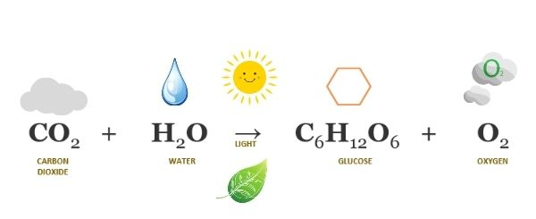
Perhaps the greatest miracle of life on earth is photosynthesis, the process used by plants to convert carbon dioxide and water via sunlight into sugars for energy, creating oxygen as a by-product– replenishing the oxygen in the atmosphere that we need to survive. Photosynthesis takes place in the cells of green leaves, green because they are filled with chlorophyll, which reflects green light, while absorbing the energy of other light frequencies. Each leaf on every tree is a miniature solar panel, receiving solar energy and using it in this extraordinary way, using endlessly renewable energy as cleanly as possible. Plants therefore remove carbon dioxide, and store carbon, locking it away, which is why deforestation is understood to be so dangerous for its environmental impact.
Photosynthesis not only affects the climate but provides plant energy for herbivorous creatures which pass on that energy within their bodies to the carnivores which prey on them. The sun’s energy therefore drives the process for life among all living things in an endless cycle of food and decay, driving life cycles of creatures and making space for adaptation and change – the processes of evolution.
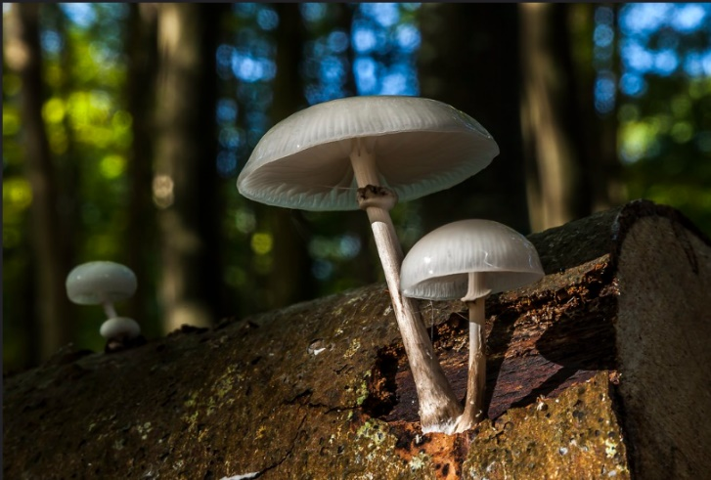
Greg Clarke/flickr
We can see the spiritual importance of these interconnected relationships within the creation narratives – in the Garden of Eden there are important and specific trees, as well as relationships with all living things which have been named and are to be looked after by the humans. When humans break the interconnections by disobeying God’s instructions, the delicate web of life and care is broken irrevocably and humans now have to make a way in a much harsher environment, one where disaster can threaten and overwhelm. Everything is out of balance and much labour and suffering is experienced by humans trying to make their way in this fallen world.
One of the consequences of living in this harsher environment is that the Sun can be a danger to human beings as well as a source of life and the provider of light to illumine human activity. In the Middle Eastern world of Scripture, extreme heat and scorching sunlight brings the possibility of death. The Bible reflects a world in which people carried out active tasks (and warfare) in the cool of the morning and the evening and necessarily avoided the intensity of the midday sun. The manna that sustained the Israelites in the desert was to be gathered in the early morning. If left till later, it would melt away, or rot. Both the Psalms and Isaiah talk of protection through God’s mercy from the death-dealing of the Sun.
In Jonah, however, the scorching Sun becomes an important lesson. Having sheltered under a bush, God causes the bush to wither away leaving Jonah totally exposed:
‘When the sun rose, God prepared a sultry east wind, and the sun beat down on the head of Jonah so that he was faint and asked that he might die. He said, ‘It is better for me to die than to live.’’ Jonah 4.8.
This is a lesson about salvation and mission, in which Jonah’s regret for the bush and its shade, and its place in world, reflects God’s desire for nothing and no one to perish, and hence God’s desire for Jonah to speak to the people of Nineveh. To this end, the Sun is an instrument of theological learning and understanding, not only about our own stewardship of creation, - ‘You are concerned about the bush, for which you did not labour and which you did not grow; it came into being in a night and perished in a night’ (Jonah 4.10) but also about our responsibility for being obedient to God in living as followers of God’s word and intention. As Ecclesiastes says, the Sun shines on both good and evil people, and what we do is similarly evident to God who knows the secrets of our hearts.
In Jesus’s parable of the sower, the scorching sun and hot wind ruins the plants that are not anchored to roots able to find moisture. They wither up in their rocky ground and blow away. In making this analogy, Jesus drew on the direct experience his audience would have of the changing amounts of heat during the day.

Jonas Bengtsson/flickr
This reminds us, especially those of us who live in cooler countries, that many people still have to pay much more attention to the heat of the sun and arrange their lives according to heat at particular times of day. With the UK having experienced its hottest day on record in July 2022, warnings were given about being prepared for unusual heat. Many of us may have endured sunburn or even sunstroke as a result of not being prepared for intense sunlight, but in many places, death from sun exposure, especially if people are forced to work in intense heat, or have no choice but to be out in it with little or no shade or access to water, is a real possibility. We tend to romanticise ‘sunshine’ in the West, forgetting that it can be a killer, and that many people live daily in that knowledge and can do little but endure it as they go about their lives. Climate specialists indicate that as the planet warms, more people and more wildlife on land and in the seas, can expect to suffer effects on their lives from extreme heat in the future.
Beyond this, reminders in Scripture of the dangers of the Sun’s rays, bring us to the importance of further understanding that if we damage or destroy elements of the protective atmosphere which surrounds the Earth, so we will lay all life on earth, not just ourselves, open to damage from the Sun’s radiation. For many years now, there has been concern about holes in the ozone layer which offers a protection from the Sun’s harmful ultra-violet radiation. Because oxygen molecules in the stratosphere hit by UV radiation form ozone and because there is so much oxygen available, damaging radiation is absorbed far from Earth’s surface. Holes in the ozone layer caused by human use of chemicals, particularly chlorofluorocarbons (CFCs) permit more UV radiation to penetrate the layers of Earth’s atmosphere.

Fossil fuels, the Sun as renewable energy and nuclear fusion
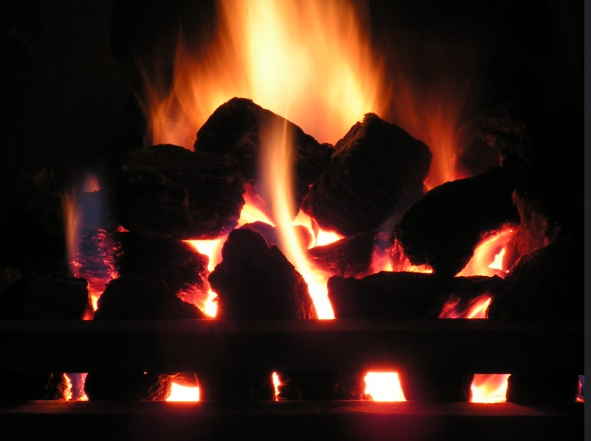
Tristan Fearne/flickr
Since early human species learned to make fire, we have echoed the processes of the sun by creating our own heat and light. Warmth is essential to our comfort and wellbeing. But to do so, we have typically unleashed the energy locked up in plants through burning wood and peat and then discovering the potentials of fossilised plants, burning coal, petroleum, natural gas, oil shales, bitumens, tar sands, and heavy oils. Fossil fuels are formed by the anaerobic decomposition of these dead plants containing organic molecules created in ancient photosynthesis. It takes millions of years for the fuels to form under a combination of heat and pressure to create high-carbon fossils and these have been extracted heavily by mining in particular since the Industrial Revolution. Fossil fuels power factories, run cars and planes, and keep cities warm and bright. But in releasing the energy locked up in these fossil deposits for our own purposes, we also release carbon dioxide and particulates which create smog and acid rain. Quite apart from adding greenhouse gasses to the atmosphere, damaging existing plants, human health and our own infrastructure, fossil fuels are non-renewable. Once they are completely mined, drilled out or pumped from deep undersea wells, there are no more available.
The war in Ukraine in 2022 has also brought into immediate focus the problems we face being reliant on fossil fuels such as oil and gas, as so much of these have come to Europe from Russia. Sanctions and controls on pipeline fuel of this kind drives up energy prices, with the World Bank predicting, in April 2022, a rise of 50% in energy prices, with gas prices doubling and coal prices 80% higher than in 2021. Energy costs have become an urgent political and social question as more people face fuel poverty in winter. Control of precious and dwindling resources has become prominent in international politics where countries are in conflict, with talk of ‘blackmail’, ‘gas war’ and ‘weaponising’ of energy. These events have brought into focus the effects on human beings when our reliance on fossil fuels created by ancient photosynthesis, in relation to their availability, results in loss of supply. Environmental policy has accepted that fossil fuels will be exhausted at some time in the future, but not anticipated sufficiently that restriction of those precious resources, the result of the sun’s bounty, could happen now.
The war has also placed increased focus on obtaining other sources of energy, such as obtaining shale gas from fracking. This practice has caused some controversy about its safety and efficacy. In 2016, the Church of England produced a paper examining the moral and theological case for shale gas extraction and notes that ‘Shale gas is a potentially useful element in achieving a transition to a much lower carbon economy. The government’s public commitment to reducing the UK’s carbon emissions under COP21 provides a context which should ensure that shale gas is not treated as an alibi for ducking carbon reduction commitments’. Indeed, if the rate of climate change is to be kept in check to anywhere near 1.5 degrees of warming then deadlines for emission cuts will mean fracked gas will have an increasingly small role to play in transitioning.
In September 2022, and in the wake of rising costs of energy and citing ‘weaponisation of energy’, the UK government lifted the ban on fracking, putting aside concerns about possible earth tremors arising from the process. However, the following month, various MPs indicated that they would be in favour of finding a way to block this after the Business Secretary, Jacob Rees-Mogg, argued that a higher degree of risk was ‘in the national interest’. The ban was subsequently immediately reinstated by prime minister Rishi Sunak in October 2022.
Fracking however, produces only another non-renewable source of energy and therefore puts off thinking about what happens when we have depleted the products of all this photosynthesis and the miracle of plants using sunlight. Consequently, we need to turn back to the Sun to understand renewable, clean energy. We need to do this by reflecting theologically on the purpose and presence of the Sun in creation and the clues we find there which asks us to use our knowledge and stewardship of creation to review again why our Sun exists and what it can teach us about the best way to live and organise our lives and needs for the best outcome for our planet. The fifth mark of mission reminds us that we must ‘strive to safeguard the integrity of creation, and sustain and renew the life of the earth’.
The Sun, as we have seen, operates steadily and unchangingly by a process of nuclear fusion. Currently scientists are trying to find a way to replicate this on Earth, but it is exceptionally difficult. Nuclear fission, the process behind nuclear power, is not the same process, and creates radioactive waste which it is difficult and dangerous to dispose of. Nuclear fusion creates much lower-level waste. It has been reported that scientists at the Joint European Torus (JET) at Culham in Oxfordshire have been able to create 59 megajoules of energy from a fusion pulse of five seconds. The ITER project for nuclear fusion scheduled for experiments in 2025, hopes to go much further in pursuit of renewable, clean energy through nuclear fusion, the process which powers our Sun.
In August 2022, it was reported that the Lawrence Livermore Laboratory’s National Ignition Facility had, in 2021, managed a fusion ‘ignition’ that brings nuclear fusion closer to being a self-sustaining process and therefore a useful source of energy modelled on the sun’s processes. But it is still a huge ask. One hundred and ninety-two of the world’s most energetic lasers hit a millimetre-sized capsule filled with hydrogen. This created a small sphere 18,000 times hotter than the sun’s surface and experiencing 100 million times Earth’s atmospheric pressure. The hydrogen underwent fusion and released 1.3 megajoules of energy, the NIF’s highest ever energy yield. However, the experiment has proved extremely difficult to replicate and the dream of commercial nuclear fusion power plants depends on the output in energy being higher by about 100 times than the amount used by the lasers. Yong-Su Na and colleagues at Seoul National University in South Korea have also reported running a reaction at temperatures needed for a viable reactor and keeping the device stable for 30 seconds. Beyond making fusion happen, there is the significant problem of costs of materials for the fusion reactor structure and the breakdown of those materials under the stress of the forces involved: ‘Clearly, there is a lot of engineering to do before the dream of bottling the power of stars becomes a reality.’ In March 2023,t he United Kingdom Atomic Energy Authority (UKAEA) and the US Department of Energy's (DOE's) Oak Ridge National Laboratory (ORNL) announced that they had entered a five year strategic research partnership to better understand the performance and behaviour of materials required for use in future commercial fusion power plants.
Cold
The particular concerns about energy also point to our need for warmth, so that the prospect of a winter without being able to afford adequate heating causes intense worry. In developed countries in particular, we have been used to relying on supplies of energy for heating our houses, transport and workplaces, while charities try to underline the message that for many, especially those who sleep on the streets or cannot afford heating, cold winter nights can lead to misery, suffering, hypothermia and risk of death. In freezing conditions, some unhoused people will sleep during the day when the presence of the Sun keeps temperatures somewhat higher and walk about all night in order to try to keep warmer and keep their body temperatures higher, fearing if they sleep at night they might not wake up.
The Sun, for us as human beings, represents both light and warmth; darkness and cold threaten us and our wellbeing and perhaps, when the question of energy restriction and cold comes to us, we might appreciate rather more that there are many people among us already who endure the cold in the winter months and need help to find warmth and shelter. As the energy crisis bites, there are more concerns even about people who are housed. When people cannot afford to heat their homes, they are not just cold but at risk of the debilitating effects on their health from damp and mould. Children and older people are particularly at risk. In the context of an energy crisis and resultant lack of affordability for even more people, churches have also been looking at whether churches, church halls and other church-owned buildings could become warm places where people could go to spend time or work in order to save on heating their homes. Some pubs, hairdressers and other businesses have also signed up to provide warm spaces, or ‘warm banks’ for those in need. Advice has also come from CILIP, the Chartered Institution for Library and Information Professionals, backed by Martin Lewis (Money Saving Expert) on how public libraries can also provide warm spaces.
Some concluding thoughts
We can see, therefore, that the presence of the Sun in the life of every human person is intimately connected to our physical, mental and spiritual wellbeing. Thinking about the Sun theologically, points us to God’s intention in creation and to the necessity of being good stewards of the creation in which we respect the integrity of the earth and strive to preserve it.
When we think about the day-night cycle and how our bodies are attuned to the amount of heat and light provided by the Sun we recognise our kinship with other animals and with plants, as cold-blooded creatures become more active as they warm up and how we and other warm-blooded creatures need to avoid overheating and becoming parched in the heat of the sun. As creatures, we are naturally active during the day and sleep at night, but when we change those natural cycles and artificially light our nights, we not only throw birds and other creatures out of their natural rhythms, but ourselves as well. Through reflecting on the Sun in our lives, as part of God’s creation, we recognise the links between health, wellbeing and the presence of sunlight and its vital warmth. We should therefore respond compassionately to those who are deprived of light and warmth and in particular those who labour in dark cheerless places, who live on the streets in winter or who are plunged into fuel poverty.
Reflecting on the Sun as a gift of God reminds us that we must not take the relationship of the Earth and the Sun for granted. Life on Earth exists because of a delicate relationship between sunlight and our atmosphere, the creation as God has intended it. Through science, we understand ever more about that relationship which alerts us to the damage we can do to our living conditions as well as the pursuit of clean, renewable energy based on our understanding of how the Sun works.
Finally, reflecting on the Sun reminds us that it is a witness to a greater reality that exists in God. Proverbs 4.18-19 imagines spiritual maturing in wisdom to be like the sun getting brighter towards noon, while evil doers create only darkness in which people blunder about. The light, warmth and radiance of the Sun is an inkling of the eschatological reality, so that we are not in the end enclosed in the darkness of ignorance and hopelessness, but with our deeper understanding of the wonder of God’s creation, we emerge at last into God’s glorious light.

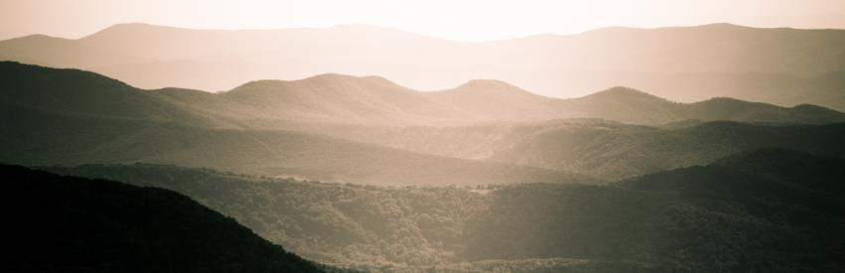
Brandon Atkinson/flickr

https://www.esa.int/ESA_Multimedia/Images/2022/03/The_Sun_in_high_resolution
Such as the wolf Sköll in Norse mythology, who sometimes, at eclipses, comes close to devouring the Sun and will finally manage to do so at Ragnarok.
Cf Ecclesiastes 1.5 for the cyclical understanding of the Sun’s rising and setting.
https://www.newgrange.com/
The Church has since revised its opinion. In 1992 Pope John Paul II said that, ‘Thanks to his intuition as a brilliant physicist and by relying on different arguments, Galileo, who practically invented the experimental method, understood why only the sun could function as the centre of the world, as it was then known, that is to say, as a planetary system. The error of the theologians of the time, when they maintained the centrality of the Earth, was to think that our understanding of the physical world's structure was, in some way, imposed by the literal sense of Sacred Scripture....’ https://www.vatican.va/content/john-paul-ii/it/speeches/1992/october/documents/hf_jp-ii_spe_19921031_accademia-scienze.html. The Church officially apologised to Galileo in 2000. http://www.vaticanobservatory.va/content/specolavaticana/en/research/history-of-astronomy/the-galileo-affair.html
The sun shall no longer be your light by day, nor for brightness shall the moon give light to you by night; but the Lord will be your everlasting light, and your God will be your glory. Your sun shall no more go down, or your moon withdraw itself; for the Lord will be your everlasting light, and your days of mourning shall be ended. Isaiah 60.19-20 The sun shall be turned to darkness, and the moon to blood, before the great and terrible day of the Lord comes. Joel 2.31
https://www.nasa.gov/mission_pages/sunearth/news/flare-impacts.html
https://www.bbc.co.uk/news/world-60317806
Genesis 1. 14-18 And God said, “Let there be lights in the vault of the sky to separate the day from the night, and let them serve as signs to mark sacred times, and days and years, and let them be lights in the vault of the sky to give light on the earth.” And it was so. God made two great lights—the greater light to govern the day and the lesser light to govern the night. He also made the stars. God set them in the vault of the sky to give light on the earth, to govern the day and the night, and to separate light from darkness. And God saw that it was good. who made the great lights, for his steadfast love endures for ever; the sun to rule over the day, for his steadfast love endures for ever Psalm 136.7-8.
Though we now know that the moon emits no light of its own, but shines because it reflects the light of the sun.
As in Deuteronomy 2-5 – the penalty for worshipping celestial bodies, as other surrounding peoples did, was death by stoning. Also Deuteronomy 4.19 warns about being distracted by the Sun and tempted to worship. Cf Job 31.26-28.
Islamic prayer times were set up originally by shadow lengths based on an advanced knowledge of astronomy and mathematics. However, those prayer times forbid coinciding with the rising, zenith or setting of the sun - thus minimising the danger of worshipping the sun rather than its creator. https://fiqh.islamonline.net/en/times-when-prayer-is-forbidden/
Robert Alter, drawing on Abba ben David in The Language of the Bible and the Language of the Sages, (1967) points out that the ancient vernacular Hebrew which informed rabbinic Hebrew was largely excluded from the literary language of the Bible. To this end, the biblical word for Sun shemesh, was not the same as vernacular ḥamah. This might suggest a theological status for talking about the Sun in biblical contexts, rather than the ‘ordinary’ word used in common parlance. The Hebrew Bible, Volume 1, p. xxv-xxvi.
https://webbtelescope.org/resource-gallery/images
Isaiah 13. 9-10 Behold, the day of the Lord is coming, Cruel, with fury and burning anger, To make the land a desolation; And He will exterminate its sinners from it. For the stars of heaven and their constellations Will not flash forth their light; The sun will be dark when it rises And the moon will not shed its light.
On that day, says the Lord God, I will make the sun go down at noon, and darken the earth in broad daylight. Amos 8.9. Cf Mark 13.24. Luke 21.25-26. For the day of the Lord is near in the valley of decision. The sun and the moon are darkened, and the stars withdraw their shining. Joel 3.14-15
Matthew 27.45; Mark 15.33; Luke 23.44
The sun stopped in mid-heaven, and did not hurry to set for about a whole day. There has been no day like it before or since, when the Lord heeded a human voice; for the Lord fought for Israel.
Although life on Earth can exist far from sunlight and warmth, such as under ice, or in the total darkness of the depths of the sea or in caves. Such creatures may be blind or have bodies which can create ‘lights’. But whether life can exist on a planet which is not warmed and illuminated by a star as Earth is, is still unknown.
https://www.nhs.uk/live-well/healthy-body/how-to-get-vitamin-d-from-sunlight/
https://www.sleepfoundation.org/circadian-rhythm
Linda Geddes (2019) Chasing the Sun: The New Science of Sunlight and How it Shapes Our Bodies and Minds (Wellcome Collection)
https://www.bbc.co.uk/news/world-asia-44695232
Perhaps that is why, as recorded in Mark 1.32, people bring those who are sick and demon-possessed to Jesus after sunset for healing.
The sun shall no longer be your light by day, nor for brightness shall the moon give light to you by night; but the Lord will be your everlasting light, and your God will be your glory. Your sun shall no more go down, or your moon withdraw itself; for the Lord will be your everlasting light, and your days of mourning shall be ended. Isaiah 60.19-20
Acts 26.13
Matthew 14.2.
https://www.lse.ac.uk/granthaminstitute/explainers/whats-redd-and-will-it-help-tackle-climate-change/#:~:text=Forests%20and%20trees%20store%20carbon,contribute%20to%20climate%20change%EF%BB%BF%20.
https://www.climateandweather.net/global-warming/deforestation/
Eg Genesis 29.7
Judges 9.33 for example
Isaiah 49.10 They will not hunger or thirst, Nor will the scorching heat or sun strike them down; For He who has compassion on them will lead them And will guide them to springs of water. Psalm 121.6 The sun will not smite you by day, Nor the moon by night.
https://www.bbc.com/future/article/20220718-the-tips-from-science-for-staying-cool-in-a-heatwave
https://www.who.int/health-topics/heatwaves#tab=tab_1
https://www.who.int/news-room/fact-sheets/detail/climate-change-and-health
https://www.worldwildlife.org/threats/effects-of-climate-change
https://www.biologicaldiversity.org/programs/population_and_sustainability/climate/
https://www.nasa.gov/audience/foreducators/postsecondary/features/F_Ozone.html
https://www.zmescience.com/science/news-science/how-long-fossil-fuels-last-43432/
https://www.theguardian.com/business/2022/apr/26/ukraine-war-food-energy-prices-world-bank
https://www.bbc.co.uk/news/business-62318376
However, it has also been argued that the pressure on fossil fuel supplies could hasten the need to look at greener and cleaner energy. See https://www.newscientist.com/article/2313010-how-the-war-in-ukraine-will-change-the-way-the-world-uses-energy/?utm_source=nsnew&utm_medium=email&utm_campaign=NSNEW_240322
https://www.churchofengland.org/sites/default/files/2017-11/shale-gas-and-fracking.pdf
https://www.bbc.co.uk/news/science-environment-62982332
https://www.bbc.co.uk/news/uk-politics-63222652
https://www.theguardian.com/environment/2022/oct/26/rishi-sunak-ban-on-fracking-uk-no-10
https://www.anglicancommunion.org/mission/marks-of-mission.aspx
https://assets.publishing.service.gov.uk/government/uploads/system/uploads/attachment_data/file/1038746/radioactive-wastes-from-fusion-energy-corwm3735-preliminary-paper.pdf
https://www.nature.com/articles/d41586-022-00391-1?utm_source=Nature+Briefing&utm_campaign=0c581bdf12-briefing-dy-20220211&utm_medium=email&utm_term=0_c9dfd39373-0c581bdf12-45437250
This relates to the Lawson criterion for ignition which states that the fusion heating must be high enough to overcome all physical processes that might then cool the plasma.
Physical Review Letters, DOI: 10.1103/PhysRevLett.129.075001
https://www.newscientist.com/article/2336385-korean-nuclear-fusion-reactor-achieves-100-millionc-for-30-seconds/
https://www.newscientist.com/article/mg25634090-100-can-a-slew-of-nuclear-fusion-start-ups-deliver-unlimited-clean-energy/?utm_source=nsnew&utm_medium=email&utm_campaign=nsnew_201022&utm_term=Newsletter%20NSNEW_Weekly
https://world-nuclear-news.org/Articles/UK,-US-scientists-to-collaborate-on-fusion-materia
https://centrepoint.org.uk/about-us/blog/being-homeless-in-winter/
https://www.endfuelpoverty.org.uk/about-fuel-poverty/
https://www.warmwelcome.uk/
Though of course many churches may themselves struggle to cope with rising energy costs and this has to be factored in to what can be provided for local communities. Further, it is important that the message is that warm spaces are for everyone without exception.
https://warmspaces.org/
https://www.bbc.co.uk/news/63316116
https://www.northantscalc.com/uploads/a-warm-welcome-2022.pdf
But the path of the righteous is like the light of dawn, which shines brighter and brighter until full day. The way of the wicked is like deep darkness; they do not know what they stumble over.

