November Season: Reconciling Mission through prayer and reflection
Mission Theology and Apologetics Group

Table of Contents

November Season 3
1: Remembering the Dead (All Saints/All Souls) 5
2: Facing the Monsters 8
3: Becoming a Phoenix 10
4. Being at Peace 15
5. Christ the King: Ends and Beginnings 18

The Mission Theology and Apologetics Group is an ecumenical group formed in partnership between Churches Together in Britain and Ireland and the Church of England



We provide resources in the areas of Spirituality, Theology, Reconciliation, Evangelism, Apologetics and Mission

This resource belongs to our Reconciliation series. Please print and share.

November Season

Reconciling Mission through Prayer and Reflection

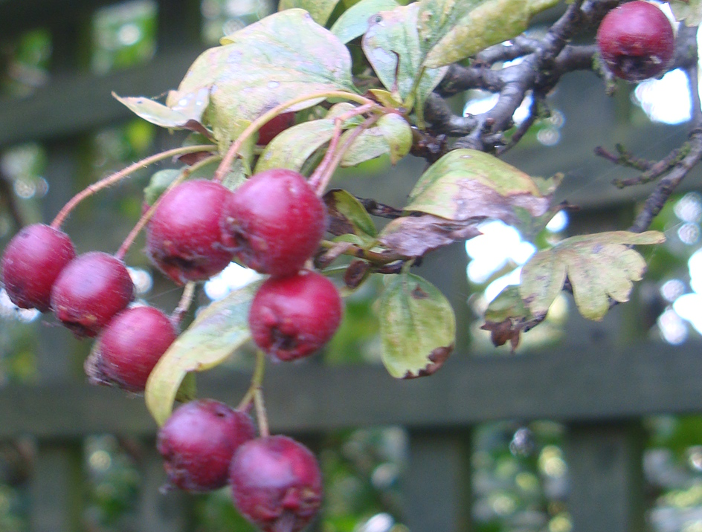

Remembering the Dead
Facing the Monsters
Becoming a Phoenix
Making Peace
Beginnings and Endings

Mission isn’t just about doing. It is also about discovering who we are before God and finding out more about our faith and the gifts we have to share with others.

Prayer and reflection shape and form our spiritual lives. For the period which ends the Christian year, in November just before Advent, which is sometimes called the ‘Kingdom’ season, we offer five resources which touch on matters of death and life; hatred and forgiveness; hope and possibility; peace and reconciliation; and how we shape a vision in Christ the King for the future of us all. Remembrance Day falls in November so these resources offer ways to think about those who have died as well as celebrate and prepare for wonderful new beginnings. To have a heart for mission requires that we learn from the past and from those who have gone before us, so that we can look forward in hope to the sharing of faith and to the coming of God’s Kingdom.

You can use these resources individually or in groups and you can choose which ones you want to use for reflection. The first is perhaps most appropriate for All Saints and All Souls and the last more appropriate for Christ the King at the end of the Christian year before the start of Advent, but it is up to you how many of the resources you want to use and when you want to use them.

Each resource offers a reflection to think about, discussion questions, a passage of Scripture and a time of prayer. Above all, the resources ask you to imagine what kinds of things trap us in negative situations, thoughts, feelings and emotions, and what in our faith enables freedom, hope and joy. When we arrive at the feast of Christ the King, and look forward to a new Christian year with its anticipation of the birth of Jesus Christ as good news for all, we arrive at the place where that hope and joy is to be found.

But what will you do with it then?

More resources:

www.bbc.co.uk/religion/religions/christianity/holydays/allsaints_1.shtml

1: Remembering the Dead (All Saints/All Souls)

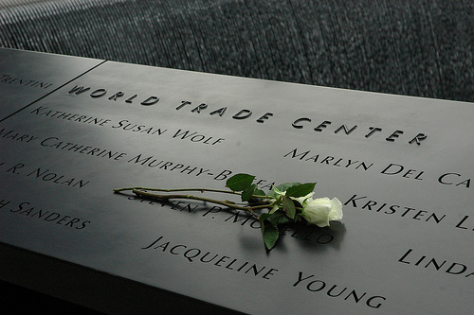

Photo: Tom Hannigan

Reflection

On September 11th 2001, four aircraft were hijacked and two of them deliberately flown into the twin towers of the World Trade Center, causing both buildings to collapse. Another plane was flown into the Pentagon and yet another crashed. Almost 3000 people died in the attacks. Many of the people who died left no trace of their bodies; the fire and the collapse of the buildings vaporised or crushed them so that they could not be recovered.

Everyone knows the basic facts about 9/11 and about its political aftermath, but the magnitude of another question is perhaps not so appreciated, - how do you commemorate an event like this; how do you remember so many dead people? Even more important, how do you create a memorial which will enable the dead to be remembered as once living, breathing, loved, human beings, when perhaps nothing of their earthly bodies remains to bury? And further, what part can such a memorial play in enabling us to move forward, not trapped by thoughts of vengeance, hatred or despair, but in the liberation of hope and expectation?

Food for thought or for group discussion:
Suppose it was your job to plan such a memorial, what would you do?

The memorial to the people who died in the 9/11 attacks which is called Reflecting Absence is laid out as a pair of reflecting pools around the sites of north and south towers, but unlike most war memorials (such as the ones you see in churches, or in town centres) which usually list names alphabetically, the names are laid out with careful thought as to their arrangement. The names are organised so that they are grouped with those they were with when they died; they are arranged as communities, rather than just individuals. This reminds us that bonds of human contact - being work colleagues, working as a team of fire-fighters, or even sitting next to someone you don’t know on a plane, - create relationships which are meaningful. The President of the Memorial, Joe Daniels, said ‘what matters most is the relationships that were had in life rather than just how these people died.’ The sheer number of dead should not become an ‘abstraction’ but resolve into real people who are mourned by the families and friends they loved and who loved them.

The names are also not carved into stone but the letters are cut outs, set in a piece of bronze, so that they cannot weather or fade and at night, the cut out letters are illuminated so that the names of the dead shine out into the night. The darkness does not overshadow them or take them away. The absent is made present.

https://www.911memorial.org/learn/resources

But there are also those who find the memorial less liberating. For example, one person wrote that they did not find the memorial either moving or sacred enough.

Food for thought or group discussion:

What do you think has to be present (or absent) for a memorial for someone you love to be ‘sacred enough’?

Exploring Scripture

Mark 12.26-27

26 Now about the dead rising – have you not read in the Book of Moses, in the account of the burning bush, how God said to him, “I am the God of Abraham, the God of Isaac, and the God of Jacob”? 27 He is not the God of the dead, but of the living. You are badly mistaken!’

Food for thought or for group discussion
What do you think Jesus meant by saying that God is a God of the living? How do we reflect that in the way we commemorate the dead?

Prayer

Lord of the living and the dead,
All creation is present to you
And you call each of us by name.
Today we recall to you,
in letters of blazing light,
all those whose love we miss,
whose lives are ended
but whom we entrust
to your eternal, reconciling love.
Amen.

If you are going on to the next resource you might want to start thinking about this: where (if anywhere) do you think the names of the 9/11 hijackers should be included?

2: Facing the Monsters

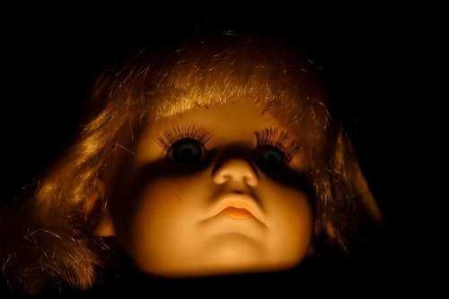

Photo: Paul Everett

Reflection

The names of the 19 hijackers are not included in the 9/11 memorial and had they been it is likely that those names would have been attacked and defaced. Yet those people also died and left their families behind. The fact of their deaths does not go away, and raises the question: how, as Christians, do we deal with ‘monsters’? How do we also think about those who commit atrocities, including, in our own country, child-killers such as Ian Huntley, Ian Brady Fred and Rosemary West, or Mark Bridger? How do we pray for suicide bombers?

Such people are monsters to us because they can harm us and our children. We are frightened by people that want to hurt us or will hurt us if we don’t do what they want. Any horror movie will make that very clear. But we also fear monsters that want to do other harm than just hurt or kill us. There are monsters who want to steal our possessions or hack our computers and steal our identities; monsters who might accuse us of something we didn’t do and take us to court; monsters who prey on our vulnerability to exploit us; monsters who make promises of employment and shelter and sell us into slavery. When we read about such things in the newspapers or see them on TV they cause us fear.

Food for thought or for group discussion
What monsters do you most fear?

‘Monster’ is a word tabloid newspapers often reserve for people convicted of terrible crimes. When such a crime occurs newspapers stop at nothing to convince us of their monstrosity. Andrew Brown, writing in the Church Times (22/11/02 p 12) commented on the tone of theological certainty when newspapers write lurid headlines like ‘Go to HELL’ when violent criminals are sentenced or when they die. He also commented on the way the papers give their readers what they want: ‘the promise of eternal torment for someone else’.

Monsters arise from our fear and what we want is to be sure that those monsters are locked away from us and from our children, not just in this world, but in the next. We want monsters to go to prison, where we can’t see them or know about them, and we want monsters to go to hell, where we won’t meet them. Our freedom and salvation necessitates their entrapment and punishment.

But what if these people repent?

In the film Con Air, an evil child murderer escapes and is seen entering the home of a little girl. She invites him to play with her. They have tea and they sing ‘He’s got the whole world in his hands’. We see the killer leaving alone and later....we see that the girl is still alive and undisturbed. What has happened? What has changed? In the film, we see at the end that the killer stays free. He has another chance. But would you have trusted him with your child?

Food for thought or question for group discussion
There are monsters, such as Herod, in the story of Jesus too. How do you think the November season prepares Christians to live in a world where some monsters have great power and can do great evil?

Something to watch: Longford (Channel 4 film)

Exploring Scripture

Revelation 20: 11-15
11 Then I saw a great white throne and him who was seated on it. The earth and the heavens fled from his presence, and there was no place for them. 12 And I saw the dead, great and small, standing before the throne, and books were opened. Another book was opened, which is the book of life. The dead were judged according to what they had done as recorded in the books. 13 The sea gave up the dead that were in it, and death and Hades gave up the dead that were in them, and each person was judged according to what they had done. 14 Then death and Hades were thrown into the lake of fire. The lake of fire is the second death. 15 Anyone whose name was not found written in the book of life was thrown into the lake of fire.

Food for thought or for group discussion
Suppose you had to record in the book what the 9/11 hijackers had done – what would you write?

Prayer

For those harmed by monsters

God of earth and heaven,

You are the God of the lost and broken,
You are the God of the murdered, the stolen, the tortured, the disappeared.
You know the resting places of all your children,
Each bone is known to you
Each broken hope is gathered up by you.
In you alone is all restored, all found.

Our Father in Heaven,
Even as your son our Lord Jesus Christ,
Was lost to you and broken on the cross,
So in his resurrection we find again,
The vanished ones who have broken our hearts.

Amen

For the monsters

God of earth and heaven,

You are the God of the outcast and the sinner,
You are the God who grieves for the murderer, the thief, the torturer, the evil doer.
You know the deeds of all our hearts,
Each act is known to you,
Each story of pain and hate is gathered up by you.
In you alone the true face of those turned away is found.

Our Father in Heaven,
Even as your Son our Lord Jesus Christ
Went to the wicked, the spurned, the hated, the insane,
So in his resurrection we find again,
The ones we cannot love with our hardened hearts.

Forgive them Lord
Forgive us Lord.

Amen.

If you are going on to the next resource you might want to start thinking about this: how would you offer hope to a monster?
3: Becoming a Phoenix

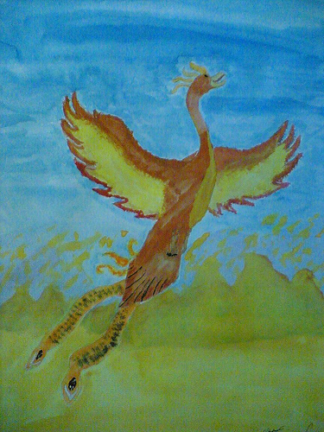
Photo and painting: Darren Cox

Reflection

In legend, the Phoenix was a bird which lived, grew old, burst into flame when it died and then was reborn from the ashes of its burned body. In the Harry Potter stories of J K Rowling, Professor Dumbledore is strongly identified with his pet phoenix, Fawkes, and Dumbledore himself dies, is buried amidst flames and is encountered again, alive, beyond the grave. In Christian tradition, the phoenix also became a symbol for Christ, dying and rising. Dumbledore sacrifices himself to save others from evil and Fawkes the phoenix heals mortal wounds through his tears.

In Christian tradition, the phoenix has been a powerful symbol of healing, reconciliation and the victory of life over death. But what does that mean for us? Is it possible to experience the liberation of becoming a phoenix or enabling others to do so?

What we may call the ‘phoenix experience’ is often a significant part of a person’s spiritual journey. Christians may experience a sense of being raised up at the moment of their conversion, baptism and/or confirmation as new faith creates a transformed life and freedom from an old way of living. For others, the phoenix experience may come after recovery from illness, perhaps when years of suffering and increasing disability are transformed by donated organs, replaced joints, or new medication or medical techniques. The phoenix experience can come out of a new relationship after heartbreak, or a new job or the birth of a baby. Even a much needed holiday or a few days’ retreat can lead to the sense of renewal that is not just mental and physical, but spiritual as well.

Food for thought or for group discussion
What sort of phoenix experiences have you had which offered transformation, renewal and new hope? Where might you look for such an experience?

However, many people in our society today feel that their lives are burning up and turning to ash: those who are struggling to find employment; those who are trying to make ends meet on very little money; those who are coping with cuts to their benefit or trying to exist on a small pension. For many people too, the dreams and ambitions of a bright future have been dashed: getting a degree may not help you get the job you wanted; or the expectations that your children would have a better or easier life than you have disappeared. What does it take to become a phoenix? In the wider world too, so many people who expected to live out their lives in their communities, practising their faith, going to school, raising families, have found themselves facing displacement, becoming refugees, watching their villages and places of worship broken into ruins by war and weapons.

Yet if we believe in the power and love of Jesus Christ, we believe that it is possible to rise from the ashes and indeed that we must help others to do so. Becoming a phoenix is based on hope and help, a spiritual promise and practical aid.

Food for thought or group discussion:
Who are the people in your community who help others rise from the ashes? What could you or your church do to help them?

Exploring Scripture

Luke 10. 30-37
30 In reply Jesus said: ‘A man was going down from Jerusalem to Jericho, when he was attacked by robbers. They stripped him of his clothes, beat him and went away, leaving him half-dead. 31 A priest happened to be going down the same road, and when he saw the man, he passed by on the other side. 32 So too, a Levite, when he came to the place and saw him, passed by on the other side. 33 But a Samaritan, as he travelled, came where the man was; and when he saw him, he took pity on him. 34 He went to him and bandaged his wounds, pouring on oil and wine. Then he put the man on his own donkey, brought him to an inn and took care of him. 35 The next day he took out two denarii and gave them to the innkeeper. “Look after him,” he said, “and when I return, I will reimburse you for any extra expense you may have.”
36 ‘Which of these three do you think was a neighbour to the man who fell into the hands of robbers?’
37 The expert in the law replied, ‘The one who had mercy on him.’
Jesus told him, ‘Go and do likewise.’

Food for thought or for group discussion
What does being a good neighbour mean to you?

Prayer

Lord, Jesus Christ,

You have been crucified and have risen;
You have overcome suffering and death.

We pray for all those who lives are in cinders,
Whether through age, illness, injustice or poverty.

Help us to reach into the place of ashes,
And find the new life nestling within.

Help us rekindle the hope of the fallen,
and bring warmth and healing through your saving love.

Amen.

If you are going on to the next resource you might want to start thinking about this: what part does reconciliation play in the phoenix experience?
4: Being at Peace

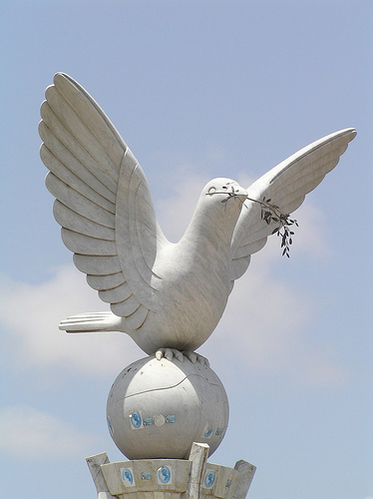

Photo: Jeff Attaway

Reflection

For many years, Estonia lived under Soviet rule. But in 1989, Estonians began a ‘Singing Revolution’ singing on street corners about their country and their hope. Mass singing demonstrations included both national songs and hymns which had been forbidden by the Soviets. As a result of this, they gained in confidence and began to feel that they could stand up against the oppressiveness of the Soviet regime.

In Advent, there is a ceremonial lighting of the Christmas tree in the town squares. This Christmas tree ritual has been enacted for centuries, apart from during the years of Soviet occupation. The lit candle is at the bottom of the tree and people come and light their own candles from it and take the flames away with them. The living flame in the tree was symbolically significant as the days got shorter and light became more and more important. Homes and shops displayed the living flames, - and this showed that they had not been taken over by the night.
This act of keeping the flame alive took on a new significance in the 1990s as Estonia got its independence although the Soviet army did not leave Estonia until 1994 after which it was free. So the lights also came to celebrate the freedom when the last of the old regime left. An old tradition became a new one, though both showed that this was a time of hope. Light also became equated with hope in people’s homes. So the hope of Advent became the hope and celebration of freedom. This tremendously powerful symbol motivated and inspired people, - yet Estonia is not a specifically religious country. During the occupation pastors and other Christians were killed. Yet now religious freedom and liberation from occupation went together, linked in a secular way. This reminds us to consider how traditions speak to each other and can create a powerful and moving dialogue between them.

Pause for thought, or for group discussion:
What symbols of speak to secular traditions in your family or community in the run up to Advent and to Christmas?

Eddie’s story

Eddie came to Britain from Estonia with his family during the Second World War and became a gardener, tidying up people’s flower beds and mowing lawns. Whenever Eddie was found working on a flowerbed, you could hear him muttering under his breath. When he was asked what he was talking about to himself, Eddy said that every weed he pulled from the border was one of the occupying forces and that by ‘pulling them out’ he was allowing the ‘Estonian’ flowers to breathe and reveal their beauty. When Estonia became independent, Eddy continued to weed people’s borders with his customary vigour. But now he sang.

Pause for thought, or for group discussion:
If you had been Eddie’s employer how would you have gone about learning his story? What would his song have meant to you?

Exploring Scripture

Matthew 5.14-16
14 ‘You are the light of the world. A town built on a hill cannot be hidden. 15 Neither do people light a lamp and put it under a bowl. Instead they put it on its stand, and it gives light to everyone in the house. 16 In the same way, let your light shine before others, that they may see your good deeds and glorify your Father in heaven.

Food for thought or for group discussion
Where are the lights of hope in your community? Are there any lights which are being hidden, which need to be revealed?

Prayer

Lord of light and darkness,

We thank you for the lights of faithful people,
both secular and sacred.

We thank you for the power and gift of song
and for the words and music of hope and freedom.

Help us always to seek to keep flames of love alive
for all who live under occupation or oppression.

Help us always to listen for songs of liberation
and to join our voices to those who stand against injustice.

We thank you for the gift of being at peace
and pray for all nations where the gift is not yet given.

Amen

If you are going on to the next resource you might want to start thinking about this: where do you see hope for the future?
5. Christ the King: Endings and Beginnings

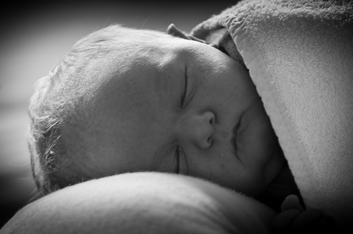

Photo: Jan de Graaf

Reflection

Saul, by Rosemary Kay, is the story of a baby born prematurely at 23 weeks. He survives against all odds and in the face of terrible struggle until, just before his term date, he gets meningitis and dies. This true story is fictionalised by his mother so that it is told in the first person, which gives his short life meaning and purpose, but also does more. Saul’s life is the story of each one of us from birth to death. He was meant to be born perfect, but he wasn’t. He wasn’t born in the fullness of time, but prematurely, before the Good Time. He has a memory of perfection, but his struggles take him further and further away from it. Yet through it all he knows there is a good story to live by. He is guided by the knowledge of a greater and more wonderful reality, which he experiences after his death. As we journey with him in the face of his terrible suffering we discover with him that his life, which is full of pain and misfortune, is transfigured by love.

Food for thought, or for group discussion
What happens when the future turns out to be very different from the one you anticipated? Where do you find meaning and new hope?

Towards the end of his life, Saul learns to hate the nurses, doctors and endless procedures which cause him pain. In order to protect himself in his helplessness and vulnerability, he becomes remote, hard and filled with hatred. But he can’t stay that way:

‘We all laughed and the laughing made something go crack! Inside me. It was the hard feelings starting to crack open....And soon, I couldn’t stop myself from dancing....I couldn’t stay stiff and angry. How could I?...

...There was no more hate. Instead I started to glow. The mean, hard feelings melted and left a great shaft of happiness, all fresh and clean.’ p. 270-272; 282.

Saul’s story reminds us that there has to be a time when hating turns to dancing. The time of reconciliation is when the energy that has to be put into hating is used instead for love and joy. Reconciliation in this life is when the hating turns to dancing.

This is echoed in words from St Anselm on the conception of Jesus:

Blessed Lady, sky and stars, earth and rivers, day and night – everything that is subject to the power or use of man – rejoice that through you they are in some sense restored to their lost beauty and are endowed with inexpressible new grace. All creatures were dead, as it were, useless for men or for the praise of God, who made them. The world, contrary to its true destiny, was corrupted and tainted by the acts of men who served idols. Now all creation has been restored to life and rejoices that it is controlled and given splendour by men who believe in God. The universe rejoices with new and indefinable loveliness. Not only does it feel the unseen presence of God himself, its Creator, it sees him openly, working and making it holy. These great blessings spring from the blessed fruit of Mary’s womb. Through the fullness of the grace that was given you, dead things rejoice in their freedom, and those in heaven are glad to be made new. Through the Son who was the glorious fruit of your virgin womb, just souls who died before his life-giving death rejoice as they are freed from captivity, and the angels are glad at the restoration of their shattered domain. Lady, full and overflowing with grace, all creation receives new life from your abundance.

Food for thought or for group discussion
The run up to Christmas is a time of tension and difficulty for many families. What can we do to help people make their Christmas a time of dancing, not hating?

Exploring Scripture

2. Cor 5. 16-21
16 So from now on we regard no one from a worldly point of view. Though we once regarded Christ in this way, we do so no longer. 17 Therefore, if anyone is in Christ, the new creation has come: the old has gone, the new is here! 18 All this is from God, who reconciled us to himself through Christ and gave us the ministry of reconciliation: 19 that God was reconciling the world to himself in Christ, not counting people’s sins against them. And he has committed to us the message of reconciliation. 20 We are therefore Christ’s ambassadors, as though God were making his appeal through us. We implore you on Christ’s behalf: be reconciled to God. 21 God made him who had no sin to be sin for us, so that in him we might become the righteousness of God.

Food for thought, or for group discussion
Where, in this time of preparation, will you be the ambassadors of Christ the King? Where will you hope to see a ‘new creation’?

Prayer

Lord,
Each life is a departure
A train leaving a station
A journey from your door
Help us to know our destination
Our place of final alighting
And to make the most of the journey
Using whatever we have to take with us
To make sense of where we have to go
The place where you await us

Lord,
Deliver us from apathy,
Blankness, detachment,
A turning away.
Help us to help those
Who have fallen into despair
Whose lives are full of leavings
Endings but no beginnings.

Lord
Help us to see the vision
Of your face in each face
We meet on every street
Use us, our hands and eyes and lips
To lift others towards your prefected face
For you to gathering them in
To the time of dancing
You are the potter, Lord
We are the clay,
Remake us.

Amen

