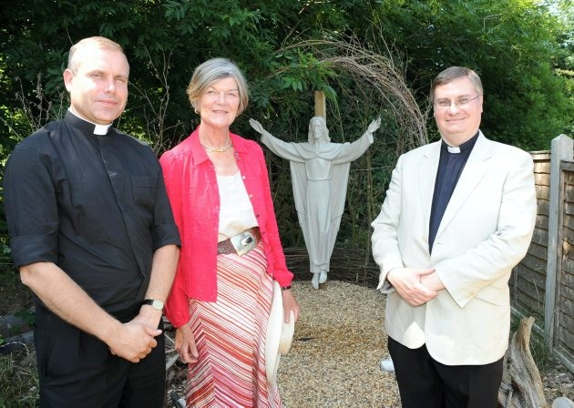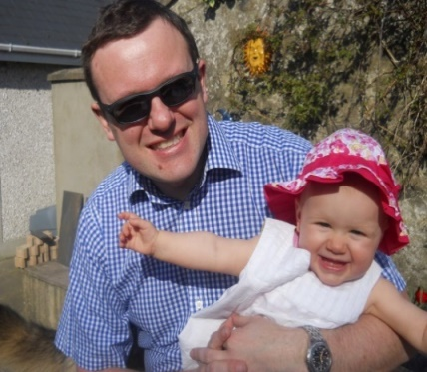MISSION THEOLOGY ADVISORY GROUP
A PARTNERSHIP BETWEEN THE CHURCH OF ENGLAND AND CHURCHES TOGETHER IN BRITAIN AND IRELAND
And Mission
Evangelism
Reconciliation
Theology
Spirituality

We provide materials on peace and reconciliation through our book Unreconciled? and through active peacemaking through our members in Calais
We provide mission theological thinking on current issues, including on Migrants Money Flooding Trafficking Food banks Lent and Advent

We provide resources for people searching for faith through our website Spiritual Journeys with more than 1000 things to explore, look, do, ask and dream
www.churchofengland.org/more/church-resources/deeper-god-mission-theology www.ctbi.org.uk/mission-theology-advisory-group-resources www.dispossessionproject.org www.facebook.com/missiontheologyadvisorygroup www.spiritualjourneys.org.uk

We specialise in mission in relation to social action, through The Dispossession Project, and in our work on social engagement and evangelism
Deeper into God.....

We are committed to appropriate and effective evangelism using our book Sense Making Faith and our work on five themes in the theology of evangelism

