FAITH AND LOVE IN THE FIRST WORLD WAR (REMEMBRANCE)
Mission Theology and Apologetics Group

Table of Contents

Faith and Love in the First World War 4
Introduction 4
Mud 6
Rats 8
Lice 10
Poppies 12
Cigarettes 16
Daughters 20
Ghosts 22
Guns 25
Wire 27
Gas 29
Shrapnel 31

The Mission Theology and Apologetics Group is an ecumenical group formed in partnership between Churches Together in Britain and Ireland and the Church of England



We provide resources in the areas of Spirituality, Theology, Reconciliation, Evangelism, Apologetics and Mission

This resource belongs to our Reconciliation series. Please print and share.

Faith and Love in the First World War

Introduction

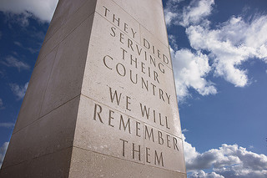
Photo: Ian Britton
No one who fought in the First World War remains alive today to tell us what it was like. Popular TV shows such as Downton Abbey sometimes feature scenes of new, intense forms of warfare: trenches and tunnels, explosive shells, the injuries and horror of being gassed, but for most people today, that war is buried deep in history books and passed-on memories from lost generations. Since then so many wars, so much cruelty and inhumanity, and worse weapons, have decimated our peoples and our planet.
Yet we still remember the Armistice at 11am on 11th November. The Armistice which brought the First World War to an end. It is still a significant and poignant moment.
In the reflections and prayers which follow, we look at little things which affected the lives of all who were involved, friend and enemy alike; little things which nonetheless are spiritual matters, asking questions about God in the midst of warfare. What was it like to have lice in your clothes, or mud in your boots? What was it like to live in a smashed landscape full of barbed wire? What was it like to stay at home imagining what was happening and have to carry on living without perhaps ever knowing what happened to your loved ones?
In what follows we will not look at the big, overarching questions of warfare but at its underbelly, at the simple human concerns which were present then and present now in the conflicts which continue to break our hearts around the globe. Where is God in this? In our reflections we will reach down into those dark, little known places and try to find out.
One of the people whose recollections we have followed is perhaps not as well known in this country as our own war poets and chroniclers. Frederic-Louis Sauser, known as Blaise Cendrars, a writer of Swiss-Scottish parentage who lost his right arm in the First World War, wrote a book called La Main Coupée, published in English under the title Lice. In that memoir Cendrars remembers friends and comrades, but also openly wonders whether God could be found in those horrific circumstances. Recalling with pity and despair the death of a man who suffocated upside down in a latrine, Cendrars says bitterly, ‘God is absent from the battlefields. He is keeping his nose clean. He is hiding. It is a disgrace.’
Yet the question of where God is matters. Cendrars documents the way spirituality springs up perpetually in the trenches: why it is necessary to go to great lengths to recover a friend’s blown-off moustache and bury it; how ordinary objects become spiritualised; how letters from home become angelic messages. He himself spent thirty days in jail for taken forbidden photographs of the destruction of a roadside shrine. The final horrific memory, documented in Lice, is the incessant calling of dying young men for their mothers, to which Cendrars responds with ‘Why died I not from the womb? Why did I not give up the ghost when I came out of the belly? Why did the knees prevent me? Or why the breasts that I should suck?’ (Job 3.11-12). Cendrars, along with all those who passed on their experiences, directs us to the effects of war on the spiritual being through the little things, and offers us insights for reflection.
In the first four reflections: Mud; Rats; Lice; and Poppies, we look at some aspects of the human body and the natural world and what these meant to the spiritual lives of the men of the First World War. After this, we look at people, living and dead. Finally, we reflect on weapons and wounds.

Mud

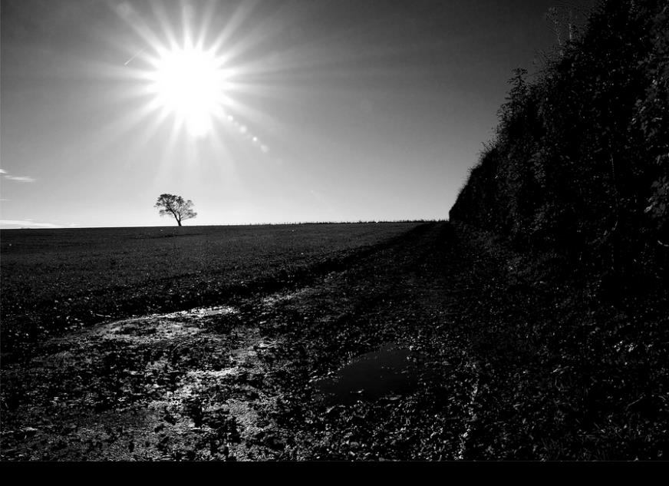
Photo: Janet Ramsden
‘I contemplated this livid dawn, slowly disrobing in the mud. Nothing in this whole miserable, dripping, ravaged and tattered landscape was solid, and I myself stood there like a beggar at the threshold of the world, soaked to the skin, slimy, plastered with shit from head to toe...’
When we repeat the lines from Laurence Binyon’s famous poem For the Fallen, ‘at the going down of the sun and in the morning/we will remember them’ we perhaps do not remember the conditions of the stand-to which Cendrars recalls so vividly. The First World War was the first to include extensive trench warfare. For the men going to the trenches, one of the biggest features of ordinary life was the presence of inescapable mud. If you cut twelve foot deep trenches in that earth, you hit water, and mud was the inevitable result, added to by rainfall. Additionally, prolonged shelling churned the ground between the trenches into mud and reduced no-man’s-land to a mass of ruined earth. Soldiers had to stand in the mud for hours on end, feeling it seep into their boots and clothes, until like Cendrars, they were soaked through and unable to get dry. This led to many soldiers suffering from ‘trench foot’, with gangrenous sores developing as a result of prolonged exposure to damp. The writer and artist David Jones talked vividly in his own war memoir about the way the ‘fluid mud is icily discomforting that circles your thighs’.
So if we remember them, perhaps we should remember the pain, cold, wet and mud and what those conditions do to the human spirit. Mud forms part of the spiritual landscape of the First World War, representing destruction, dirt, pain and soul-sapping work. When carefully tilled fields and entire landscapes turn to featureless mud it is like the undoing of creation and a foretelling of death.
It was possible to drown in the mud of no-man’s land. If wounded soldier fell into the mud, they might well asphyxiate before they could be reached. Mud was therefore also the enemy, lying in wait to claim you. Yet mud was also what kept you safe in the trenches, the moving of tons and tons of damp soil to create a maze of earthworks that were your best protection against bombardment. Mud offered soldiers a different soundscape, as bullets, grenades and shells buzzed, plopped and burst into the sodden and churned ground and became memories that could not be explained adequately if they had not been shared.
So if we ‘will remember them’ we should remember what it is like to live on the edge of life and death in the mud, the soil of God’s good creation, sheltering you, but also ready at a moment’s notice to become your tomb, to turn you, wet and dirty, back into the mud itself.

Prayer
God of the earth, God of dirt and mud, at the going down of the sun and in the morning, we will remember all those who endured the cold, clinging wet and fluid soils.
We will remember the tilled fields once white for harvest, the stands of trees, smashed to pieces, the landscapes of human toil and habitation, reduced to ruin, the spoil heaps of waste.
We will remember the mud-sounds of war, the buzzing of bees that are bullets, zinging into soil, the wet explosions, fountain splatters of earth, the strange sucking and gurgle of submerged deaths.
God of the earth, God of the lost and buried, help us to value your good soil, to tend it, plant it, restore what is broken and ruined to its beauty, and when we wash the dirt from our hands, remember them.

Rats


Photo: Sonia Pauen

‘Droll rat, they would shoot you if they knew Your cosmopolitan sympathies’
Isaac Rosenberg, Break of Day in the Trenches
'Cuinchy was one of the worst places for rats. They came up from the canal and fed on the many corpses and multiplied. When I was here with the Welsh a new officer came to the company, and, as a token of welcome, he was given a dug-out containing a spring-bed. When he turned in that night he heard a scuffling, shone his torch on the bed, and there were two rats on his blankets tussling for possession of a severed hand. This was thought a great joke.’
Rats were ubiquitous in the trenches, attracted by scraps of food left in the litter of discarded food cans and by the presence of corpses. For some soldiers, the rats were a sign of life going on untroubled by human affairs. As Isaac Rosenberg noted, they could happily pass from the British to the German trenches across no man’s land, scavenging in places where humans would lose their lives. There were some accounts of soldiers taming individual rats, feeding them and caring for them as pets. Some of the rats grew very bold and would enter the trenches to filch food from under the noses of the soldiers or out of their pockets. There was an indestructability about them and they also grew in huge numbers since soldiers were not allowed to waste ammunition on killing them.
Yet for very many soldiers rats were not just vermin but nightmarish creatures, a product of the squalor and unsanitary conditions. The idea of rats eating the bodies of fallen comrades aroused feelings of disgust and horror. So rats, breeding in huge numbers and swarming around the trenches became part of a spiritual distress at the way friends and comrades met their end. Some soldiers relieved feelings of frustration and boredom by baiting bayonets and trying to kill the rats, even though it was a futile exercise. Ferrets and terriers were also introduced to try and keep the creatures’ numbers down.
How does a person cope with living among millions of rats? Rats which will consume your body if you die, or are too wounded to fight them off, rats which are, in effect, waiting to eat you? What would you do, be glad of their life and vigour or be filled with disgust and want to kill them? Are the overflowing rats of the trenches and no-mans-land gifts of creation or harbingers of hell? Both reactions are part of the spirituality of warfare and show us something about our inner selves.

Prayer
God of all creatures, we remember the rats that infested the trenches, we remember that war breeds opportunity. We remember too those who lived among them, themselves like rats fighting for survival.
Amen

Lice


Photo by roujo
Blaise Cendrars tells the story of one of his friends, Rossi, swearing and cursing as he hunted out the lice which infested his clothes.
‘Then you could see him undressing, inspecting the seams of his pants or the folds of his belly, and you could hear him swearing with rage when he crushed a whole colony of lice and larvae in the placket of his trousers or shouting with triumph when he succeeding in nicking out a crab from his pubic hair. Then he would take up his letter again, keeping one eye on his underwear. What the hell could the poor sod write to his wife or sweetheart, in conditions like these, except poetry?’
The close proximity of soldiers in the trenches meant that there was no escaping the transmission of body lice. In conditions where it was difficult to wash properly or get clothes clean, lice lived easily in the seams of clothing and hatched into fresh colonies, despite the best efforts of the men to keep them at bay. Soldiers attempted to destroy them by running a candle flame along the seams, but no matter how hard they tried to get rid of them, the lice always came back. They also spread disease, causing trench fever and making men ill and miserable.
Cendrars however points us to two other important points about the lice which impact on the spiritual condition of the louse-infested men. First of all, Rossi wages his own private war against the lice. Unable to be sure whether he is able to make any difference in the larger war of which he is part, he is able to claim small victories over the lice attacking him. He cries out in triumph when he able to pluck out and kill the lice. In this way, the men were able to regain control over the small wars, to win little victories and so impose a kind of sense on the bigger, more incomprehensible war going on about them. Secondly, Cendrars makes an interesting observation when he says that Rossi could only write ‘poetry’ to his wife. The men would not detail the horrors of rats and lice in letters home, if you are going to spend time on a precious communication, you would write of higher human matters – love, reassurance, faith, promises.
This tells us something about the indomitability of the human spirit which will, if it can, find a way to rise above the senseless and seek to impose order and create beauty even in the midst of chaos.

Prayer
God of all that creeps upon the earth
We thank you for the human spirit, which chooses life over death, love over chaos, hope over catastrophe.
We thank you for the shared bonds of human friendship, the camaraderie which brought people together, the affection and love, the poetry of letters home.
Amen

Poppies

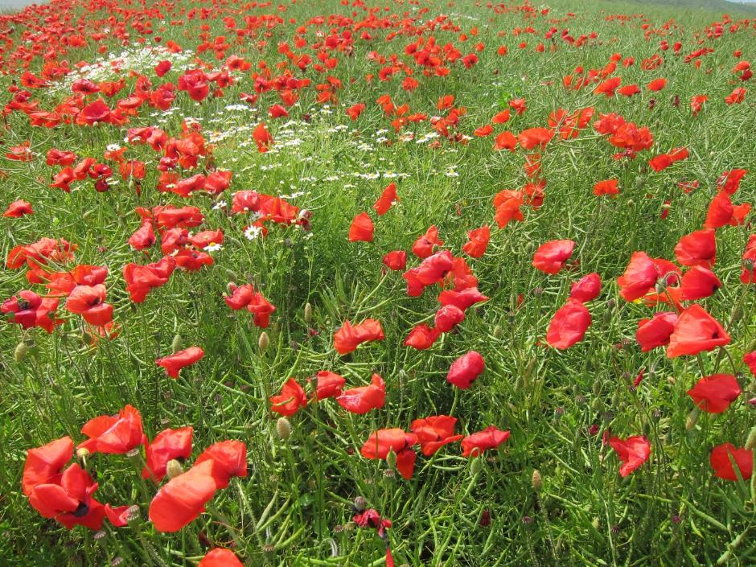

In 1916, a soldier, Private Cecil Roughton, picked a poppy from a front line trench on battleground at Arras and pressed it into a pocket notebook. That pressed poppy still survives, a direct link to that place of war and violence, where yet something beautiful endured. More significantly, it takes us to a person, who, in the midst of the business of war, could still be attracted by, and take trouble over, something that spoke of the unsullied beauty of God’s creation and kept it safe against the damage and destruction. What did it mean to him? Just a souvenir, a particular moment, a whim? Or was it an act of defiance, saying something about the triumph of the human spirit, the human being, refusing the dehumanising effects of warfare?
In the satirical comedy series Blackadder Goes Forth, the episodes poked fun at a group of men stationed in the trenches trying (and failing) to make sense of their situation and trying, by any means possible, not to get killed. Yet in the final episode, after the characters discuss their hopes and fears for the future, they are forced at last to go over the top. As the camera switches from the trench to view the men emerging, crying out and running across no man’s land amid fierce bombardment, their features blur and disappear, the shot turns into a quiet field of brilliant red poppies and the audience realises that despite their efforts, the characters are all dead. One reviewer called it ‘the most sobering ending of any war film ever done’. What was interesting about the reaction to the ending of this episode was the way the poppies, more than anything else, turned the comedy series into a serious reflection on the waste of life and the profound loss of gifted and unique human beings that war entails. Instead of laughing at the jokes, the audience mourned, taken into the reality and horror of war.
Why then has the poppy become such a powerful and enduring symbol of the First World War? And why does it carry such deep spiritual significance, enough to turn a comedy series into tears? Perhaps it is because it defeats the imagination to try and picture the carnage of the front line, the sheer scale of death and destruction, and our minds may baulk trying to inhabit what we did not experience, - but we can imagine a field of poppies, as if the dead were transmogrified into something we can get a handle on, and through which we can mourn.
For the poppy’s vivid red colour reminds us immediately of freshly spilled blood, and so recalls the death and injury that took place in those fields. The poppy’s petals are fragile and do not last very long and so the flowers come to represent the bodies of the soldiers lost on the battlefields. Poppies grew in abundance in the fields of war and so a field of poppies gives a sense of the sheer number of men lost, as though all those dead were given their own individual memorial where they fell. We have found significance in those famous lines of John McCrae ‘In Flanders fields the poppies blow/between the crosses, row on row’ placing in our minds the link between the dead and the living and enduring flowers which become their memorial. On Remembrance Day the poppy wreaths laid at war memorials conjure up those associations and so connect us with an unimaginable past.
On the centenary of the First World War, in 2014, there was created an installation in the Tower of London Moat called ‘Blood Swept Lands and Seas of Red’ , created by nearly 890,000 ceramic poppies to remember the British and colonial service personnel who died in the war. The last poppy was placed on Armistice Day, 11th November 2014. Nearly four million people had visited the Tower of London by that date prompting an extension of the hours of floodlighting to allow more people to see the exhibit. The sheer numbers flocking to see the poppies, some of whom left photographs and reminders of family members, showed the tremendous emotional and spiritual draw of the Tower’s moat flooded with poppies. The poppy will continue to evoke in us a sense of loss and a way of imagining all those sacrificed lives.
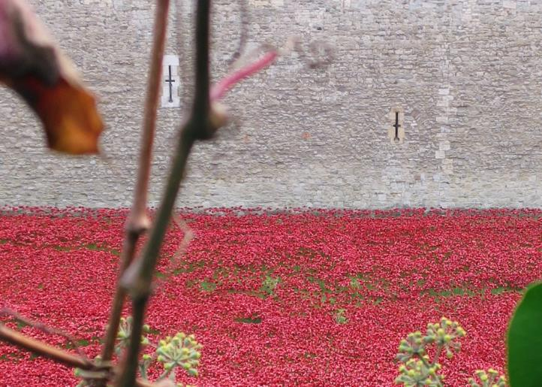

Prayer
Creator God,
You give each person the precious gift of life, yet in war so many gifts are broken or come to perish. Help us to look upon the poppies blowing in the fields and see through them to the loss of human beings, fathers, sons, husbands, brothers.
May we be thankful for our own gift of life remembering those whose lives were taken from them.
Amen

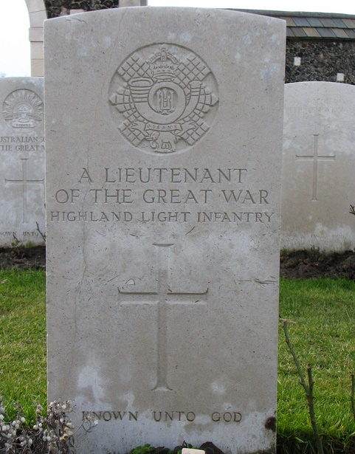

Photo by fdecomite
We look here at the spiritual issues involved in human relationships and at bonds of love and friendship and at loss.
There are four reflections on Cigarettes, Sons, Daughters and Ghosts.

Cigarettes

‘When there ain't no gal to kiss you,
And the postman seems to miss you,
And the fags have skipped an issue,
Carry on.’
Geoffrey Studdert Kennedy (‘Woodbine Willie’) The Spirit
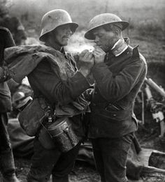

In a society which now well understands the dangers of smoking, it is easy to overlook the importance of cigarettes to the soldiers fighting in the First World War. Cigarettes brought calm to agitated men, stuck waiting around; they gave soldiers something to do and something to share. Cigarettes were currency but also easy and important gifts.
This was well understood by Geoffrey Studdert Kennedy (“Woodbine Willie”), a forces chaplain, who combined giving Woodbine cigarettes along with Bibles to soldiers leaving for the front. He said that his ministry was based on ‘a box of fags in your haversack, and a great deal of love in your heart’.
This tells us something important about the spirituality of the First World War. In a situation where the impact on the body was so extreme, afflicting people with cold, wet, noise, and stress, things which gave bodily comfort became sources of powerful restoration and hope. Similarly, smoking also helped soldiers deal with the boredom while they were waiting for orders. Lack of a ‘fag issue’ could sap the spirit and leave the men feeling bereft and irritable. So a cup of tea or a cigarette as acts of simple human kindness could help people cope and form important bonds of friendship and sharing. Cigarettes were commonly shared between several individuals, cupping it in their hands so that the burning tobacco would not show and give their position away. Soldiers also smoked pipes which concealed the tobacco and many other soldiers rolled their own from tobacco wrapped in thin cigarette papers. The tobacco was typically kept in tins to keep it dry. Soldiers who did not smoke before the war quickly took up smoking when deployed, so that it became an important act of solidarity and friendship.
As a Christian chaplain, Woodbine Willie understood that there was no pastoral care without recognising the spiritual needs of the body too. Woodbine Willie didn’t just give out cigarettes however. He was awarded the Military Cross for his bravery, searching for the wounded while under fire and helping and encouraging them back to the dressing stations. His way of witnessing to Christ was on one hand giving practical gifts, sharing his friendship, and on the other, sparing no thought for himself in helping those in need. After the war, on the basis of his experiences, he became a strong proponent of pacifism.
You can find out more about Woodbine Willie at https://www.bbc.co.uk/news/uk-england-25349294

Prayer
Loving God,
We remember with thanks the service of Woodbine Willie. We thank you for the comfort the soldiers found in tea and cigarettes, new rations, friendships.
We pray today for all our forces’ chaplains. We thank you for their care and Christian witness, their selfless love and dedicated service.
Amen
Sons
‘..the swift iron burning bee
Drained the wild honey of their youth’
Isaac Rosenberg, Dead Man’s Dump

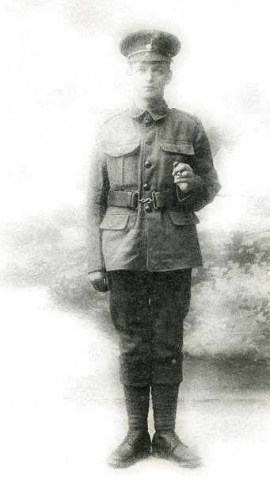
‘Reg’ Photo uploaded to Flickr by Tim Green; edited ARR.

Blaise Cendrars wrote that the ‘most frightful cry one can ever hear’ was the sound which came from the battlefield at night of mortally injured soldiers calling for their mothers. The sounds of those men calling for their mothers was so dreadful to the other soldiers that they would shoot at the sounds in the dark in the hope of silencing the suffering soldiers rather than have to go on listening to their pleas.
There is something in the cries of these wounded soldiers of the First World War about to die far from home, which plumbs the spiritual depths of a person’s being. Cendrars notes that they are ‘infantile’ voices; the wounded become children calling for the person who loves them, who will come to take care of them, heal them, wipe their tears. When all hope is gone and the dying person knows that they are alone and beyond help, then they strive to return to the place where they were last safe and in reach of comfort. That this would so unsettle the surviving soldiers is hardly surprising, stirring up a mixture of fear, loss, grief and compassion. How eerie and distressing those calls must have been and how terrible the suffering of those dying by inches in the dark.
This last appeal for help has been documented in other situations. Critically wounded soldiers call to their friends for immediate aid and to their mothers to bridge a deep spiritual void. What does this tell us? It tells us that in the desperation of war, when a person is dying, alone and lost, there is a deep need for return: return to one’s place of origin, return to a time of safety. But such cries are not necessarily just of despair and regression but might also be a final declaration of connection and love. It is not surprising then, that Scripture talks of a homecoming to a tender God who wipes the tears from the eyes of those who have died (Revelation 21.4).
We are told that from the cross, in his dying moments, Jesus believed himself abandoned by God. So we might imagine that in those cries from the battlefield we also hear the voice of Christ. And what the Christian story reveals is that those cries are not unheard. When the horrors of human destruction are over, Jesus returns to his friends to show that this is not the end. He says to them: ‘Peace be with you’ (John 20.19).

Prayer
God of love,
We remember all those in the First World War who died far from family and friends. We pray for all who cried out at their end and for all who heard their cries.
Today we pray for all who are parted from their families; all who feel abandoned and lost ; and for all who are making their way back to you.
Amen

Daughters


Photo: V H Hammer

‘But, though kind Time may many joys renew, There is one greatest joy I shall not know Again, because my heart for loss of You Was broken, long ago.’
Vera Brittain, Perhaps (to R.A.L)

A story from Anne Richards, convener of the Mission Theology and Apologetics Group, Church of England.
‘When I was a teenager, Auntie Jane was a well-known figure in the village where I lived. A pillar of the local Congregational church, she was often seen about on her bike or working on her allotment. She lived in a small, run-down cottage and lived frugally on her vegetables, ironing her skirts with an old flat iron warmed in front of the fire. I helped her knit endless squares for blankets for children in other countries while she sang warbly arias from The Messiah incessantly, and she once embarrassed me beyond measure when I went with her to a concert and she sang louder than the entire choir from her place in the audience(and horribly out of tune). Her contribution to ecumenism was to go to every other church’s bazaar, fete or concert and her inevitable conclusion was always “Very nice cup of tea. Not as good as ours, but very nice all the same”. Everyone thought she was an eccentric spinster, gone a bit daft from too much religion and living alone.
One day, she asked me to come by her cottage as she had something to give me. When I got there, amid much singing and talking to herself under her breath she reached under her simple little single bed and took out a worn suitcase. Inside the suitcase was a length of soft, shiny, faded and yellowed material, a bit frayed around the edges.
“What is it?” I asked.
“It’s parachute silk” she said. “I thought you might like it for your dress when you get married. I had hopes you know, so I kept it, but he didn’t come back, so...so...I don’t need it anymore.”
I was at once touched by the offered gift and embarrassed by its obvious uselessness. The silk was so damaged it was coming apart in her fingers even as she held it out. Yet it was clear that for a person who owned almost nothing she was offering me the most precious thing in her possession. But it was in that moment, holding the faded, frayed silk, I saw past her dotty old lady exterior to the young woman she had been, holding in her hands the soft, bright and precious material, full of hope. There had been a boyfriend, who could have been a fiancé, with a promised wedding at the church, a life together, children, and hopes of growing old with a companion. I asked her to tell me about it. As a teenager herself, she had been put to sewing the parachutes for people manning observation balloons. Her boyfriend was not allowed a parachute in his plane however, because they were felt to be too bulky and to tempting to use if the plane were hit. So the parachute under her bed had another kind of terrible poignancy.
Her boyfriend lost his life, - and she lost hers even though she survived. She had a life, a good life, a life of dedication and service, which the church nurtured and nourished and also consumed, but the war took from her one of her cherished futures.
Vera Brittain, (mother of British politician Baroness Shirley Williams) made an important contribution to the cause of pacifism. Yet she also lost her fiancé, to whom her poem Perhaps is dedicated, and never got over the death of her brother in the war, requesting that her own ashes be scattered finally on his grave.
We give thanks for the sons, husbands and fathers, who were lost, but we should give thanks and pray for the mothers and daughters like Auntie Jane and Vera Brittain who made different lives and worked for a better, more peaceful world, when theirs was shattered. Their broken hearts, their memories of other, hoped-for lives, in faded photographs and keepsakes kept under beds, should also be remembered.’
Prayer
God of the broken-hearted, you hold in your heart the tears of all who mourn. You know the evenings spent with photographs, with questions, the void of the missing and the dead.
We give thanks for those who go on living; their rebuilt lives, their acts of dedication. For those who nursed, dug, fed, and worked for peace, so that others should not suffer as they had done.
Help us to see beyond their smiling faces, and take from them the gifts entrusted to us. May we receive whatever is left unhealed until that final healing is found in you.

Ghosts

Whispers shall comfort us out of the dark-- Hands--ah God!--that we knew! Visions and voices --look and hark!-- Shall prove that the tale is true
Rudyard Kipling En-Dor


Photo: Matt Wilson

For many families, the household had said goodbye to fathers, brothers and sons and had maybe received a few communications through letters or postcards as the war progressed, then the letters stopped and nothing further was heard. Ever.
Many soldiers were not just killed but vaporised in an explosion or blown to so many bits that it was impossible to recover for sure anything that might have been an individual’s body. Blaise Cendrars tells the story of a soldier who was blown up by a shell when he was getting in a horse-drawn cab. His friends gathered up whatever bits they could find and buried the mixture of horse and human together. Eventually however, they also found his moustache, blood sticking it to a shop sign. So they recovered the moustache and buried that; the only part of ‘him’ they could really lay to rest.
So many who fought and died simply became ghosts for their families who had no real way to achieve closure or say goodbye. They could be almost certain that their loved ones were dead, but how and where they could not know. People felt guilty for moving on with their lives, or for remarrying. Unanswered questions and terrible imaginings of their loved-ones ends accompanied them into their future.
It is perhaps unsurprising that spiritualism rose in popularity, as those left behind turned to psychics and mediums to hold séances and give readings in which the silent missing and the dead were given voices and passed on messages of love and comfort to those grieving. Sometimes, the ‘spirit’ was said to have materialised in the darkened room and went about touching and stroking the bereaved. This continued despite some obviously fraudulent people offering services, as satirised in Kipling’s poem En-Dor. Grieving families seem to have gone to them even though they were well aware the people they were paying were frauds. They needed to have that sense of recovery and closure even if they actually knew it wasn’t real. Sometimes what people wanted was permission to move on, to form new relationships and to have the chance, any chance, to say goodbye.
This tells us how important to spirituality a funeral can be. Without a body or a ritual that allows the living to say goodbye it can be difficult to accept that a person’s life narrative is closed and so people will need to find ways to invent that closure. The ghosts of the First World War are not just ‘spirits’ or ‘remnants’ of those who have ‘passed over’ as the spiritualists might have it, but vessels of love and news and relationship that the living carried with them and had nowhere to put them down. And that asks us, as Christians, a question: what do we give people who have no sense of closure? Where do we offer people a place to lay down their precious vessels of love and longing?
Prayer
God of the grieving, we remember all those today who do not know what has happened to their loved ones who are certainly dead.
We give thanks that you know their unknown resting places, their unmarked graves. We pray for all those who struggle to accept their painful loss.
Help us to recognise what they carry: the final stories, news, the ‘sorry’ left unsaid; help us to find ways to love the grieving, relieve their burdens, set them free to live.

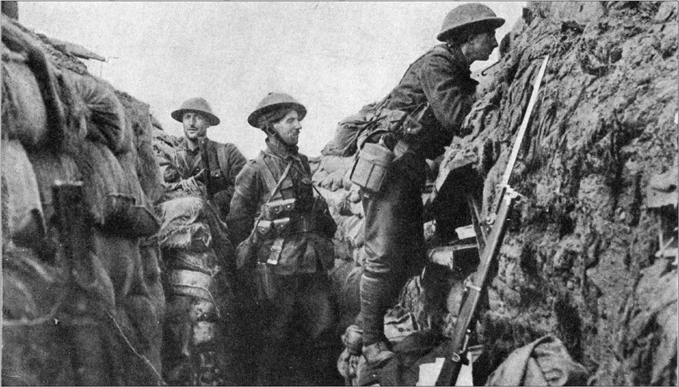

In the last set of reflections we look at the effects of munitions on spirituality. In addition to fighting hand to hand with guns and bayonets, or sniping from the trenches, soldiers were for the first time subjected to munitions which were optimised for the destruction of many people at once. Shells and gas could be released without those firing knowing how many they had killed or injured. Who or what was the enemy? A man who sought to kill you personally with his sniper rifle, or the metal object that randomly landed where you happened to be?
We will explore these issues and their effects on spirituality in Guns, Wire, Gas and Shrapnel.

Guns

‘And a bullet comes droning, whining by, To the heart of a sentry close to me.’
R B Marriott-Watson Kismet
Killed in action 1918
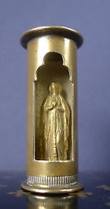

In 1917, a private soldier, William Hill, was shot during intense fighting. The bullet entered his left temple and exited at the other side of his skull. He collapsed and was taken to be dead. However, after he had been removed on a stretcher and left with a number of other corpses, he regained consciousness, got off the stretcher, and began to help other wounded, apparently unaware of the gaping wounds in his head. Not only did William Hill survive, but he appeared to have no serious injury. His friends, astonished by his luck, called him ‘Lazarus’.
William, however, did not believe it was luck. He believed that he had been saved for a purpose. Formerly uninterested in religion, he decided that he had in effect died and been raised to new life. After the war he became a minister and dedicated his life to the service of others. In his pocket, he carried the spent casing from a bullet. Whenever he met a new person, he would say ‘I’m William Hill, like the bookmaker, and I should be dead, but through Jesus Christ I am alive’. And he would show them the bullet and talk about his faith.
Such miracles of survival did sometimes happen. Blaise Cendrars tells of his friend Garnero, who was blown up, scalped by a shell and who had fallen into a catatonic state. Believing him dead, Cendrars laid him in a shell hole and covered him with earth. Years later, Cendrars met Garnero in Paris, to find him alive and well, though missing a leg. Another shell had exploded him out of his grave, blown off his leg and shocked him into life so that he was able to yell for help. Garnero, another ‘Lazarus’, recalled the rough tenderness and kindness shown at his ‘burial’. He noted too, that Cendrars had not escaped unscathed and now had only one arm.
One of the popular souvenirs from the First World War was a ‘pocket shrine’ made from the casing of a bullet. The inner part of the shell rotated to reveal, typically, a carved image of the Virgin Mary. Many soldiers tried in their own way to turn their firearms, the very embodiment of death and destruction, into ideas of life and salvation. Cendrars, his recollection shot through with irony, relates how his friend Goy was put on a charge for putting photos of his wife and daughter into his rifle butt: ‘A rifle butt, with its registered number, must not be transformed into a reliquary. It is sacrosanct.’
Yet what this tells us is that one of the ways in which soldiers asserted their humanity was through spirituality, even if they were not particularly devout. By carrying a deadly bullet transformed into the Mother of God, or placing a photo of a loved-one or a family, into rifle butt, showed a desire to assert what is good and true over the evil of death. The guns could not be stopped, but they might be transformed by small acts of human defiance, small acts which continued to say that God’s world had been made differently and the hope of that world still remained.

Prayer
God of Love,
We remember all those who carried guns and used them. We thank you for those who survived the bullets and mourn those who did not. We thank you for the determination of those who tried to make good things in the midst of evil.
May we work for reconciliation in your world, so that all who carry guns to war today, may have the chance to lay them down for good.
Amen

Wire

‘In the Royal Welch the barbed-wire entanglement was the responsibility of the company behind it. One of our first acts on taking over trenches was to inspect and repair it. We did a lot of work on the wire.’
Robert Graves, Goodbye to All That.

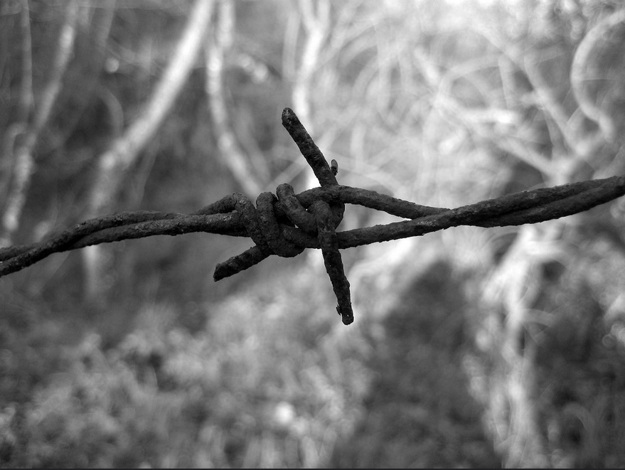
Photo by sunshinecity
‘Mind the wire’ resonates through David Jones’ First World War memoir In Parenthesis, as he recalled making his way through the maze of trenches with his friends. He was talking not just about barbed wire defences but telephone wire, the important means of communication. Wire was everywhere at any height and in the dark unbroken wires could knock or trip you over or broken pieces could snag on your clothing.
Barbed wire was both friend and foe and thousands of miles of it were employed as part of trench warfare. Barbed wire could be delivered in large coils and unrolled and erected quickly on posts as a defence for the trenches. Sometimes multiple lines or coiled entanglements of wire were put up and cups of stones hung on the wire which would jangle at any approach. Access points had to be very carefully defended. The wire then, was a defence against the unseen enemy coming towards the trenches at night, but it could also be an enemy if you were trying to get back from a sortie and got tangled in it. Once you were caught on it, panicking and pulling to escape might make it more and more impossible to do so. So soldiers had simultaneously to learn how to repair the wire and invent better ways of breaking or getting over it. On raids towards the German trenches, Blaise Cendrars remembers the zigzagging network of German wire and the fear that cutting the wire might sound an alarm or detonate a mine. Barbed wire then, was one of those strange elements of war that could be both friend and foe; it could save your life or end it. Soldiers were all issued with wire cutters, both to facilitate the endless repair that Graves recalls, but also to break through the wire as well. ‘You stretch out hands to Jerry-wire as if it were bramble-mesh’ wrote David Jones.
Another result of the miles and miles of war defences was that the wire became a gruesome gallery of death and decay as dead soldiers became impaled on it and sometimes decayed where they hung, irrecoverable, facing their friends with the grisly reality of their death. Cendrars recalls a ‘mummy’ entangled in the wire. It’s not surprising that one of the songs of the First World War carried the lines ‘If you want to find the old battalion/They’re hanging on the old barbed wire’.
Wire then, was another spiritual issue. It was a guardian of your life, but it could also contribute to your death. It could signal danger, but also betray you. It also confronted you with the possibility of your own death and spoke to your deepest distress about not being able to recover and bury the dead. It is not surprising that it entered the anxious voices of In Parenthesis or became part of a song. How else could you deal with it?
Prayer
Merciful God,
We remember all those whose lives were wound about by wire: mending, defending, cutting, breaking. We remember all those who lost their lives on the wire, those whose bodies hung there while their friends could do nothing.
We pray today for a world beyond barbed wire, for freedom from fear and anxiety, from the jangle in the night that announces the enemy. We pray this in the name of your Son who hung on a cross while his friends could do nothing.
Amen

Gas

Gas! Quick, boys! – An ecstasy of fumbling, Fitting the clumsy helmets just in time; But someone still was yelling out and stumbling, And flound'ring like a man in fire or lime
Wilfred Owen Dulce et Decorum Est
Killed in action 1918

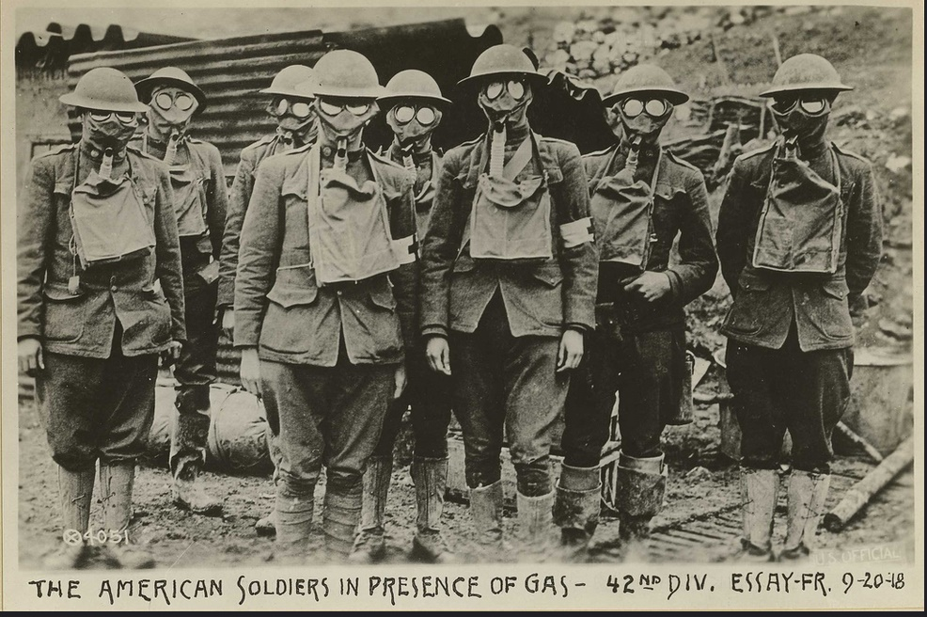

In the Preface to his war memoir, In Parenthesis, David Jones mused on the change from fighting hand to hand where you could, as it were, look into the eyes of your enemy, and ‘loosing poison from the sky’. He mused on all the lovely things human beings are capable of experiencing, and wondered what it meant that to all these experiences had to be added things like doing gas-drill.
Vera Brittain wrote: ‘I wish those people who talk about going on with this war whatever it costs could see the soldiers suffering from mustard gas poisoning. Great mustard-coloured blisters, blind eyes, all sticky and stuck together, always fighting for breath, with voices a mere whisper, saying that their throats are closing and they know they will choke.’
Gas was disabling rather than necessarily a killer, although sometimes soldiers died weeks after gas inhalation, their lungs already compromised from the insanitary conditions and smoking. Phosgene and chlorine gas were also used. So gas masks and drills were a necessary part of life at the front in an attempt to prevent injury through contact with the poison. However, gas was perhaps most effective in creating dread and fear in people who could see the slow moving clouds approaching and know that they could not avoid being enveloped in it. Unlike being ammunitions which would either hit you or miss you, the gas was all the more frightening for being pervasive and getting inside you, making it difficult to see, speak or breathe.
What does the reality of chemical weapons mean to us? As created beings are we perhaps more afraid of the idea of gas clouds and poisons entering us with the air we breathe than bullets or explosions? There is a psychological horror about gas that can profoundly affect us. What did the approaching gas mean to those who fought in the trenches and how, spiritually, did they cope with this strange, creeping enemy that could get into their eyes and lungs?
As David Jones noted, a world which requires human beings to do gas drill has moved a long way from God.

Prayer
Loving God,
We remember all those affected by gas in the First World War. We accept their horror and their pain.
We give thanks for all those who comforted and nursed the victims of gas attack, and for all who worked to provide gas masks and protectors.
We hold before you all who are victims of chemical warfare in our time. We pray for all those working to prevent such weapons.
Amen

Shrapnel

‘Tomorrow we return to the trenches. The men are pessimistic but cheerful. They all talk about getting a “cushy” one to send them back to “Blitey”. ....They look forward to a battle because that gives them more chance of a cushy one in the legs or arms than trench warfare.’
Robert Graves Goodbye to All That
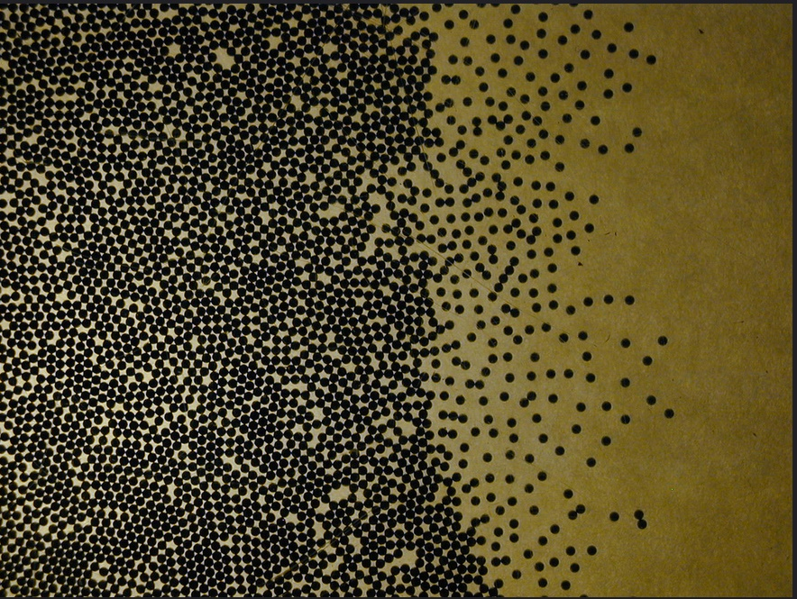
Photo by flikr
Shrapnel came from a hollow shell which was designed to explode above an enemy position, showering the men below with lead and steel balls. Another kind of explosive, the fragmentation shell, was designed to explode on impact and fragment into many pieces of damaging metal. Both kinds of shell were intended to cause maximum casualties for the fewest number of munitions.
Both kinds of explosive could kill, but many more soldiers were seriously injured by the shrapnel and fragments embedding themselves in their bodies. If you were really ‘lucky’ you might get a ‘Blighty one’ as Robert Graves records above, an injury which would send you home to recover, but not so devastating as to affect you permanently.
Shrapnel injuries caused not just disability but also disfigurement and these injuries were the drivers behind important advances in early plastic surgery and reconstruction techniques in medicine. Many soldiers suffered horrific injuries to the face and this required doctors and hospitals to investigate new ways of treating such damage so that ex-soldiers would again be able to see, hear, smell or eat. These kinds of injuries needed not only physical healing but also a way to come to terms with the spiritual issues associated with healing and wholeness.
But some people were also injured in such a way that the shrapnel or metal fragments could not be extracted and so the shrapnel became part of their daily existence and a permanent reminder of the war. In this way, shrapnel injuries became part of a person’s legacy and their spiritual development. To carry the evidence of war inside the body meant that it could not be left behind, only accommodated and hopefully transformed.
But there were also psychological and spiritual forms of shrapnel, not physical bits of metal but the trauma of the explosions and injuries resulting in ‘shell-shock’. Such shell-shock, which we would today call Post-Traumatic Stress Disorder (PTSD), would leave ex-soldiers with nightmares, flashbacks and feelings of dissociation or intense anxiety. David Jones remembers breaking down: ‘all gone to pieces and not pulling himself together not making the best of things’ and was himself affected by mental suffering after the war, unable in fact to write In Parenthesis until some years later. Some surviving ex-soldiers were not able to settle back into their home life afterwards or make sense of their experiences. Some people carrying this mental ‘shrapnel’ in their minds committed suicide.

Prayer
God of our healing,
We remember not just those who were killed in the First World War, but those who were injured and disfigured by shells and bombs. Especially we pray for those who broke down, those who ran away, those who were shell-shocked.
Today we pray too for all who bear in their bodies the marks of war. All those who carry shrapnel, all those suffering from PTSD.
We pray for all who work in health professions who seek to rehabilitate those hurt by war.
We pray that all those who carry shrapnel in their minds or bodies can be restored to health and wholeness.
Amen

Cendrars, B., (1946) La Main Coupée, (1973) English translation Lice, London, Peter Owen Ltd, p.149.
Cendrars p. 47
Jones, D., (1937) In Parenthesis, London, Faber, p.45.
Graves, R., (1929/1957) Goodbye to All That, London, Penguin, pp.116-117.
Cendrars, pp. 10-11.
http://www.imdb.com/title/tt0526712/reviews
J. K. Mozley, ed., G. A. Studdert Kennedy by his friends (1929). P 141.
Cendrars, B., (1946) La Main Coupée, (1973) English translation Lice, London, Peter Owen Ltd, pp. 186-188.
Cendrars, p 20.
Cendrars, B., (1946) La Main Coupée, (1973) English translation Lice, London, Peter Owen Ltd, pp.58-69.
Cendrars, p.35
Jones, D., (1937) In Parenthesis, London, Faber, pp. 36; 44; 197.
Cendrars, pp 25-29.
Jones, p.166.
Cendrars, p.55
Jones, p.xiv.
Brittain, V., (2009 ed) Testament Of Youth: An Autobiographical Study Of The Years 1900-1925, ch 10. W&N.
Jones, p.153.

