Social engagement and Evangelism: resources
Mission Theology Advisory Group

Table of Contents

Social Engagement and Evangelism Resources 4
Introduction 4
Resource Pathways 4
Starting a Conversation 6
Themes: Starting Out 6
Heads up or Heads down? 6
Starting a Conversation 8
Themes: Trust 8
Your Hair in their Hands 8
Starting a Conversation 10
Themes: Hope 10
Making Rent 10
Starting a Conversation 12
Themes: Confidence 12
Flesh and Blood 12
Starting a Conversation 14
Themes: Sharing 14
Last Train Home 14
Engaging with the Bible 16
Themes: Starting out 16
The Faith of the Syrophoenician Woman (Mark 7. 24-30) 16
Engaging with the Bible 18
Themes: Trust: 18
The True Kindred of Jesus (Matthew 12. 46-50) 18
Engaging with the Bible 20
Themes: Hope: Creating New News 20
A New Commandment (John 13.34-35) 20
Engaging with the Bible 22
Themes: Confidence 22
The Woman at the Well (John 4. 27-30; 39-42) 22
Engaging with the Bible 24
Themes: Sharing; Being the Face of Love 24
The Howling Man (Mark 5.1-13) 24
Making a Change 26
Themes: Starting Out 26
Driving 26
Making a Change 28
Themes: Trust 28
Sharing the Peace 28
Making a Change 30
Themes: Hope 30
Smart Living 30
Making a Change 32
Themes: Confidence 32
Being there 32
Making a Change 34
Themes: Sharing 34
Mapping the Kingdom 34
Reflection: 36
Starting out 36
Let us Pray 36
Reflection: 38
Trust 38
Sanctuary 38
Reflection: 40
Hope 40
Giving 40
Reflection: 42
Confidence 42
Confidence 42
Reflection: 44
Sharing 44
Faces and Meetings 44

The Mission Theology Advisory Group is an ecumenical group formed in partnership between Churches Together in Britain and Ireland and the Church of England



We provide resources in the areas of Spirituality, Theology, Reconciliation, Evangelism and Mission

This resource belongs to our Evangelism series. Please print and share.

Social Engagement and Evangelism Resources

Introduction

In September 2015, the diocesan social responsibility officers of the Church of England gathered together in Ely for their national conference. One of the things they did there was to look at stories of faith informing action which they had gathered together and shared to gain insights and wisdom into how faith and social action change individuals and communities.
The conference also heard from Dr Anne Richards, the convener of the ecumenical Mission Theology Advisory Group, on five themes for a new perspective on evangelism. These five themes were:
- Pursuing the Human – identifying people who understand those who have no contact with or knowledge of Christian faith and who are best placed to engage with them effectively.
- Making Community – understanding that Christians have particular gifts and skills for initiating, developing and sustaining relationships in the wider world and supporting people to do this in their daily lives.
- Creating New News – accepting that the Good News of Jesus Christ is bad news for some people for whom Christian commitment comes with severe cost. Supporting those, especially young Christians, who are mentors for young people struggling with contemporary moral and social issues which many of us don’t really understand.
- Honouring Memory – understanding that successful evangelism is not just about the course of a person’s future, but also about what God has done with their past and their own journey, identifying the experiences and gifts which new Christians bring to the church.
- Being the Face of Love – witnessing to God’s love in Christ through our actions and behaviour within the Church and within the world.
Anne suggested that the stories at the conference showed that social action by Christians could be instrumental in building a bedrock of trust, hope, confidence in the gospel, and opportunities for sharing which would create a fertile ground for evangelism and witness.
As a result of working together, looking at the stories and the five themes, the SRO network commissioned MTAG to produce resources for use in dioceses which would enable individuals, groups, congregations and community partnerships to build up trust, hope, confidence and faith-sharing from simple beginnings.

Resource Pathways

MTAG resources use four pathways for people to explore and which can be mixed and matched. These pathways are:
Word-based [YELLOW] for people who want to explore and discuss a story, or look at questions and ideas together.
Activity-based [GREEN] for people who want to get on and do something, research, try something out or just explore and see what happens.
Worship-based [BLUE] for people who want to engage a topic through bible study, prayer and reflection. Often used in a stand-alone manner when churches want to put aside a day for a particular issue or for retreat or Lent/Advent.
Spirituality-based [PINK] for people who want to see how issues impact their own faith, nurture their own gifts, and offering opportunities for reflection on individual change, transformation and commitment.
There is also a separate document for engaging with issues arising from BREXIT using the same themes.
Individual elements of the pathways can be combined according to taste, tradition and interest. There is no ‘right’ way to use the resources.
The themes are also colour coded, if you want to follow or concentrate on a particular theme.
In addition, this set of resources has five extra resources [ORANGE] for individuals, congregations and community partnerships which feel enabled and want to engage further in social action or issues of social justice.
Each resource is fully downloadable and reproducible on one sheet of A4. Their elements can also be developed, changed or re-ordered as necessary to fit group interests or needs.
A grid setting out the complete set of resources is shown below:
 | Starting  Out  Pursuing  the  Human | Trust  Making Comm-  unity | Hope  New  News | Confid-  ence  Honouring Memory | Sharing  Face  of Love
Story | Heads Up or Heads Down? | Your Hair in their Hands | Making Rent | Flesh and Blood | Last Train Home
Activity | Driving | Sharing the Peace | Smart Living | Being there | Mapping the Kingdom
Liturgy  Bible  Prayer  Reflection | The SyroPhoenician  woman | Jesus’ family | A new commandment | The woman at the well | The Howling Man
Spirituality | Reflection on prayer | Reflection on sanctuary | Reflection on gift giving | Reflection on confession | Reflection on faces and meetings

Starting a Conversation
Themes: Starting Out Pursuing the Human

Heads up or Heads down?

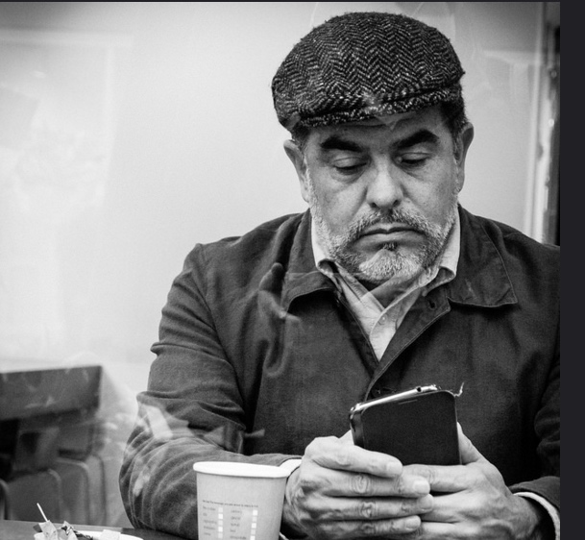
Photo by Matthew G on Flickr
A story for discussion in groups or for individual reflection
Some thoughts from Professor John Drane
Luke 21.28
Now when these things begin to take place, stand up and raise your heads, because your redemption is drawing near.
When you live in Scotland, like I do, you often see people going about their business on the street, heads down, battling with the wind or the rain.
Or these days you can go into a room full of people, or into a meeting, and they’ve all got their heads down, crouched over their phones, looking for notifications or tweets or messages.
And perhaps as a people, we’re more likely to look down and away from others if we’re crushed into a lift, or a crowded tube, or a busy café. We don’t want to be caught staring; we modestly look down and away. We keep our heads down even when shopping or going about our daily lives. I’ve been in shops where the staff think it’s positively strange for a person to meet their eyes and smile.
But in the Bible, the lifting up of heads is associated with the nearness and approach of God. Psalm 24 says ‘Lift up your heads, O gates! and be lifted up, O ancient doors! that the King of glory may come in’. Luke 21.28 tells readers of the gospel to lift up their heads and get ready for God.
You know when dogs sense their masters and mistresses returning, their heads go up, their ears prick up and they wait expectantly? There’s something in these bible passages which invites us to ‘sniff the air’ for God’s presence and for what God might be doing right now among us.
What might happen if we intentionally lifted up our heads a bit more? What might catch our attention? Who might we meet? Who might we surprise? Where might we see God at work?
Some questions:
- Are we ‘heads up’ or ‘heads down’ people? As individuals? As a church? As a community? As a nation?
- What do you think people might miss when they’ve got their heads down or buried in their phones?
- When might we intentionally go ‘heads down’ to avoid things we don’t want to face?
- Do you think if we lifted our heads up a bit more we might create more opportunities for mission?
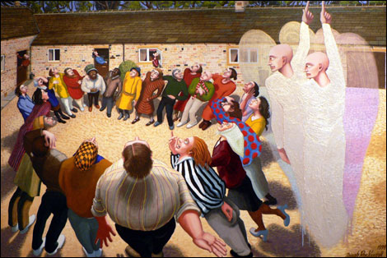
The Ascension of Jesus by Dinah Roe Kendall, an artist who uses her paintings to introduce people to Jesus. The Ascension is one of her favourites. Everyone is looking up. Find out more about Dinah at https://www.canterburydiocese.org/media/outlook/winter2014_dinahroekendall.pdf
Where next?
Have a look at some of the other resources on Starting Out/Pursuing the Human.

Starting a Conversation
Themes: Trust Making Community

Your Hair in their Hands


https://www.ipsos-mori.com/researchpublications/researcharchive/3685/Politicians-are-still-trusted-less-than-estate-agents-journalists-and-bankers.aspx
The poll illustrated above, shows results gathered by the research company Ipsos Mori when it investigated which types of professions people trust to tell them the truth. Clergy fare less well than hairdressers.
Why is this? It is because we nowadays tend to spend more time talking frankly to our hairdressers than to our local minister because people don’t go to church as frequently as they used to? Or is it because so many things have been reported about the Church which make us feel that things have been covered up and the truth has not been told?
Who we trust to tell the truth matters. It matters when we are ill and want to know what is wrong and what can be done. It matters when we have to make judgements about those who govern us, about those who run our local services, or who teach our children, or from whom we buy goods and services. When people twist the truth or lie to us and we realise we have been duped, we don’t trust those people any more.
Hairdressers pay us individual attention. We allow them to touch us, to shape what we will see in the mirror. They help create the ‘look’ we want to show to others. They are instrumental in a big day like a wedding. They can lift our spirits when we feel down and hairdressers in hospitals and care homes often make a big difference to how people feel. Many people build up a relationship with a particular hairdresser over time and share stories with them about their lives and families. And yes, it’s surprisingly common to talk about spiritual issues too.
Trusting ourselves to the ministrations of another person enables us to begin the makings of community, whether that’s cooking food for others to eat, serving in a shop, teaching children, walking a neighbour’s dog or any of the many interactions between human beings that take place every day. So if as Christians, we seek to care for and to serve others, to make relationships with others in our daily lives in the service of the gospel, then those beginnings of community and relationship have to be founded on trustworthiness and truth.
Some questions for discussion:
- What does your own list of trustworthy professions look like?
- Why do you think hairdressers poll so highly as truth-tellers?
- Why do you think people apparently trust clergy, Christians and the Church less than they used to?
- What would it take for people to trust clergy? Christians and the Church to tell the truth?
- How important are truthfulness, transparency and trustworthiness for sharing the gospel with others?
- How do you think relationships of trust can flower into groups, friendships and communities?
- Why do you suppose people trusted Jesus?


Photo by Jacob BØtter (a hairdresser) on Flickr
Where next?
Look at other resources from the Trust/Making Community section.

Starting a Conversation
Themes: Hope New News

Making Rent

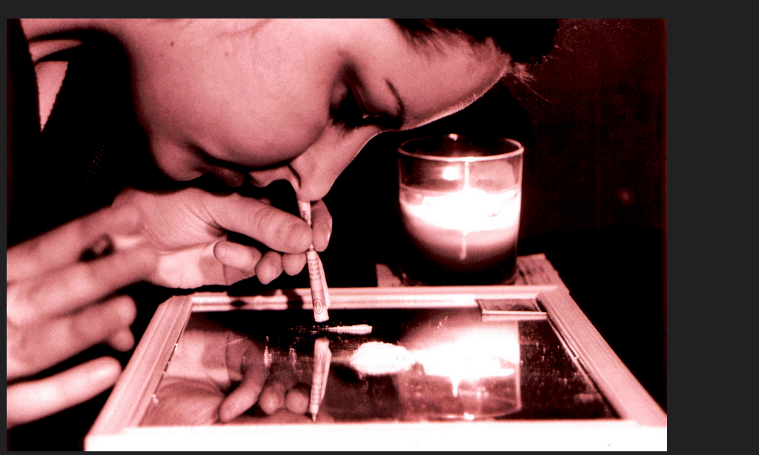
Photo: ‘Relaxing after Work_MMVI’ by andronicusmax on Flickr
A story for discussion in groups or for individual reflection
Arthur is 24 years old. He struggled to find work after leaving university and was unemployed for more than a year until he found a job with an agency in London which paid him £14k a year. His commuting costs alone were £5k. Life at the agency was horrible. He was constantly shouted at by his boss and had to work late every night to hit his targets. He lived under the threat of being fired. Many of the other employees were young, like Arthur, and many simply left after a few weeks or were sacked whenever the boss felt vindictive.
However one of the things which most shocked Arthur was how his co-workers coped with the stress and financial strain they were under. On his first Friday at work he was offered cocaine. He said no. But as time went on he discovered that for many of his friends, weekends meant drugs, casual hook-ups, gambling or gaming. Many were too broke to afford rent and went without food or heating. Some were living on friends’ sofas or stuck at home with their parents. Those in relationships often broke up through cheating or arguments about money. One friend worked evenings as a stripper; others had second jobs cash in hand; yet others did some drug dealing on the side.
After a while Arthur left and found a better, more stable job, but even there, he found his young co-workers were often caught up in the same chaotic lives, struggling to find a way to live in London.
Yet in the two years he has been in work, Arthur has found that people come to him for advice and help. They asked him why he didn’t do drugs, why he didn’t go on dating sites or Tinder, and how he coped with having so little money and still managed to hold on to his goals and dreams. When one of them has a ‘melt-down’ he takes them out for meals and drinks he can ill afford and listens to their problems. And because they know he is a Christian, they ask him too, about spiritual matters – the purpose of life, how to be happy, how to have hope, how to change.
Some questions to think about:
- What hope has Christian faith got to offer to people who are stressed and worried about the future?
- How might Christians be equipped more effectively to understand the issues facing young people in and out of work in our society?
- How can Arthur’s church and Christian friends support him in helping his co-workers?
- What sort of ‘new news’ do you think young people today need to hear?
- What do you think are the risks to Arthur and his own faith?

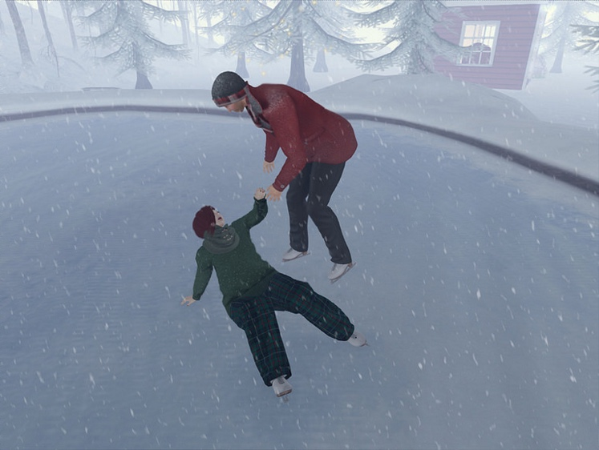
Photo by Lucie Bluebird-Lexington on Flickr
Where next?
Have a look at some of the other resources on Hope/New News.

Starting a Conversation
Themes: Confidence Honouring Memory

Flesh and Blood

A story for discussion in groups or for individual reflection

Photo by Arl Bakker on Flickr
Told August 2015 to Anne Richards
I am diabetic. I went to hospital for a routine blood test. My husband took me in the car and I was really early. He dropped me off and went to do some shopping. I wasn’t supposed to eat or drink anything, so I didn’t go to the cafeteria. But I didn’t want to wait in the waiting room either, so I went for a walk around the outside.
When I walked around the side of the hospital I saw this boy, this teenager, kicking one of the bushes. He was smashing it. There were leaves and twigs everywhere. I went up to him and shouted at him to stop it and to look at the mess he was making. I called him a vandal. He just looked at me and told me to f off. I didn’t want trouble so I walked back the way I came.
Then I wondered why he was there and why he was behaving like that. It was odd that there was this boy on his own smashing up a bush. But he had told me to f off and I didn’t fancy getting in an argument or worse. So I said a prayer, well, not really a prayer, just a ‘what do you think I should do?’ I didn’t get an answer in words, just a feeling that I should go and see what he was doing. So I went back round and he was still there, but he had stopped. I went up to him and said I was sorry I yelled at him and asked him if he smoked. He said he did, so I gave him a cigarette. I joked that I was going to get into trouble because I’m not supposed to smoke.
He didn’t say anything so I asked him if he was ok.
He said his nan just died and that his mum was inside the hospital crying and he was waiting for his dad to come and deal with her, because he couldn’t. I said I was sorry and that I felt like that when my husband’s mum died. I asked whether it was expected (his nan had cancer it turned out) and whether they had planned the funeral. He said he didn’t know what they were going to do, so I asked whether his family would like to talk to the hospital chaplain about what to do next. He had never heard of a hospital chaplain and asked what that was. So I explained. He said his family weren’t religious but I said that didn’t matter. I said that if he was finding it hard to talk to or help his mum because his nan had died, then the chaplain could help.
He asked for another cigarette and I saw he was starting to cry. So I told him that I wasn’t particularly ‘religious’ but that I believed in God and Jesus and I firmly believed that death wasn’t the end. I said the chaplain could explain about that if he wanted to ask about it. I wasn’t that good with explaining it myself, but I did believe it. He said he would tell his mum that the hospital had someone she could talk to. Then he said that if I was a Christian, perhaps I could say a prayer for his nan. I said I would and I said I would say a prayer for him and his mum and dad as well. He nodded and said goodbye and thank you. I sat in the waiting room and prayed for them all.
Some questions to think about:
- Where do you think God might have been at work in this story?
- What do you make of the woman’s claim that she isn’t ‘particularly religious’?
- How do you think the woman’s memories and past experiences helped to change the situation?
- How important would the boy’s memories of his nan have been in responding to her death?
- How might this story give us confidence to speak to others about our faith?
- What might it take to recognise that the ‘vandal’ was a person in deep distress?
- What do you think the hospital chaplain’s role would have been in helping the whole family?


Photo by Mr Thinktank on Flickr
Where next?
Have a look at some of the other resources on Confidence and Honouring Memory

Starting a Conversation
Themes: Sharing Being the Face of Love

Last Train Home


Photo by Andrew Hart on Flickr
A story for discussion in groups or for individual reflection
Told to Anne Richards, summer 2015
I was on the last train home the other day, the one they call the Vomit Comet, because everybody comes back drunk. It was pretty horrible. There were all sorts of loud, drunk blokes and the carriage stank of alcohol. I don’t like getting that train, but I had to work late so I had no choice.
This girl got on. She was pretty wasted. She sat next to me and kept putting her hand to her face and looking ill. Then she seemed to fall asleep.
After a couple of stops she suddenly woke up and put her hand to her mouth and tried to get up. I tried to help, but it was too late. She was sick everywhere on the carriage floor. People yelled and got out of the way and some told her to get off the train because she was disgusting. But she just sat down again, saying she was sorry. She found some tissues and cleaned her face and dropped them on the floor over the mess.
A couple of the drunk blokes came up and started suggesting she go home with them and started talking about how easy it would be to sleep with her because she was so out of it. I started to get really worried that something might happen to her. I didn’t want to take on the blokes, but they were getting very nasty.
I asked her if she was all right and if someone was meeting her and what station she was getting off at. But she seemed too out of it to say anything very coherent, so I was even more worried. I got her to say her name and eventually found out where she was going to get off.
I rang the taxi firm I use and asked if they would send a taxi for her. When her station arrived (2 before mine) I helped her off the train and then somehow got her outside to the car park. I put her in the taxi and then asked the driver to take her home and then me. It took a while to find out where she lived and the taxi driver was getting annoyed that she was too wasted and might make a mess of the taxi. I did wonder what I had got into but I was determined to get her back safely.
When we got to her house, her parents were in and were very upset by the sight of her. They wanted to talk to me but I said I had to get home myself and the taxi was waiting. I gave them my phone number and went home.
The next day her dad phoned me and said thank you and said that she was really ill and that she thought her drink had been spiked. I don’t know if that was true though. He asked me why I had done it when I didn’t know her and if I wanted money for doing it. I was a bit offended that he would think that. I said that she was sitting next to me and I thought she was in danger and that if that happened to my daughter I would want someone to take care of her. I then said I had been brought up as a Christian and that being a Christian was about looking after others, especially if they couldn’t help themselves. And I said about the Good Samaritan and how he looked after somebody who was in danger and when no one else would. And he said ‘You are my daughter’s Good Samaritan’.
Some questions to think about:
- What would you have done if the drunk young woman had been on your train home?
- Do you think there should be limits on the risks we will take to help others?
- How do you think this situation developed as an opportunity to say something about the Christian faith?
- How do you think the various people involved felt about the woman’s actions?
- Where do you see opportunities for looking out for others in the course of your daily life?
- What do we need to do to become ‘the face of love’ for others?


Where next?
Have a look at some of the other resources on the same themes of Sharing/Being the Face of Love

Engaging with the Bible
Themes: Starting out Pursuing the Human
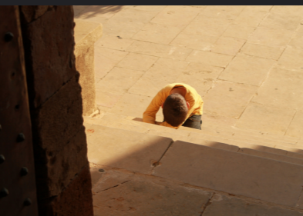
Photo: Rabiem22 on Flickr

The Faith of the Syrophoenician Woman (Mark 7. 24-30)

From there he set out and went away to the region of Tyre. He entered a house and did not want anyone to know he was there. Yet he could not escape notice, but a woman whose little daughter had an unclean spirit immediately heard about him, and she came and bowed down at his feet. Now the woman was a Gentile, of Syrophoenician origin. She begged him to cast the demon out of her daughter. He said to her, ‘Let the children be fed first, for it is not fair to take the children’s food and throw it to the dogs.’ But she answered him, ‘Sir, even the dogs under the table eat the children’s crumbs.’ Then he said to her, ‘For saying that, you may go—the demon has left your daughter.’ So she went home, found the child lying on the bed, and the demon gone.
What’s going on?
In this story in Mark’s gospel, Jesus is in the region of Tyre (now in modern Lebanon), a cosmopolitan trading region filled with many people of different beliefs and practices. There, despite trying to remain unnoticed, he is tracked down by a non-Jewish woman with a sick child. She asks Jesus to heal her child but he initially rebuffs her, quite rudely, saying that his healing ministry is for his own people. Yet the woman persists; although she is not Jewish she believes that Jesus can heal her daughter. Jesus responds to her raw faith in his divine power to help her and she goes home to find her daughter healed.
Why does it matter?
This story offers some important insights into the way we engage today with people who are not Christian. First, the gospel writer places Jesus in a region full of many different people with different thoughts and ideas, trading their wares and bustling about. It’s not the sort of place for a heavenly-minded Jew trying to stay ritually pure. In this story Jesus does what many of us do, hide away from the throng and try to stay with our kind, focusing on what we’re meant to do. Yet he can’t keep the wider society and culture out. It comes to him anyway, with its problems and concerns. In the face to face encounter, Jesus states the issue: you are not one of us, you don’t belong, I’ve got affairs with my own people to put in order, - but the woman’s need and belief that Jesus has something real and life-changing to offer her means that she won’t just go away. And so Jesus finds that the love and grace of God cannot be withheld for the chosen few; his ministry is for everyone.
Starting a conversation
- What is it like for Christians living in our modern society? How might Jesus’ experience feel familiar to us?
- Imagine what it is like for a complete stranger to come into one of our churches. What does that feel like?
- What do you think Jesus learned from the encounter with the woman?
- How does this story help us when we meet people outside the Church?
- How might this story help us engage with people of other faiths?
Prayer: Lord Jesus Christ, help us to bring your love to every person we meet.

What next?
Things to think about in your local situation:
At church
- What sort of ministry of welcome does your church have?
- How regularly do non-church members knock on the parish priest’s door? Come to the church or church hall? Parish office? Other church buildings? Approach church members? How could that access be improved?
Photo: David Amsler on Flickr
- What ONE thing could be changed in your church to help people who are not Christians feel more welcome?
- How do you find out what visitors to your church experience when they attend?
In the world
- What happens when you meet people who are not Christian in your daily life?
- Do the people you know feel they can approach you as a Christian about matters of faith and spiritual issues?
- When do people you know approach you for help about anything?
- What sort of situations could there be where you wouldn’t help someone who asked you?
- What ONE thing could you do to help people feel they can trust you?
Have a look at other resources in the Starting Out/Pursuing the Human sections

Engaging with the Bible

Themes: Trust: Making Community

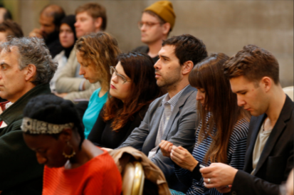
Photo by Columbia GASPP on Flickr

The True Kindred of Jesus (Matthew 12. 46-50)

While he was still speaking to the crowds, his mother and his brothers were standing outside, wanting to speak to him. Someone told him, ‘Look, your mother and your brothers are standing outside, wanting to speak to you.’ But to the one who had told him this, Jesus replied, ‘Who is my mother, and who are my brothers?’ And pointing to his disciples, he said, ‘Here are my mother and my brothers! For whoever does the will of my Father in heaven is my brother and sister and mother.
What’s going on?
Imagine you are in church, preaching, teaching, leading worship or giving a talk of some kind. You get a text on your phone to say that your mother or your brother or sister is outside and want you to come out and talk to them. It’s urgent and they really want you to go out and meet them. Instead, you make their request into a teaching point. Everyone in the church is your family and they have a claim on you too. In fact this is what God’s kingdom is like, an extended family where everyone treats people with the respect and care you would give to your own family.
This is what Jesus does. He uses the occasion to change the hierarchical relationships of teacher and followers to a family united in the love of God. As God is Father, so everyone’s religious identity is now defined by kinship, with all the ties of mutual duty, love, hospitality, trust and respect that entails.

Why does it matter?
Jesus proposes a radical way of looking at ourselves as a community. Following God is not about having status or roles but being in relationship with one another. Discipleship is not about gaining special access to divine truth or having power over others but having the same responsibilities and care for one another as in a family.
It matters too, because this was an aspect of living in the life of Christ that the disciples often simply didn’t ‘get’. They argued about who was going to be the greatest and were shocked and horrified when Jesus washed their feet. Yet Jesus constantly urged the disciples to be family to one another and asked one of them to adopt his mother even as he hung on the Cross. We too, often forget about being family and community and are still today hung up on roles, titles, status and power.
Starting a conversation
- What activities in your church feel most like being a family?
One particular elderly woman always stood just outside the church door after the service and said ‘God bless’ to everyone as they went down the steps. People would say ‘Thanks, Mum.’
- Suppose your welcome and outreach to others were re-modelled as an invitation from an open and extended family. Who in your Christian community would you identify as mothers and fathers? Who would be sisters and brothers?
Prayer: Lord, help us always to be your brothers and sisters
What next?
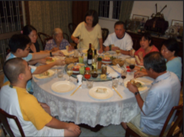
Make a list of activities you do for and with your family in a typical week. For example:
- Washing and ironing
- Making meals for family members
- Looking after people when they are sick
- Baby sitting
- Celebrating special occasions
- Spending time and having fun together
Photo by Yun Huang Yong on Flickr
If you imagined the social action your church or churches together do in the community as being extensions of these family activities, how might that change the way you view them?

Have a look at other resources in the Trust/Making Community sections

Engaging with the Bible

Themes: Hope: Creating New News

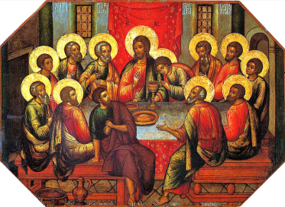
Photo by paukrus on Flickr

A New Commandment (John 13.34-35)

I give you a new commandment, that you love one another. Just as I have loved you, you also should love one another. By this everyone will know that you are my disciples, if you have love for one another.’
What’s going on?
The context of this ‘new news’ matters. In John’s gospel, Jesus says these words at the Last Supper. Judas has just left and Jesus knows where Judas has gone and that he was going to betray him. The other disciples do not. What is going to happen when they find out? What will happen when Jesus is arrested, tried and sent to execution?
The chances are that the disciples will fall apart. They might well turn on each other, doling out blame for Jesus’ death. Without their leader and teacher, as they struggle to understand God’s will, they might well just give up and the ties that bind them together might simply dissolve.
Every Jew understands the commandments as the holiest expression of God’s Law. Now Jesus offers a new commandment, a defining religious requirement, part of their religious identity. And this new commandment is to replicate Jesus’ life in their own lives, to be Christian witnesses to others, characterised by love for one another, not blame, recrimination, power struggle or despair. This is why people will look to the disciples to give them hope. Living in Christ means to live in a new way, which overcomes even the darkest and most bewildering experiences. Jesus throws them a lifeline, a way to be the new Christian community. They just don’t know it yet.
Why does it matter?
Jesus is about to place himself entirely in God’s hands. But at the Last Supper he also lays the foundations for the disciples’ future. In washing their feet, instituting the Eucharist and giving this new commandment, he offers a way of being with each other, and with God, which will be a sign of hope for those they minister to and evangelise in the future. In doing these things, he also gives us the same commandment: we are to love one another so that people will know that we are Christian disciples. But do we do this?
Starting a conversation
- A lot of what people ‘know’ about the Church is gathered from scandal stories in newspapers and other media. What could we do in our own local witness and behaviour to change and challenge those perceptions?
- What needs to happen when Christian communities are very obviously not loving one another?
- Jesus said ‘....as I have loved you’. What do you think the disciples understood by that?
Prayer: Lord Jesus, help us to live by your new commandment in all we are and what we do.
What next?
Some things to do:
- When you are next planning events in church or for your local community, think about how you could advertise it for new news that brings hope to people. Why would people be surprised, pleased, excited or curious about what your church is offering or saying about itself?
- What ONE thing could you change (or start) in your church or in your own life which would show Christ’s love for his friends more clearly?

Photo: Caitlin Doe on Flickr
Have a look at other resources in the Hope/Creating New News sections

Engaging with the Bible
Themes: Confidence Honouring Memory


Photo: gags9999 on Flickr

The Woman at the Well (John 4. 27-30; 39-42)

Just then his disciples came. They were astonished that he was speaking with a woman, but no one said, ‘What do you want?’ or, ‘Why are you speaking with her?’ Then the woman left her water-jar and went back to the city. She said to the people, ‘Come and see a man who told me everything I have ever done! He cannot be the Messiah, can he?’ They left the city and were on their way to him.
Many Samaritans from that city believed in him because of the woman’s testimony, ‘He told me everything I have ever done.’ So when the Samaritans came to him, they asked him to stay with them; and he stayed there for two days. And many more believed because of his word. They said to the woman, ‘It is no longer because of what you said that we believe, for we have heard for ourselves, and we know that this is truly the Saviour of the world.’
What’s going on?
Jesus breaks some cultural and religious boundaries when he talks about God to a Samaritan woman who is drawing water from a well. Samaritans and Jews did not get on together and men were not supposed to talk to unaccompanied women. But this is not just a theology lesson; Jesus shows that he knows all about the woman’s life, including all about her past. Despite her complicated life, Jesus entrusts her with good news about God. She becomes an evangelist, telling everyone in her community about Jesus so that they go to find about him themselves. Having talked to Jesus they go back to their community and tell the woman that they believe in Jesus and that she has spoken the truth.
Why does it matter?
Many commentators focus on the way Jesus cuts across cultural taboos, but it is also important that Jesus talks to the woman in the context of her whole history: ‘He told me everything I have ever done’. She is a person with a past, but that past is also what adds depth and confidence to her testimony and makes people want to find out about Jesus for themselves. If this person can be excited about Jesus, perhaps it’s worth finding out about Jesus. The woman is so amazed by Jesus she rushes off, leaving her water jar behind, inviting people to ‘come and see!’ People do come and see and invite Jesus to come into their lives and share with them.
Photo by David Rosen on Flickr
Starting a conversation
- How might a person’s past or reputation add weight to what they say about their faith?
- How important is it that Jesus show he knows ‘everything I have ever done’?
- How do you think the woman’s community reacted when she turned up talking like this (and without the water)?
- Does your church welcome people of every background? How would you feel about worshipping alongside people who are divorced, or are gay or are transgender?
- How would you feel about worshipping alongside people who have been in prison, or are homeless, or who have mental health issues?
- Are there elements in your own personal history which help you empathise with people going through problems now?
Prayer: Lord Jesus, you know the secrets of our hearts, help us invite others to ‘come and see’.
What next?
Things to do: building confidence
- You could look at providing a safe space in your church for people who might want to talk about difficult episodes in their past.
- You could also review your church’s work in mission and evangelism. Are there people who are being overlooked because they don’t ‘fit’ the picture of an evangelist?
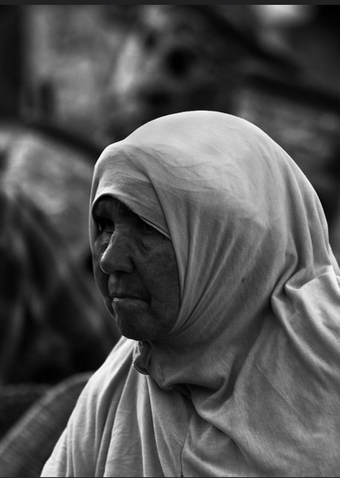
Have a look at other resources in the Confidence/Honouring Memory sections.

Engaging with the Bible
Themes: Sharing; Being the Face of Love

Photo by Aleksander Dragnes on Flickr

The Howling Man (Mark 5.1-13)

They came to the other side of the lake, to the country of the Gerasenes. And when he had stepped out of the boat, immediately a man out of the tombs with an unclean spirit met him. He lived among the tombs; and no one could restrain him any more, even with a chain; for he had often been restrained with shackles and chains, but the chains he wrenched apart, and the shackles he broke in pieces; and no one had the strength to subdue him. Night and day among the tombs and on the mountains he was always howling and bruising himself with stones. When he saw Jesus from a distance, he ran and bowed down before him; and he shouted at the top of his voice, ‘What have you to do with me, Jesus, Son of the Most High God? I adjure you by God, do not torment me.’ For he had said to him, ‘Come out of the man, you unclean spirit!’ Then Jesus asked him, ‘What is your name?’ He replied, ‘My name is Legion; for we are many.’ He begged him earnestly not to send them out of the country. Now there on the hillside a great herd of swine was feeding; and the unclean spirits begged him, ‘Send us into the swine; let us enter them.’ So he gave them permission. And the unclean spirits came out and entered the swine; and the herd, numbering about two thousand, rushed down the steep bank into the lake, and were drowned in the lake.
What’s going on?
In this strange and disturbing story, Jesus goes to a man who is so desperately mentally ill and inwardly tormented that people have chained him up. But none of their restraints have lasted and he is roving about screaming and hurting himself. He has been abandoned and is living among the dead. Jesus talks to the man, agrees how he will be healed and gives him healing. The evil that has afflicted the man is driven out and destroyed.
Why does it matter?

On one level this is a story about the triumph of Jesus over the spiritual realm, driving out evil and restoring the man as he was meant to be under God. However, on another level, what is important is that there is a face to face meeting between Jesus and a man nobody else knows what to do with, a person abandoned as a hopeless case, tied up and cast out away from society. Yet Jesus does not treat the man as a ‘case’ or a showpiece in exorcism; he shares a conversation with him. He asks him his name, finds out about what it is like to be in his condition and heals him. Jesus reveals God’s love and compassion to the man, meeting him on his own terms and in his own place. He shows us a way that we too can be the face of love to others.
Starting a conversation
- What sort of people do you think are in the position of the howling man today?
- Where are the ‘no-go’ places in our society and who is best placed to help the people who live there?
- If Jesus spent time sharing with the man before healing him, what should we be sharing with those we try to help? What might we learn from them in our turn?
Prayer: Lord Jesus, help us to be the face of God’s love to others, especially to those whom others have abandoned, given up, or who are unheard or ignored.
What next?
Some things to do:
- Look round your local area for charities which help the most vulnerable in our society. Find out what they do and see if there are ways in which you and/or your church could help or support them.
- Think about how you could support people who provide ministry to those who ‘hidden away’, such as those in prison, in secure psychiatric facilities, people who are victims of trafficking etc.
- Put aside a period of time (eg Lent or Advent) to concentrate on being the face of Jesus’ love to those around us, perhaps taking a bit more time to listen to friends or colleagues, or making time to visit people who are lonely or in need of a chat.
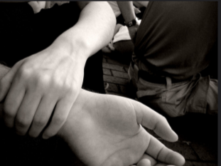
Photo: ‘Compassion and Friendship’ by Adam Smith on Flickr
Have a look at other resources in the Sharing/Being the Face of Love sections

Making a Change
Themes: Starting Out Pursuing the Human

Driving


Photo by whatleydude on Flickr
A woman was invited to a street party but she refused to come and join in with her neighbours. When someone knocked on her door and asked her why she didn’t want to come and join them, she said that whenever she drove up the narrow road to her house and pulled over to let somebody pass, they never waved or said thank you, so she didn’t want to socialise with such ungrateful people.
For a lot of us, getting in the car and driving off is second nature. If we’re fortunate enough to own a car, then it often becomes an extension of our home. We pile the kids in to go to school, the swimming pool, to visit relatives. We put the dog in the back to go to the park. We go to the supermarket, the garden centre, on trips out, or visits.
Often though as soon as we’re behind the wheel or comfortably sitting in the passenger seat we zone out. We put the radio on, talk to passengers or just think about what we’re going to get at the shops or whether we’re going to be late for the school pickup. Other road users and pedestrians are just there going about their business or annoying us with their bad driving.
But suppose that we considered our own driving behaviour as a way of being socially responsible? Perhaps it really would make a difference to other people, if we made an effort to drive with their welfare consciously in mind and helped people who might be less confident than we are. The AA reports some appalling instances of harassment of learner drivers and a general lack of consideration and respect. http://www.theaa.com/motoring_advice/news/driving-school-road-rage-idiots.html
Jesus asks us to love our neighbour and we tend to think of neighbours as people who live near us or who share our lives in some way. But on the road, all the vehicles and pedestrians around us are our neighbours. Perhaps it would make someone’s day to be given space at a busy junction or left a parking space nearer to the entrance of church or shop.
What really makes me cross is when someone dangerously cuts you up and the car they’re driving has got a fish sticker on the back...
Here are some ideas to think about. You could also come up with ideas of your own.
- Acknowledge and say thank you to anyone who gives way to let you pass.
- Be more aware of pedestrians at crossings. Wait that bit longer for a parent with a toddler crossing the road. Don’t speed up to get past them before they start to cross.
- Consciously anticipate the road conditions and traffic. What do you need to do to drive more safely? How can you help other road users get about safely? Think especially about people around buses and ice cream vans, cyclists and motorcyclists.
- Make sure your car is in good repair and all the lights are working and that you are not endangering others by making it difficult for them to see you.
- If you feel angry with someone who has driven badly, find a way to let it go rather than retaliate.
- Make space for people to join traffic – ever tried to get on to a jammed motorway from a slip road or on to a main road from a busy junction and been stuck there as people crowd you out? You could help someone by leaving enough space for them to get out. NOTE: if you are going to let someone out, make eye contact with them and either just wait for them to pull out or indicate with you hand you are letting them go. Don’t flash your headlights as there is a scam called ‘flash for cash’ where some criminals deliberately invite people out by flashing and then hit them to claim insurance. Flashing headlights to let people out might make them vulnerable to this scam.
- If you are able bodied leave the closest parking spaces for people who might find it more difficult to walk to the shops or the health centre or the church. It can’t hurt to park a bit farther away from the entrance, even if it’s raining.
- When you have parked your car think back over the drive. How have you helped your neighbours on the road? Who might have had a better day? What tempted you to get annoyed and how did you react?


What next?
Have a look at some of the other resources in the Starting Out/Pursuing the Human sections.

Making a Change
Themes: Trust Making Community

Sharing the Peace

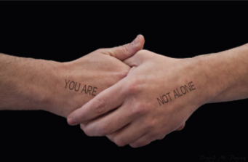
Photo by David Pacey on Flickr
John 20.21 Jesus said to them again, ‘Peace be with you. As the Father has sent me, so I send you.’
What do you do in your church to greet one another, or to share the peace with one another? A hug, a kiss, a handshake, a polite nod in the direction of the other person? Does it matter how we do this? Is it something we look forward to or dread doing?
In some countries it is a matter of politeness to greet others, shake hands and perhaps even share a drink or a conversation before buying something in a shop. In the UK, we tend to just march in, find what we want, hand it over, pay for it, and march out again.
Yet on the whole, Christians are good at making community wherever they go. This means we are more likely to consider the other person in the encounters we have in our daily lives and to see them as interesting human beings rather than as ‘just’ service providers. It might be that meeting one another as a family on a Sunday, equips us with the ability to see others in terms of relationship. How can we build on that, so that we become more willing to engage with others rather than just ‘take’ from them, and more able to build trust with those around us?
I’ve served about thirty customers this morning and you are the only one who has said ‘thank you’...
One way might be to imagine sharing the peace of Christ with everyone we meet on a daily basis. That means building on what we do in church, pausing to allow enough time and space to acknowledge the other person and to wish God’s blessing upon them. You can do this whenever you are out and about or if you work in a profession that is public facing.
I tried to ask what the she wanted but she wouldn’t get off her mobile phone....

It may sound odd, but we now live in a society where respect for others, politeness and gratitude are sometimes in short supply. Being more intentional about enquiring after others, offering to help, saying thank you and being willing to have a short chat can actually make someone’s day, especially if they work in a job which lays them open to rudeness, or even verbal abuse. Many people working to provide others with goods and services also feel taken for granted, exploited and undervalued. Even professional people like doctors and solicitors need to feel valued and often only get complaints rather than kindness and appreciation.
Here are some thoughts about how we can ‘make community’ and share God’s peace every day.
- Try not to be too rushed, so that you have time for the other person, rather than thinking about what a rush you are in.
- If your phone rings, leave it. Help the other person to feel they are important to you.
- Say hello, ask them a question [eg ‘what sort of day are you having?], say thank you and mean it.
- Try not to say the empty things people always say.
- If the person has a name badge, remember their name and pray for them later.
- If you get the chance for a friendly conversation, use it.
- Imagine sharing the peace with them or say something like ‘I hope you have a peaceful day’.
- If you regularly see this person in your daily life, like a bus driver or GP receptionist, make them part of your prayer life, thanking God for them and what they do. Tell them you are glad to see them or grateful and appreciative for the services they provide.
- At times like Christmas and Easter or other appropriate occasions, you might be able, as a church, to take something like biscuits, fruit or other small gifts to places you have ‘made community’ to show appreciation for what the staff do.
This is an exercise in building trust and applying what we offer in church to the wider world. While these relationships might lead to evangelism and invitation in due course, the important matter is to learn about ourselves and how we relate to others as we try to lead meaningful Christian lives.
Try doing this with others from your church or group for a week and then compare experiences.
- How easy or difficult was this to do?
- What sort of reaction or response did you get from people?

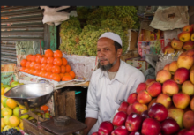 Photo: Manish Bansal on Flickr
What next? Have a look at some of the other resources in the Trust/Making Community sections.

Making a Change
Themes: Hope Creating New News

Smart Living

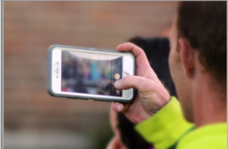

We are living in a time of computers, tablets, satnavs, apps and smart technology from phones to fitbits. Our sources of information come increasingly from the internet, and so it matters how connected we are to wifi or mobile communications. For younger people today the internet has always been part of their lives; older people may be busy trying to learn new skills and to manage the welter of fast-changing new technology. Often, it is younger people who today have more wisdom and ‘savvy’ about using smartphones and the internet than their parents and grandparents. Should we trust them more to lead the way in this?

The question, ‘who is my neighbour?’ takes on a new perspective today, when social media platforms like Facebook and Twitter allow us to connect instantly with people on the other side of a city or even the other side of the world. There are people who share their intimate lives with others online, perhaps when living with disease, and get support, encouragement and prayers from those who follow their story and help them feel less alone. On the other hand, we also hear of trolls who bully, belittle and berate individuals, using the relative anonymity of their status online to vent their hatred or spleen, causing upset and distress.
With these new technologies come new opportunities and new problems. On the one hand a smartphone can stop young people getting lost, reassure parents that all is well and provide easy access to help and assistance should something go wrong. On the other hand the rise of cyber-bullying, online grooming and sexting causes parents new worries.
Reliance on technology such as smartphones has caused the missiologist Mike Frost to coin the term ‘excarnation’. People nowadays may choose to live more through their technology, taking selfies and videoing events and looking at those later, than experiencing the moment. Our technology invites us to engage with reality differently, so that in a train carriage full of people there can be a whole host of invisible people also present at the other end of conversations and experiences.
So in an increasingly ‘excarnate’ world we can ask:
How do we make sense of new technology as a sign of hope for the future God intends for us?

What new news do people today need to hear to help them know how to use their internet enabled devices wisely?
- Make a list of helpful technologies which are useful to human beings in transforming our world for the better.
- Make a list of cautions about the use of internet-enabled devices in daily life.
Some examples might be:
- Technologies used to cure diseases such as malaria
- People not taking care with selfies and putting themselves in danger by forgetting where they are.
Reverse the lists by looking at the dangers of technological advance without proper ethical controls and at the helpful side of internet-enabled devices.
Some examples might be
- Issues around gene-editing and genetic modification; or internet scams and phishing.
- GPS to help you if you get lost.
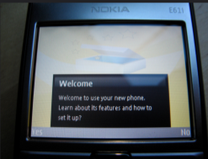
Photo: Andrew Currie on Flickr
In 2015 the composer Andrew Lloyd Webber urged churches to provide wi-fi to make churches more connected to their communities. Some churches and church halls already do this. How, as Christians, can we provide wisdom to generations after us about appropriate use of technology and the internet and how can we use it ourselves to obtain good information, care for and support others, and reach out and sustain others?
Things you can do in your church:
One initiative might be to get younger people in the church to provide a helpline service for older people who are worried about computer viruses and phishing scams.
Another might be for older people to provide a personal ‘human voice’ helpline service for anyone suffering from cyberbullying.
You can probably think of even more possibilities and examples of helping your neighbours and communities.
What next? Have a look at some of the other resources in the Hope/Creating New News sections.

Making a Change
Themes: Confidence Honouring Memory

Being there

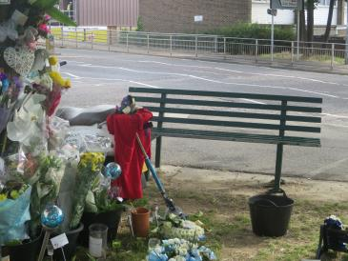
A young motorcyclist was killed in an accident and at the site of his death, his friends gathered to bring flowers, cards, and toys. His motorcycle was also left there and people wrote messages on it. Some people brought cans of beer in a bucket and left another bucket for rubbish which was cleared away daily. Someone else brought a bench and people sat on it to remember their friend. After a while an elderly man came every day to sit on the bench and talk to the dead person’s friends about what they were feeling. And soon people came to spend time with him, asking him all sorts of questions about faith, life, the universe and everything. One day though he wasn’t there and the people missed him and wondered where he was. He had gone to church because it was Sunday.

A group of young adults from several local churches undertook to provide a map of a large, rather neglected graveyard in their area, charting names and dates and drawing the locations of graves. While they were there, they found they were increasingly talking to relatives and friends at funerals and helping when people came to visit, lay flowers and remember. From these encounters, the group found themselves forming some smaller groups. One developed a bereavement ministry for people immediately after funerals had taken place; another small group started to work with funeral directors to provide practical help about preparing for funerals. A third group operated a befriending service to widows and widowers offering people coming to visit the chance of a cup of tea in the garden centre next door. A fourth group offered prayers for bereaved families.
We sometimes think that a confident sharing of our faith with others is about leading people forward into a new stage on their spiritual journey. Evangelism is about their life with Christ from now on. But people’s memories and relationships are an important part of their spirituality too. Who they have been, even if they have tragic or difficult pasts, can be important to their development as people of faith. Life crises, like illness, divorce, or the death of friends, children or parents, also bring the importance of remembering and reflection into the foreground. It is part of spiritual development, how people make sense of surviving those events.
Similarly, and perhaps paradoxically, having confidence in faith does not necessarily mean having all the answers. The elderly man on the bench was confident in his ability to receive the grieving of bewildered friends; he did not claim to be able to solve or change their grief, but came back day after day to share with them, pray with them or even just sit in silence with them.
These stories show us that standing alongside vulnerable people, grieving people, lonely people and lost people, being prepared to listen to them, honour their memories and simply to come back, day after day, builds confidence in those people that Christians do care, will care and can be relied upon. Trying to ‘solve’ people’s issues without solidarity, or evangelising them to wash away their pasts, can in fact erode such confidence.
Things to do and think about:
- What existing ministries do you have in your church which can build confidence in the community in Christians as a source of help and solidarity?
- How might those ministries be extended?
- Who are the people in your community whose memories especially need to be honoured and respected?
- How might those people offer those memories back to the church?
- What opportunities do you have for commemoration and celebration as churches and as communities?
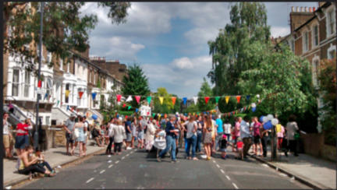
Photo, ‘street party’ by Iain and Sarah on Flickr
What next? Have a look at some of the other resources in the Confidence/Honouring Memory sections.

Making a Change
Themes: Sharing Being the Face of Love

Mapping the Kingdom

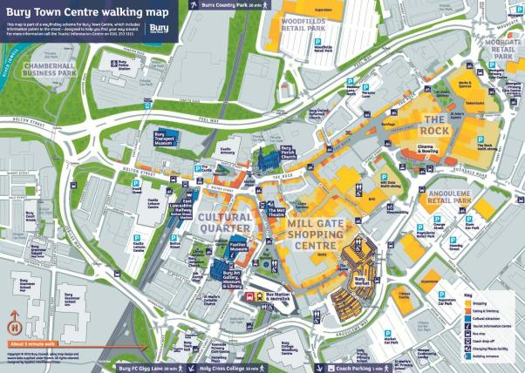
This is a map of Bury but you can use any basic town map or a map of your own local area.
Imagine, either individually or in a group, that you are looking at this map from a God’s-eye view.
- Where do you see a Christian presence on the map – where Christians are active and making a difference?
- Where do you see places where Christians regularly gather?
- Where do you see places where Christians regularly go in their daily lives?
- Are there areas of the map which are not touched by Christian presence? What’s happening in any of those areas? What might God already be doing there?
- Where might people of other faiths fit into this picture?
- Are there features missing from the map where people are overlooked, unmentioned or forgotten?
- Imagine this map as a map of the kingdom of God overlaid on the physical geography – where is the kingdom becoming most apparent? Where is it not in evidence?
- What changes would have to take place for the kingdom of God to be realised across the whole map and who would be involved in that?
- What new things (housing, shops, schools, leisure centres) have been happening in your local area that could benefit from Christian hospitality and engagement?
- In rural areas, how does the kingdom include farmers, animals, land, land management?
- Is the map different according to season?
- How can we be the face of love to tourists or visitors?
- How can we use our kingdom maps to build confidence in sharing our Christian presence and witness to Christ everywhere we go?

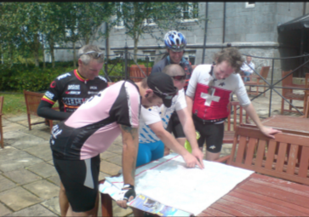 Photo: Dick O’Brien on Flickr
Things to do:
- Imagine you are recording satnav instructions for Christian activities in your area. How would you direct a person starting on a main road into your area looking for worship, services, enquiries about faith, help with personal problems etc? A number of you could do this in a group, map out the directions and overlay them to see what different journeys that might entail. You might then want to visit some of those places and see how they work as ‘stations’ for people trying to find out more about Christian faith or looking for Christian help.

Identify ONE area of the place where you live where you can be the face of Christ’s love to other people.
- What is that area and what does it need?
- What have you got to offer (Presence? Time? Volunteering? Talents?)
- Who else could you work with (including other churches, faith groups, community groups, agencies, farmers etc)?
Set a time limit (a day/week/month) to this, and then review what difference it has made to the map.
What next? Have a look at some of the other resources in the Sharing/Being the Face of Love sections.

Reflection:
Starting out Pursuing the Human

Let us Pray

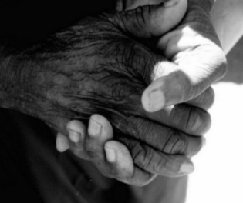
Photo ‘Praying Hands’ by Phil Warren on Flickr
A man came to a friend’s funeral. When the minister said to the congregation ‘let us pray’, the man turned to the person next to him and said ‘what do I do?’
When the Church of England’s Social Responsibility Officers came together to discuss stories on faith in action at their 2015 national conference, it was noticeable how many of those stories included the importance of prayer. Praying with and for others, praying in worship for the world, praying for guidance and wisdom to know what to do to help others, praying for God to be present in social action and working for social justice, praying for strength and courage in difficult decision, praying when we fail and people still go hungry, unhelped, or die.
Researchers like David Hay and Rebecca Nye, who have studied the spirituality of people who do not go to church, show that many such people have powerful spiritual experiences and may feel that they have genuinely encountered God working in their lives. But they may not have the words to articulate these experiences or ask questions about them, and many more worry that they will be laughed at or humiliated if they try. Such people often want to pray but don’t know how to begin or if there is a ‘right way’ to pray.
When those around Jesus asked him how to pray, he gave them the words of the Lord’s Prayer (see Luke 11.1-4). He also taught them about prayer; that it is primarily an expression of relationship with God as Father, not a set of demands or a wish list to a distant deity (see Matthew 6.5-14). To that extent prayer is personal to each one of us. There is no ‘right’ way to pray, but Jesus says that praying for show, to look extra religious or to impress others is not what praying is about.
Things to do:
- Spend some time thinking about how you pray. How could you deepen and extend your own prayer life?
- Under what circumstances would you feel comfortable praying with someone outside the Church?
- How would you talk about the Lord’s Prayer to someone who had never heard of it?
- What would you say to someone who asked you how to pray?
- People of all faiths and none are often profoundly grateful for the prayers of their Christian friends. How could you let the people you encounter and work with know that they are in your prayers?
At Christmas a team of Christians went from door to door in a parish with a notebook, asking people if there was anything or anyone they would like them to pray for at the parish church. A lot of people wrote in the book about sick relatives, job worries, bullying, exam stress and many other problems and concerns. All were prayed for at a special service, but the book also created a picture of issues in the local area, especially loneliness and isolation. The church then organised a series of schemes, including befriending schemes, a Christian taxi and baby-sitting service and a pet-share scheme, to help people they had heard about through the day of prayer.


Photo: Nancy Hann on Flickr
What Next?
Have a look at other resources in the Starting Out/Pursuing the Human sections.

Reflection:
Trust Making Community

Photo: Anthony Easton on Flickr

Sanctuary

A woman was phoned by an anxious neighbour who had noticed a tall young man in a hooded top hanging around the woman’s front door. After a while the young man was joined by two others, also in hooded tops, who were looking in through the windows. The neighbour was concerned for the woman’s safety and asked her if she should call the police. The woman looked out and saw that the tall young man was her son. The other two were his friends.

Many people today are as anxious as the neighbour in the above story. Because people fear things like crime and terrorism, common worries and suspicions often centre on people who appear in some way suspicious or different. That means that people who are vulnerable or in fact in most need of help and care can be viewed as threatening, alarming or simply to be avoided.
Another prime cause of anxiety in today’s society is the fear that we are not in control, that powers of evil are at work in the world and that our lives are disintegrating. People often feel that those who govern us cannot be trusted and so our futures are in danger, whether the issues are around the NHS, pensions, patterns of migration, or climate change.
Christians are not immune to these worries and concerns, but we can start to think about how to get a handle on them if we think about them as spiritual issues.
Some things to think about:
- How does Christian faith help us deal with fears, worries and concerns about the state of the world and our local situation?
- How can we help others with their own worries and anxieties through building up trust?
- How can our churches and Christian communities be places of sanctuary and safety for vulnerable people and those mistrusted by others?
Why should people trust us?
- How often do we tell the truth; behave with honesty and transparency; show respect for others; show kindness and compassion; act with integrity?
- What do we do when we fall short in our behaviour?
- How do we witness to a God who can be trusted?
If your church or community is involved in social action:
- How do social action projects build trust and confidence in Christians and Christian behaviour?
- Does the church come across as a place of safety, where people can be trusted to help?
- How do your projects address spiritual needs of fear and concern as well as material needs?


Photo: J P on Flickr
What Next?
Have a look at other resources in the Trust/Making Community sections

Reflection:
Hope Creating New News

Photo by asenat29 on Flickr

Giving

Think back to your last birthday or Christmas and the gifts you received from your family or your friends and about those you gave to others.
Did you get:
- What you wanted?
- What you needed?
- What other people thought you wanted?
- What other people thought you needed?
- What other people thought you might like?
- What other people really would have liked to receive themselves?
- Something which clearly indicated they couldn’t think what to get?
What would have happened if you really didn’t want a gift at all?
Gift-giving is actually quite a complex business, and indeed it is a spiritual issue. After all, we talk about the gift of God’s love, the gift of grace, the gift of redemption, the gift to us of Jesus as God’s son. Gift-giving can be an act of hospitality, respect, love, kindness and compassion. It can cement friendship and bring great joy and gratitude.
But gift giving can also create problems, especially when it includes an exercise of power, requiring reciprocation or putting a person in another’s debt or placing obligations upon them. Gift giving can also come with assumptions about what the recipient wants or needs, without actually finding out the truth about what those wants or needs are.
A Christian charity built a well in an African village. But the well kept being vandalised. The charity didn’t understand why the villagers would keep breaking it; after all, the well freed the women of the village from walking many miles to get water. It turned out that the women themselves were breaking the well. The walk to get water was important to them. It gave them time alone to talk about their own concerns and a break from the other chores of the village. No one had asked them their views. Everyone assumed the well in the village would be the best option for them.
Many kinds of evangelism and social action are undertaken on the assumption that God’s love, freely given to others, must be the best kind of gift that Christians can offer to others. But if we don’t stop to imagine what it is like to be the recipients, and don’t give them space to let us know what they want and need from us, then we can be in danger of abusing the gift in our own desire to ‘do good’.

Something to do:
Think about the work you and your church do in the areas of mission and evangelism and social action.
- What steps do you take to find out what people actually want and need?
- What space is available for those you help to give something back?
- What do you need to think about in reaching out to minority groups of people, vulnerable groups of people; people of other faiths?
- Suppose we thought about the time and effort we put into evangelism and social action as creating signs of hope for others. What would those ‘signs of hope’ be?
- How can really taking time to understand the needs and wants of others create new news about God for those people?
DFID: giving aid to people needing shelter in Nepal.
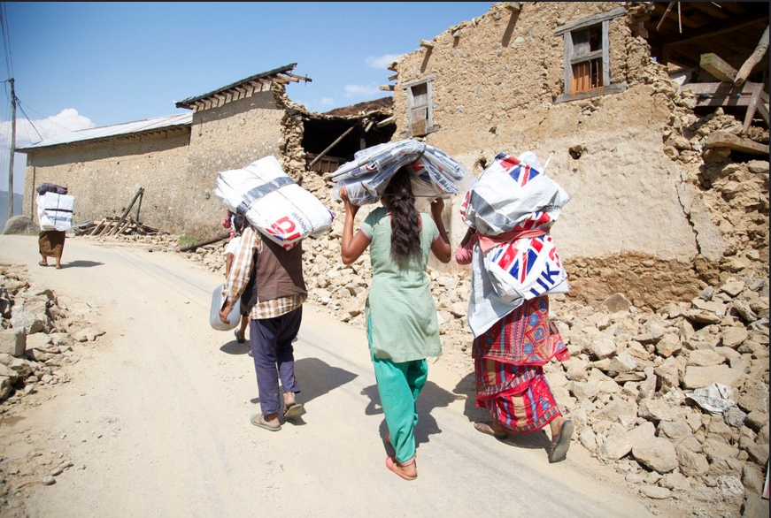
What next? Have a look at other sections in Hope/Creating New News.

Reflection:
Confidence Honouring Memory

Confidence


Gospel Ship – exhibition in Aberystwyth Museum 2015 (1)
One of the traditional spiritual disciplines of the Church has been to confess our sins and receive God’s forgiveness. How that happens depends on the particular traditions of our churches and how facing up to the way we fall short as Christians affects us personally.
The Book of Common Prayer says:
ALMIGHTY and most merciful Father, We have erred, and strayed from thy ways like lost sheep, We have followed too much the devices and desires of our own hearts, We have offended against thy holy laws, We have left undone those things which we ought to have done, And we have done those things which we ought not to have done, And there is no health in us: But thou, O Lord, have mercy upon us miserable offenders; Spare thou them, O God, which confess their faults, Restore thou them that are penitent, According to thy promises declared unto mankind in Christ Jesu our Lord: And grant, O most merciful Father, for his sake, That we may hereafter live a godly, righteous, and sober life, To the glory of thy holy Name. Amen.

One of things that people perhaps forget about these importance acts of confession and penitence in worship is that, with absolution or the assurance that our sins are forgiven, they give us confidence to go forward. When we think back over the ways in which we have got things wrong, not lived up to our aspirations, gone our own way, and lost sight of the future God desires for us, we do not have to be weighed down, crushed by our failures. Prayers of confession give us ways of making sense of our memories and learning from our past failures and mistakes, and because we always and without fail, are offered the chance to start again, to live ‘godly, righteous and sober’ lives to the glory of God in the future, we can be confident that when we go out into the world to try to share our faith with others, to try and do God’s will in the world and help others, that God goes with us. It does not matter that sometimes we fail, or get things wrong. Worship connects us with a chance to reflect on the things we have got wrong, or failed to do and gives us the promise that we can always learn from our mistakes and begin again.
Something to do:
- Make the prayers of confession in church work for you. Don’t just use them on Sundays, make them a part of starting any new endeavour in mission and evangelism or social action. Use them to build confidence that we are called to share our faith and witness with others in the world.

Gospel ship: exhibition in Aberystwyth Museum 2015 (2)
What Next? Have a look at other resources in the Confidence/Honouring Memory Sections.

Reflection:
Sharing Being the Face of Love

Faces and Meetings

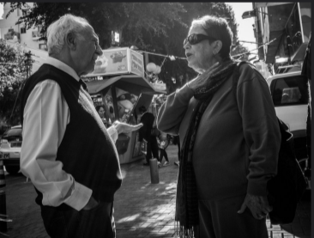
Photo by plofiz on Flickr
‘We live before the faces of others. Some are there physically, others in memory or anticipation. We have been formed face to face from our earliest days, deeper than conscious memory.’
Professor David E Ford, Self and Salvation p. 17
We are used to seeing ourselves in mirrors but we rarely stop to think what people see when they meet us, work with us, share with us, worship with us. What sort of face do we present or offer to others? And what do our face-to-face relationships have to do with the way we offer the gospel and the reality of Christ’s love to others?
Working in Westminster, I am often asked for directions, information, or I find myself being engaged in conversation by tourists, visitors and all kinds of other people. I have had questions about how to find the actor Hugh Grant, how to meet the Queen, where to get a decent sandwich, where to find a sex-worker (yes, really!), who lives in Westminster Abbey, and whether I could go to court and hold the hand of a frightened witness.
The strange thing is that people really do seem to single me out. But why? I notice that when there’s a large group of people available for people to ask, they still seem to hone in on me. I really don’t want people to ask me, because I’m a very introverted person and not very good at giving directions and I’m always worried I will give them the wrong advice or information and they will hate me afterwards. I’ve given awkward answers in French, Spanish, German and Italian and been addressed in a host of other languages I don’t actually understand.
Is it because I wear glasses? Does that make me look knowledgeable? Do I look approachable? Is a woman more approachable than a man? Is it my age? The fact that I’m often wearing my office badge? The fact that I’m wearing a cross? Do I look trustworthy? Streetwise? Do I look like the sort of person who will stop and help (I always do). Or is it that people somehow think that this face, my face, is the one they can address, rather than this face or that face in the crowd?
It’s a mystery to me. But also a privilege. Chance encounters and meetings are ways of being Christ for people. I can’t know what difference to their day I might make, but stopping what I’m doing, giving people attention and maybe walking in their lives a little way might be significant in ways I will never know. I hope so.
Anne Richards
Some things to think about:
- What are the visible signs of being a Christian?
- What makes one person more approachable than another?
- How could we be more prepared to help the people who might stop us in the street?
- What kinds of people might we be wary of helping and why?

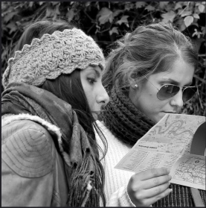
Photo by Michael Summers on Flickr

What next?
Have a look at other sections in Sharing/Being the Face of Love.

