Social engagement and Evangelism: Brexit resources
Mission Theology Advisory Group

The Mission Theology Advisory Group is an ecumenical group formed in partnership between Churches Together in Britain and Ireland and the Church of England



We provide resources in the areas of Spirituality, Theology, Reconciliation, Evangelism and Mission

This resource belongs to our Evangelism series. Please print and share.

Starting Out
This is one of our ‘Brexit’ resources in the Social Engagement and Evangelism series.
Check out the full range of resources in the Church Resources section of the Church of England website.

Pursuing the Human

Enabled Church: Starting a Conversation

Genesis 11.7 ‘Come, let us go down, and confuse their language there, so that they will not understand one another’s speech’

One of the issues which has arisen from talking to people who voted to Leave the European Union in June 2016, was the rise of what might be called the ‘Babel’ factor, the experience of living in an area where many people are around you are talking to each other in languages other than English. Migrants living in this country have sometimes been the subject of mistrust and abuse for not being able to learn or to speak English, including from previous generations of migrants who have successfully learned the language.
Some Christians also reported that it was frustrating being unable to welcome people to church, tell people about what’s going on in their local church scene or to share faith with their neighbours when there was a language barrier. Conversely, some English workers have voiced disappointment and resentment that they are unable to join in banter, or understand instructions where their teams of workers habitually talk to each other in other languages.
For many economic migrants, refugees and asylum seekers, the task of learning English is an extra burden on top of everything else they are trying to come to terms with. Often, the children pick it up faster than the adults, making it even harder for adults to make sense of the world around them. While shops may provide shelves of familiar foods and some churches provide services in other languages for particular communities, many people feel cut off and isolated when their struggle with our language lets them down.
What can we do?
One of the best ways for people to learn English is through informal conversation rather than formal classes. Why not see if there are neighbours or people coming to church who would like a bit of space and time just to chat, without being judged for their language skills and in a space where they can make mistakes? Some other simple things that people arriving in this country have found useful are:
- A friend to accompany them to shops and to answer any questions about the goods there.
- A friend available to help with medical matters, such as going to the doctor or understanding the instructions on medication, or to help with any interactions with social workers, lawyers or the police.
- A coffee time to offer help with paying bills or making complaints.
- A school parent friend to help with school matters and children’s homework.
- A conversation ‘class’ in the evening to talk with a sympathetic person and improve conversational skills.
- A helper’s phone number to contact in case of confusions or miscommunications. People who do not speak English very well are often easily scammed.
- A named helper to assist with spiritual matters, such as reading the Bible, following a church service, or talking to a priest or minister.

Learning New Languages
At the same time, we shouldn’t just assume that the burden is on migrants, asylum seekers and refugees to learn our language. The concerns that people have about the ‘Babel’ factor emerge just as much from the fact that we don’t understand our neighbours’ languages either. That sense of being cut off from others that can happen when people around us are talking on their phones to families and friends can be improved by developing new conversational skills of our own. So it’s worth thinking about starting conversations which help others, but which also add to our own skills.
- Next time you have a coffee morning, a house group, or even at work, find out what languages people already have a working knowledge of. Find out where they learned those languages and what they have ever used them for.
- Ask any new friends at church what their words and phrases are for familiar things in church.
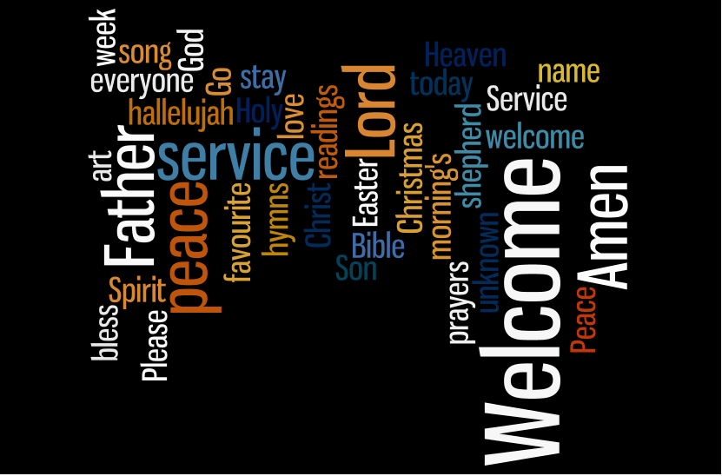
- Together with new Christian friends, trying learning the Lord’s Prayer in their language(s) and praying it together with them.
- Learn some simple conversational phrases for greeting others in your community and use them when you are out and about.
- Work together with new Christian friends to make invitation cards, produce simple notices and offers of help (lifts, baby-sitting) in their own languages so that you reach out to others from their families and communities.
- After a few months, think about whether any of these activities have helped you understand what it is like for people in this country trying to learn English.

Trust

Making Community

Enabled Church

Working against Racism

John 4.9 ‘Jews do not share things in common with Samaritans’
After the Brexit vote, there was a noticeable rise in racist behaviour and incidents. Despite the vote being about Britain’s membership of the European Union, the result also seemed to create conditions for expressed xenophobia against people of Asian and African origin as well. People who had been living in this country for many years and even several generations found themselves being abused and told to ‘go home’.
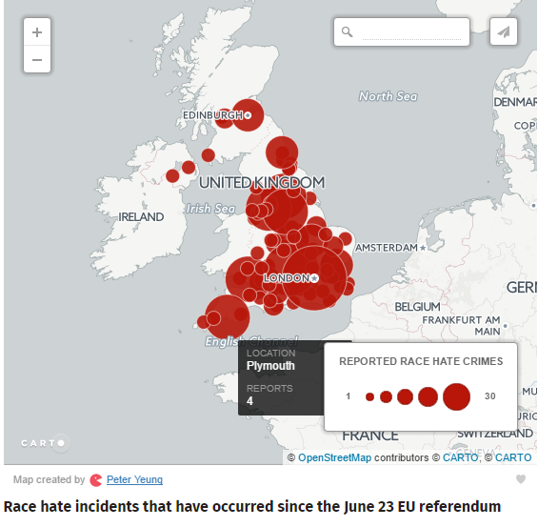reported 28/07/16
http://www.independent.co.uk/news/uk/politics/racism-unleashed-brexit-eu-referendum-post-referendum-racism-true-scale-of-post-eu-referendum-a7149836.html
Many people reported fear and anxiety about far-right groups in our society and increased mistrust of people they thought were their friends.
What can we do?
We can create trust and safer, trustworthy communities as Christians by our actions in the community and ensuring that our churches and congregations are safe spaces for people who may be targets. Here are some ideas for being active workers against racism in our communities.
- If you see someone being racially abused, do something to disrupt (safely) what is happening. Don’t take on any abuser or escalate an argument; instead move over to the victim and talk to him, offer solidarity and try to get others to react in a similar way, shielding the victim and making him less isolated. Let the victim know that he can trust you. The Safety Pin initiative is being used by some people to show this.
- Talk to people who express racist views in your presence about why they feel like that. Don’t start an argument, but try to get their thoughts and feelings out in the open where they can be challenged. Sometimes finding people they admire (eg TV stars) who fit the ethnicity profile they reject, can help create a way in to thinking about where their hatred and fear might be coming from.
- Become more aware of whom you meet and greet when you are out and about. If you find that you mainly say hello to white, middle class people, make an effort to smile at and greet in a friendly way a wider group of people regardless of their ethnicity, age, gender, ability, or economic status. If you discover it’s easier for you to address some people more than others, work on overcoming your own preferences.
- Find out more about any racist incidents reported in your local news and find out what is being done in your area to combat racism. See if you can help with their activities or programmes. #moreincommon is an initiative of Hope not Hate which invites communities to hold events which bring people together.

A Christian couple were concerned about a neighbour who regularly expressed racist views about some of their Indian friends on their street. They invited her out to a meal at an Indian restaurant where the neighbour was very dismissive of the staff. The couple astonished her by greeting their waiter by name, catching up with his news and sharing a joke with him, introducing him to their neighbour and getting up to talk to his family in the kitchen. The neighbour grudgingly agreed that it was interesting to find out about people and she might have been wrong about the people in her street and said she was going to talk to them a lot more in the future.

Photo: Un Bolshakov

Confidence

Honouring Memory

Enabled Church Remembrance

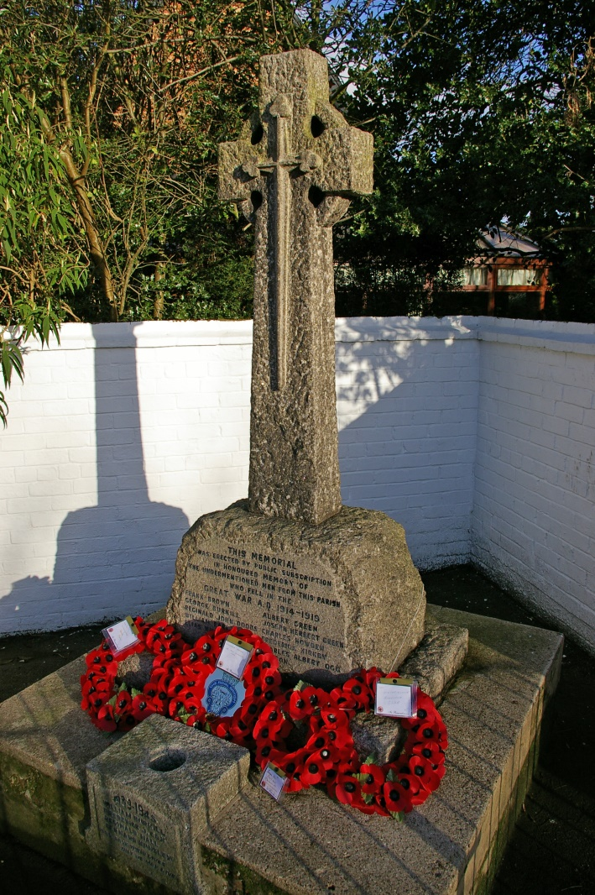
Photo: David Wright
‘Not what we fought for’
Proverbs 10.7 ‘The memory of the righteous is a blessing, but the name of the wicked will rot’
It was interesting that the referendum on Britain’s future within the EU coincided with a number of centenary events concerning the First World War, including the Battle of the Somme. Some of the people asked about why they voted Leave cited a duty to their fathers and grandfathers who fought in the two world wars. The commemorative events had made them think about issues of European power, aggression and occupation and the freedoms their own families had fought and died for. Consequently for some, mainly older people, the vote was about preserving something that was a matter of tradition, ‘Britishness’, ‘values’ and being our own masters. Some of those people talked about perceptions of Europe as interfering in British life, introducing unsuitable regulations and laws, and permitting European migrants to live and work in the UK as a kind of peacetime occupation with power imperceptibly transferring to them as they sent money and goods back to their countries of origin, undercutting self-employed British workers and squeezing British people out of housing stock and services. Some people felt that Germany was still in some way the ‘enemy’ and that Germany’s strong position in modern Europe was a threat. Their perception was that the communities they saw around them were ‘not what we fought for’.
The question is: how do we honour the memory of our ancestors and those who died in the two world wars, acknowledging the past and the lessons we might learn from it, while helping people to live in the present and the future as a different and new set of opportunities? The Church is at the forefront of Remembrance Day services and centenary events and these have generated powerful memories and popular appeal, such as the display of ceramic poppies at the Tower of London in 2014.
What can we do?
- Open up the history. The two world wars were fought for the freedom and self-determination of all European nations, not just Britain. European migrants also had ancestors who fought in those wars or were affected by those wars – what are their memories? What was it like to live in an occupied country? How do European migrants in this country think about the history of those wars?
- Use local history societies and local museums to find stories of openness, hospitality and welcome from the war years. How did people pull together and take care of each other in communities. How were POWs and refugees taken care of? How can those stories make a difference to our communities and church actions today?
- Engage local people to understand the current campaigns to bring more refugees to Britain who have existing family here.
- Tap into the memories of older people about things like being evacuated, using air raid shelters, rationing and reconstruction after the Second World War, to gain a greater understanding of what asylum seekers and refugees are experiencing right now.
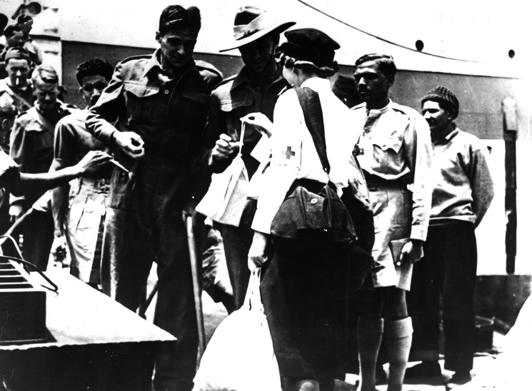A Red Cross officer meeting POWS and giving them ‘comfort’ bags.

Hope

New News

Enabled Church Speaking and Listening Truth


Ephesians 4.25 ‘let all of us speak the truth to our neighbours, for we are members of one another’
During the EU referendum campaign, many people were affected by claims made on both sides. However, talking to Leave voters afterwards, many mentioned the claim made by the Leave campaign that money sent to the EU could be spent on the NHS.
While many of those people were suspicious of the figure quoted, the claim nonetheless got their attention and sympathy, because the NHS is so important to British people. They talked about their experiences of waiting for a long time to see their local doctor or spending hours worried and in pain, in A&E. Others were frightened that their operations would be postponed or that they would not get the drugs they need in the future because of funding problems within the NHS.
The strength of feeling about the NHS and its significance in our lives tells us some important things. First that we live in an age when untruths can be told and it doesn’t seem to matter. ‘Fake news’ and unsubstantiated claims can get as much of a hold on people’s emotions and ideas as ‘truth’. Secondly, we find that people respond to ‘fake news’ as if it were truth because it chimes with their deep fears and in their spiritual heart. Ill health and its treatment are not just physical but spiritual matters. Waiting in a doctor’s surgery, in A&E, on a maternity ward, or waiting for an operation are transformative experiences in people’s lives.
We have the capacity to bring hope into these anxious, and sometimes dark, places and to bring people new news about the support, love and care that Christians who believe in Jesus Christ as God’s Truth, can offer.
What can we do?
- We can become more aware of the local and individual concerns of people in our communities.
- Find out where people are getting their information from – are the sources trustworthy? Some people might not speak English too well or have difficulty understanding or making sense of what they read or are told. We can do more to be ourselves trustworthy sources of information or fact checkers, not gossips and rumour-mongers.
- What are the newspapers saying and how are they forming opinions in your local community? You can talk to your local newsagents about what the most popular newspapers are in your area. What news have we got to counter scare stories? Churches can gather and disseminate positive stories of eg hospital care, local crime rates and the positive contributions of European migrants in the local area.
- Find out who people follow and who they listen to on television or through social media. Do opinion-formers need to be challenged?
- Find out about people’s fears. What are their issues, - health, climate change, money? Think about these as spiritual issues affecting people’s relationship with their faith. How can we provide reassurance and hope from our own faith?
- Gather stories about people’s experiences of the NHS, commuting, looking after children etc. What do these stories tell us about their ‘truth’ and their spirituality?
- Create a support network or helpline for people who are worried and upset about everyday things which impact on their lives. These things might include the NHS, train and bus services, childcare, pensions, employment, benefits, or housing.
- Help people when they realise they have been persuaded by untruths. As Christians we know that Jesus was betrayed and many lies were told about him. He did not argue about it, but continued to speak God’s truth and act God’s truth. How can we be more like Jesus in helping people who feel betrayed, anxious or hopeless?
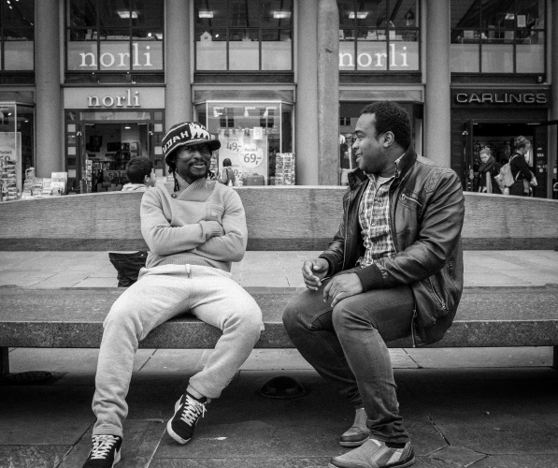
‘...when we do it like Jesus we so often experience a cascading of grace. And that cascade of grace favours mission’.
Ann Morisey, 2004, ‘Without power and at risk of being overwhelmed: a strategy for mission’ Lecture.
Photo: Anne Worner

Sharing

Face of Love

Enabled Church: Beyond ‘Nice’

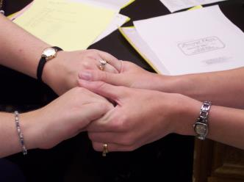
Photo: Calgrin@morguefile.com.
Deuteronomy 7.2 ‘Make no covenant with them and show them no mercy’
It was surprising in asking people about their reasons for voting to leave the EU that a number of faithful Christians, active members of their local churches, were among the most anti-migrant voices. However, after asking people about their feelings about what had happened in their communities, one of the issues which emerged was the impossibility of talking about fears and concerns in their church circles. So people said that they felt that they could not discuss their worries about their local situation, ask for prayer or seek help and advice about issues like jobs or housing, because they would not be showing Christian tolerance, ‘niceness’ or kindness towards their neighbours. One Christian, who admitted to an inner struggle with guilt and anxiety which led to a Leave vote at the polling station, said he had come to the upsetting conclusion, ‘I do not love my neighbour’.
We are called to be the face of God’s love to others, but have we been putting pressure on people to be more Christ-like than they can handle? Christians are human, fallible, sinful, so what safe spaces in churches or online are made available for people to deal with their prejudices, anxieties and fears? How do we equip people to be the face of God’s love and enable them to share their fears as well as their faith? Are mission and evangelism only about confidence? Or does the mission of the Church also require admission of failure and vulnerability? Jesus told the story of the Good Samaritan because he was well aware that those around him did not love their neighbours and he gave them a story to help them to confront those deep-rooted feelings and subvert them until they could imagine themselves in neighbour-relations with those about whom they had felt the deepest suspicions.
What can we do?
- Create safe, neutral spaces in Christian communities for people honestly and openly to express any concerns, anxieties and fears about their lives and what is happening in their local area. Find creative ways to allow difficult conversations.
- Don’t assume everybody is ok with the fast pace of change in some communities. When demographics change, services are stretched, and new people move into the neighbourhood, being the face of Christian love can be challenging. Find ways to understand how people develop deep resistance to change and where that resistance might be at work in your church.
- Create outlets for concerns, for example opportunities for prayer, confession, support groups and ways of meeting new people moving into the area. The document Hatebusters and Neighbourlovers https://www.churchofengland.org/media/2552147/hate_crime_and_the_churches.pdf points to examples of good practice for helping people become good neighbours.
- Genuine welcome, hospitality and concern for others includes acknowledging trepidation and caution on all sides. New relationships are tender shoots. Don’t just assume new people will just be absorbed into the church community automatically. Some things to think about include:
- Help people to pronounce unfamiliar names correctly. Don’t put people in positions where they can be embarrassed or struggle with prayers or announcements.
- Some people may have trouble understanding newcomers with strong accents and so avoid talking to them.
- Some Christians may be hiding grief for changes in the church and community especially if this means the loss of old friends and neighbours.
- Don’t silence people or expect them to be nice all the time. Find ways to dispel tension and create opportunities for befriending people through shared activities or stories.

